Minnesota State University Moorhead

Finding Voice and Connection through *The Poet X*

Poetry Reading Unit



Edmund Buscho, Sydney Hennen, Kenna Kuhn, Lynda Lengenfelder, William Lewandowski

Dr. E. Kirchoff

English 491: Theory and Methods: CA/L Grades 9-12

29 April 2021

Table of Contents

Overview and Rationale……………………………………………………………………….......1

Letter to The Parents……………………………………………………………………………….4

Unit Goals……………………………………………………………………………………….... 5

Calendar……………………………………………………………………………………….......6

Psychology………………………………………………………………………………………...7

Standards…………………………………………………………………………………………..8

Points Breakdown……………………………………………………………………………….. 10

Summative Assessment…………………………………………………………………………..11

Anchor Essay – Summative Assessment…………………………………………………11

Anchor Essay Rubric……………………………………………………………………..13

Poetry Portfolio Assignment Sheet……………………………………………………….16

Poetry Portfolio Grading Checklist………………………………………………………17

Spoken Word / Slam Poetry Day – Assignment Sheet……………………………………18

Poetry Slam Feedback……………………………………………………………………19

Discussion Questions…………………………………………………………………………….20

Lesson Plans..………………………………………………………………………………….....23

Day 1: *The* *Poet X* Pre-Reading Activity……………………………………………........23

Day 2: Introduction to Poetry and “I Am From” Poem…………………………………..26

Day 3: Writing Territories and Heart Mapping……………………………………….….30

Day 4: Alliteration, Assonance, Consonance………………………………………….....34

Day 5: Sensory Language…………………………………………………………….......38

Day 6: Say Their Names/Concrete Specifics…………………………………………......42

Day 7: Spanish Language Use and Decoding………………………………………….....45

Day 8: Thoughts and Feelings………………………………………………………........49

Day 9: Voice/Tone/Word Choice……………………………………………………..….52

Day 10: Line breaks and Stanzas……………………………………………………...….57

Day 11: Memoir Poems………………………………………………………………......61

Day 12: Poetry Forms & Impromptu Speeches………………………………………......65

Day 13: Poetry Day…………………………………………………………………...….68

Day 14: The Rule of “So What?” ……………………………………….…………….....72

Day 15: Spoken Word……………………………………………………………….…...75

Additional Materials and Attachments………………………………………………………….79

*The Poet X* Pre-Reading Activity………………………………………………………...79

Recommended Poems Handout…………...………………………………………..…….81

“The Thing About Dreams” Handout and Key………………………………………..….83

“Same Love” Macklemore Handout and Key…………………………………………….85

“The Raven” Edgar Allen Poe Handout and Key (for ELL differentiation) .......................87

“Through three cheese trees” Dr. Seuss Handout and Key (for ELL differentiation) .......89

“Stopping by Woods on a Snowy Evening” Robert Frost Handout and Key (for ELL differentiation) …………………………………………………………………………...91

*Alliteration, Assonance, Consonance* PowerPoint Slides…………………………..…….93

“Supplemental Sensory Language Words” Handout………………………………..……96

“Sensory Language” Handout……………………………………………………….…...97

“Some Common Tone Words with their Meanings” Handout………………………........98

PowerPoint “Writer’s Voice” ……………………………………………………….….102

Line Breaking ConceptsPrezi Link……………………………………………..………107

Line Breaking AnalysisHandout……………………………………………….……....113

“Questions for Memoirists” Handout……………………………………………..…….115

“The Perfect Cake” Memoir Poem……………………………………………...…........116

List of Poetry Forms Handout……………………………………………...………...….118

Impromptu Scoring Sheet…………………………………………………………….....119

“So What?” Assignment Sheet………………………………………………………….120

Poetry Groups Handout…………………………………………...…………………….121

Peer Review Workshop Checklist……………………………………………………....122

Editors Marks Handout………………………………………………………………....124

Works Cited………………………………………………………………………………….....125

Unit Overview and Rationale for *The Poet X*

Elizabeth Acevedo’s *The Poet X*, written almost exclusively in free verse poetry, follows the journey of Xiomara Batista. Xiomara’s poetry is flooded with conflicts, dreams, pain, and love she endures in her day-to-day life. She uses her poetry as a source of release when there is no other outlet in a world in which she has trouble finding a place to be herself. As a teenager in a conservative and religious household, Xiomara must decide if she will allow herself to be who she is or if she will submit to the rules and regulations imposed on her.

*The Poet X* has received over thirty-two awards, including a National Book Award medal, the Michael L. Printz Award, the Boston Globe—Horn Award, and many more. Reviews claim *The Poet X* is “a glorious achievement. Required reading for everybody,” (Daniel Jose Older, author of National Book Award finalist, Ghost), “skillfully sculpt[ed] powerful, self-contained poems into a masterpiece of a story, and has amplified the voices of girls,” (Ibi Zoboi, author of American Street), and that “in nearly every poem, there is at least one universal truth about adolescence, family, gender, race, religion or sexuality that will have readers nodding in grateful acknowledgment or blinking away tears” (The Horn Book Magazine).

Acevedo’s novel, *The Poet X* has been included in our curriculum because of its poetics, diverse culture of the characters and author, the variety of coming-of-age experiences in the novel, and the myriad of topics relevant and recognizable to the students, including, but not limited to: religion, family, identity, sexuality, and relationships. This text lends many avenues of growth for reading, writing, speaking, listening, and communication skills through poetics and themes. Due to the richness and diversity of this text, *The Poet X* has been added to the curriculum.

Teaching this book will provide students with a diverse perspective while giving them a story with which they can connect. *The Poet X*, which is written mostly in free-verse poetry, exposes students to a multitude of poetic and literary elements and themes that they can relate to, and it can be used as a tool for developing empathy and understanding of others’ experiences and feelings, and recognizing that self-expression through writing is not limited to prose.

*The Poet X* provides students with different levels of context and understanding of the bigger picture around them. Milner, Milner, and Mitchell, educational theorists, suggest to “encourage students to encounter the text from various angles” using three levels of interpretation of the text: “purely textual (text-to-text), the personal (text-to-self), and the global (text-to-world)” (35). Using *The Poet X*, this unit strives to give students a book they can see themselves in, while gaining worldly insight all the way down to the text itself. As Milner, Milner, and Mitchell advise, sticking solely to a traditional literary canon is a disservice to students as it acts as the “exclusion of students from their own experienced lives” (221). Xiomara’s conflicted emotions provide students a place to connect and see themselves through her writing, but also gain possible other perspectives and understanding. For this reason, this novel was chosen for the eleventh-grade classroom.

There are themes and topics that are of a sensitive nature and can be taken offensively. Possible sources of controversy in *The Poet X* include but are not limited to: themes and situations of sex, sexuality, family conflict, religion, questioning of the Bible, misogyny, and sexism. Xiomara doubts and questions religion, God, and the Bible throughout the book as she views religion as oppressive due to her mother’s strictness. For these reasons, the theme of family conflict, which Xiomara tries to remedy by sneaking around and keeping secrets through her poetry journal, may come off as painting a poor picture towards strongly religious households.

Furthermore, the themes of sex and sexuality may be deemed inappropriate for students. Xiomara, who is a fifteen-year-old girl, comments on how men treat her and talk about her body, directly focusing on misogyny and sexism with how grown men behave when they see her. More so, she describes her sexuality, sexual desire, and deciphering her adolescent thoughts on her changing mind and body, as she learns to appreciate herself and her looks. On the theme of sexuality, there is also the topic of LGBTQ+ persons through Xiomara’s brother, Twin, who has secrets of his own sexuality. Xiomara finds out that Twin is gay and in a relationship with a white boy, which also bring attention to the idea of interracial dating. Furthermore, Twin’s inability to share his thoughts and feelings as a gay teen displays not only an aspect of being an LGBTQ+ individual, but also presents the theme of religion and how religion can impact a gay individual’s identity and self-expression. These themes and topics can be easily found as offensive or inappropriate by others, especially parents.

Ultimately, the diversity of the text, the connections the readers will gain from the themes, and the literary merit of *The Poet X* give the students a rich environment to build their literary repertoire, to increase their empathetic and conscientious understanding of others, and to explore topics in a new fashion through the eyes and mind of a teen character and poetics, which is why this book was specifically chosen for this unit.

Moorhead Senior High School

2300 4th Ave S

Moorhead, Mn 56560

012-345-6789 X1001

March 22, 2021

Dear Parents and Guardians,

Your child is about to embark on a journey into the world of verse. On Monday April 5th, we will be starting a poetry unit featuring the book, *The Poet X*, by Dominican American poet and author, Elizabeth Acevedo. This book is the recipient of several awards: the National Book Award, the Michael L. Printz Award, the Pura Belpré Award, the Carnegie medal, the Boston Globe—Horn Book Award, the Walter Award, and more. I have chosen this beautifully composed coming-of-age book because it is accessible and relatable to young adults of various interests, backgrounds, and abilities. The book is written almost exclusively in poetic verse and explores themes pertinent to young adults. To further develop an inclusive learning experience in which all students of various backgrounds are represented, I intend to strengthen our classroom community so that every student feels safe sharing their voice. Throughout the unit, your child will engage in activities in which they explore their self-identity, understand their inherent value, share their unique personality and perspectives with their classmates, and come to appreciate and accept their individuality.

*The Poet X* explores relevant themes that young adults find meaningful. Acevedo’s text is both captivating and approachable. She handles sensitive topics both conscientiously and honestly. The book centers on the writings of fifteen-year-old Xiomara as she explores her identity in relation to her gender, ethnicity, sexuality, relationships, culture, family, and language. Xiomara is a young Latina girl in a religiously observant Catholic family. Although Xiomara struggles with her faith, Acevedo is careful not to demonize any faith. Some themes in this book are difficult, such as parental abuse, but are handled with sensitivity and respect. Your child will be able to read Xiomara’s thoughts as she struggles to determine who she is and who she wants to be as she comes to a place of self-acceptance. English teacher and YouTube book reviewer, Ali Dunn, recommends this book for students in ninth grade and above. She believes that there is something special about “being able to express yourself in a way that’s different and unique.” This is especially important in a time when acceptance of diverse perspectives is a sensitive issue.

If you would like to discuss anything further, please do not hesitate to contact me. I want to make sure this unit provides a meaningful learning experience for your child.

Sincerely,

Unit Goals for *The Poet X*

1. Provide students with a diverse perspective that they can connect to while developing understanding and empathy towards another culture, idea, or point of view.
2. Develop understanding of how the individual students identify with the world and reflect on the themes that apply to themselves and their peers, including, but not limited to: family conflict, homelife, parents, familial relationships; sex, sexuality, sexual desire; questioning or acceptance of God, the Bible, and religion; misogyny and sexism; race, racism; native language, bilingualism, explicit language; adolescence, body image; dating and interracial relationships; LGBTQ+, coming out, being closeted, being outed, and self-identity.
3. Interpret the text on multiple levels, so students connect and interact with the novel using various mindsets (text-to-text, text-to-self, and text-to-world).
4. Establish a foundation of poetics by breaking down poetic and literary elements to enhance their reading and writing skills using concepts including, but not limited to: alliteration, assonance, consonance, sensory language, imagery, concrete specifics, tone, voice, word choice, line breaks, stanzas, enjambment, end-stops, poetry forms (including memoir and prose poetry), syllables, meter, rhythm, and rhyme
5. Broaden their perception and appreciation of poetry by not only referencing the text, but also bringing in a variety of outside supplemental texts, poems, videos, and more to bring every student’s attention to the world of poetry.

|  |  |  |  |  |
| --- | --- | --- | --- | --- |
| April 2021 | | | | |
| Monday | Tuesday | Wednesday | Thursday | Friday |
| 5  Intro to *Poet X* Unit/The *Poet X* Pre-Reading Activity   * Discussion for 10 minutes * Lesson/ activity for 55 minutes * Free-reading for 25 minutes | 6  Intro to Poetry / “I Am From...” poem   * Free-reading for 20 minutes * Lesson/activity for 70 minutes | 7  Writing Territories and Heart/Identity Mapping (Optional Personality Tests)   * Discussion for 10 minutes * Lesson/activity for 70 minutes * Work/journal time for 10 minutes | 8  Alliteration, Consonance, Assonance   * Discussion for 15 minutes * Lesson for 75 minutes | 9  Sensory Language   * Free-reading for 20 minutes * Lesson/activity for 40 minutes * Work time for 30 minutes |
| 12  Say Their Names or Concrete Specifics   * Lesson for 60 minutes * Work/journal time for 30 minutes | 13  Spanish Language Use and Decoding   * Discussion for 20 minutes * Lesson for 40-50 minutes * Work time for remaining 20-30 minutes | 14  Thoughts and Feelings   * Lesson for 60 minutes * Journal time for 10 minutes * Free-reading for 20 minutes | 15  Voice / Tone / Word Choice   * Free-reading for 20 minutes * Lesson/Activity for 55 minutes * Work time for 15 minutes | 16  Line Breaking Concepts   * Discussion for 15 minutes * Lesson for 45 minutes * Work on Line Breaking Analysis Worksheet for remaining 30 minutes |
| 19  Memoir   * Discussion for 10 minutes * Lesson for 70 minutes * Work/journal time for 10 minutes | 20  Poetry Forms   * Lesson for 60 minutes * Independent Writing for 30 minutes | 21  Poetry Day (for National Poetry Month)   * Discussion for 15 minutes * Lesson/activity for 75 minutes * Work/journal time for remaining class time | 22  So What?   * Lesson for 70 minutes * Free-reading for 20 minutes | 23  Spoken Word   * Lesson for 55 minutes * Practice and then work time for 35 minutes |
| 26  How to Peer Review / Revise / Re-draft   * Go over “How to Peer Review” guidelines * Time to work on poems and revise before workshop | 27  Workshop / Revise / Re-Draft   * Peer workshop for 40 minutes (Peer Review Checklist) * Revise and redraft for remaining time | 28  Work on layout and cosmetics-- Work on final drafts   * Student workday and spoken word practice day | 29  Practice spoken word / slam  Unit Wrap up Day   * Entire class time dedicated to putting together final assessment and/or working on their spoken word or slam poem. | 30 |

**Psychology**

Week one the psychology teacher will cover:

* Structure/biology of the brain
  + Function of each part of the brain
* Balance of chemicals in the brain and how they affect functioning
  + Mental disorders
    - Causes and treatments
  + Judgement and decision making
* Puberty and psychology
  + Biological changes in the brain with maturation
  + Development of personal and sexual identity
* Neurological development
  + How pathways change with age and rewire with experience

Week two the psychology teacher will cover:

* Effects of nutrition, drugs, love, and alcohol on the brain
* Reward system
* Fight or flight system

Week three the psychology teacher will cover:

* Abraham Maslow’s Hierarchy
* Erik Erickson’s Eight Stages of Identity Crisis
  + Self-perceptions and how “identities” form
* Moral dilemmas / Societal norms
  + What defines right and wrong
    - Shame/guilt
  + Religion
  + Gender molds

**Standards**

11.1.4.2: Determine two or more themes or central ideas of a text and synthesize their development over the course of the text, including how they interact and build on one another to provide a complex synthesis.

11.1.5.2 Evaluate the impacts on meaning and appeal of the author's choices concerning structuring the text, including how specific parts of the text interact with each other and contribute to the whole.

11.1.8.1 Analyze the cumulative impact of specific word choices on meaning, mood, and tone of literary text. (e.g., how the language evokes a sense of time and place; how it sets a formal or informal tone).

11.3.1.2: Extend conversations by posing and responding to questions that probe reasoning and evidence; ensure exploration of a full range of positions on a topic or issue; clarify, verify, or challenge ideas and conclusions; and promote divergent and creative perspectives, demonstrating preparation for the discussion.

11.4.4.4 Determine the meaning of words and phrases as they are used in the text, including figurative and connotative meanings; analyze the impact of specific word choices on meaning and tone, including words with multiple meanings or language that is particularly fresh, engaging, or beautiful. (Include Shakespeare as well as other authors.)

11.4.5.5: Analyze how an author’s choices concerning how to structure specific parts of a text (e.g., the choice of where to begin or end a story, the choice to provide a comedic or tragic resolution) contribute to its overall structure and meaning as well as its aesthetic impact.

11.5.3.3 Analyze a complex set of ideas or sequence of events and explain how specific individuals, ideas, or events interact and develop over the course of the text.

11.5.4.4 Determine the meaning of words and phrases as they are used in a text, including figurative, connotative, and technical meanings; analyze how an author uses and refines the meaning of a key term or terms over the course of a text (e.g., how Madison defines *faction* in *Federalist* No. 10).

11.5.5.5: Analyze how an author’s choices concerning how to structure specific parts of a text (e.g., the choice of where to begin or end a story, the choice to provide a comedic or tragic resolution) contribute to its overall structure and meaning as well as its aesthetic impact.

11.5.6.6 Determine an author’s point of view or purpose in a text in which the rhetoric is particularly effective, analyzing how style and content contribute to the power, persuasiveness, or beauty of the text.

11.7.3.3 Write narratives and other creative texts to develop real or imagined experiences or events using effective technique, well-chosen details, and well-structured event sequences.

c. Use a variety of techniques to sequence events so that they build on one another to create a coherent whole and build toward a particular tone and outcome (e.g., a sense of mystery, suspense, growth, or resolution).

d. Use precise words and phrases, telling details, figurative and sensory language to convey a vivid picture of the experiences, events, setting, and/or characters.

11.9.3.3 Evaluate a speaker’s point of view, reasoning, intended audience, and use of evidence and rhetoric, assessing the stance, premises, links among ideas, word choice, points of emphasis, and tone used.

11.9.6.6:Adapt speech to a variety of contexts, audiences, tasks, and feedback from self and others, demonstrating a command of formal English when indicated or appropriate.

**Unit Breakdown of Points**

(Day 2) “I Am From” poem 5 points total

(Day 4) Lyric page 5 points total

(Day 5) Sensory language free verse poem 10 points total

(Day 6) Weekly journal check 10 points total

(Day 9) Biographical poem 10 points total

(Day 10) Line breaking analysis 20 points total

(Day 11) Weekly journal check 10 points total

(Day 12) Impromptu speech score 12 points total

(Day 14) “So What?” handout 10 points total

(Day 16) Weekly journal check 10 points total

(Day 20) Poetry slam participation 10 points total

Final assessment: Anchor essay 60 total points

Final assessment: Poetry portfolio 18 total points

**Total Points Possible:** 190 points

**Anchor Essay - Summative Assessment**

Due: April 30, 2021 at the beginning of class

Throughout the novel, *The Poet X*, Xiomara writes exclusively in poetic verse, documenting her journey of self-identity. Xiomara works through her thoughts and feelings about sexuality, religion, gender, race, ethnicity, language, sexism, and self-acceptance by writing poems in her journal. For this assignment, you will write an essay exploring one of these themes and will discuss its significance in the novel and how it is personally meaningful to you. You will also draw a connection between how the theme was treated in the novel and how you addressed that theme in the poems you wrote in your poetry portfolio. In this essay, you will also discuss at least three poetic devices that you learned about during our poetry unit and that you have used when writing your own poems. You must find three separate examples from the text that demonstrate use of each of the three poetic devices. Remember, the tone of this essay is informal. Part of your grade is based on how well you show your personality, thoughts, and beliefs.

**Major Themes**

You may choose at least one (no more than two) of the following major themes from *The Poet X* to discuss in your essay. If there is a theme you think is missing from this list, and you feel passionate about it, you can choose to discuss it in your essay. When discussing the theme(s) you select, be sure to thoroughly discuss its significance in the novel, as well as how and why it is meaningful to you personally.

* Sexuality
* Religion
* Sexism
* Feminism
* Self-acceptance
* Self-identity
* Gender
* Language
* Ethnicity
* Family
* Relationships
* Misogyny
* Spoken Word

**Poetic Devices**

Your essay will demonstrate your understanding of at least three of the following poetic devices. Choose three devices that you have used when writing your own poems for your poetry portfolio. First, discuss each poetic device (describe what it is—show your understanding) and then quote three separate examples, one for each device, from the text where they occur. Then identify examples of these devices in your own poetry and discuss the impact of these devices in your own work.

* Alliteration
* Assonance
* Consonance
* Sensory Language
* Tone
* Word Choice
* Rhythm
* Rhyme
* Line breaking
* Format
* Enjambment
* Concrete Specifics

**Specifications:**

Your essay must include the following criteria:

1. Must be word processed using Times New Roman: size 12 font.
2. Must be three to five pages in length: double spaced.
3. Have well developed writer’s voice and tone—show your personality, thoughts, and beliefs.
4. Demonstrate varied word choice—show your vocabulary skills.
5. Must be clearly written and be cohesive. Ideas must be well integrated and in a logical order.
6. Demonstrate mechanical skill (grammar, spelling, and punctuation) see the rubric for more detailed information.
7. include at least three quotes from the text, *The Poet X.* Make sure to include a page number for every quote you use.
8. Must discuss three poetic devices that are in the novel AND in your own poems.

**Anchor Essay Rubric**

|  |  |  |  |  |
| --- | --- | --- | --- | --- |
| **Criteria** | **Exemplary**  **9-10 Points** | **Proficient**  **7-8 Points** | **Developing**  **4-6 Points** | **Inadequate**  **1-3 point(s)** |
| **Content: writer’s voice, tone, word choice, vocabulary**  Score: _______ / 10 | Student’s voice and tone are clearly expressed in essay— student’s personality and attitude are strongly conveyed throughout essay. Students’ thoughts and beliefs are expressed clearly. Student skillfully chooses strong words that concisely express desired meaning. Word choice is appropriate to tone of essay: essay is subjective and personal. Student skillfully uses varied vocabulary consistently maintaining reader’s interest throughout essay. | Student’s voice and tone are moderately evident in essay—student’s personality and attitude come through but are somewhat muted. Student’s thoughts and beliefs are somewhat evident. Student chooses words that express desired meaning, but some words obscure desired meaning. Word choice is mostly appropriate to tone of essay, but essay is somewhat impersonal. Student uses varied vocabulary. Essay is moderately engaging. | Student’s voice is not evident in essay—student’s personality is mostly absent. Student’s tone is significantly weak, and as a result, thoughts and beliefs are imperceptible. Student frequently chooses words that obscure meaning resulting in detraction from intended meaning. Word choice is at times appropriate to tone of essay. student uses limited vocabulary. Essay is flat, impersonal, and unremarkable. | Student’s voice is absent from essay—student’s personality is not present. Student’s essay is flat and lacks tone—student’s thoughts and beliefs are not evident. Student’s word choice is significantly limited, and words are frequently used repetitively and/or incorrectly. Student’s intended meaning is unclear rendering writing incoherent and confusing. |
| **Major themes: self-identity, sexuality, religion, self-acceptance, sexism, gender, race, ethnicity, language, family, misogyny, feminism**  Score: _______ / 10 | Student’s choice of at least one major theme is evident. Student thoroughly discusses selected theme and its significance in the novel. Student clearly discusses connection between selected theme in the novel and in their own poems. Student clearly discusses reasoning for selecting theme and demonstrates a personal connection with selected theme. | Student’s choice of at least one major theme is evident. Student discusses selected theme and its significance in the novel, but discussion is not thorough. Student discusses connection between theme in novel and in their poetry, but discussion lacks depth. Student discusses reasoning for selecting theme, but connection with selected theme lacks depth. | Student focuses on at least one major theme in novel. Student’s discussion of theme and its significance in novel lacks depth. Student’s discussion connecting theme between the novel and their poetry is significantly weak. Student does not discuss reasoning for selecting theme and does not demonstrate a personal connection with theme. | Student does not focus on at least one major theme in the novel, or student identifies a major theme but does not discuss its significance in the novel. Student does not make a connection between a major theme and their own poetry. student does not demonstrate a personal connection with a major theme |
| **Poetic devices: alliteration, assonance, consonance, sensory language, rhythm, rhyme, line breaking, enjambment, concrete specifics**                      Score: _______ / 10 | Student skillfully discusses at least three poetic devices. Student demonstrates knowledge of selected poetic devices and accurately identifies examples in the text. Student makes strong connections between poetic devices used in the text and in their own poems. Student discusses their reasoning for selecting poetic devices in depth. | Student discusses at least two poetic devices. Student demonstrates satisfactory knowledge of selected poetic devices and identifies examples in the text. Student makes connections between poetic devices used in the text and in their own poems. Student discusses their reasoning for selecting poetic devices somewhat vaguely. | Student discusses at least one poetic device. Student demonstrates limited knowledge of poetic device resulting in inaccurate identification of an example in the text. Student’s connection between selected poetic device in text and in their own writing is weak and/or is based on a misunderstanding of the poetic device. Student’s discussion of reasoning for selecting poetic device is mostly absent. | Student does not discuss at least one poetic device, or student’s discussion significantly lacks knowledge of poetic device. Student does not identify an example of any poetic device in the text, or example is inaccurate. Student does not make a connection between any poetic device in the text and their own poems. Student does not discuss reasoning for selecting any poetic devices. |
| **Supporting evidence: at least three quotes from text**  Score: _______ / 10 | Student integrates at least three quotes from the text. Borrowed material strongly supports each of the three poetic devices. Quotes are well placed and thoroughly discussed. Each quote is referenced with a page number. The selected quotes clearly connect the novel and the student’s poems. | Student integrates at least two quotes from the text. Borrowed material supports at least two of the three selected poetic devices. Quotes are well placed, but discussion is somewhat lacking in depth. Each quote is referenced with a page number. The selected quotes moderately connect the novel and the student’s poems. | Student integrates at least one quote from the text. Borrowed material weakly supports at least one of the three selected poetic devices. Quotes may or may not be well placed and may or may not be referenced with a page number. Discussion of quote significantly lacks depth. The selected quote does not coherently connect the novel and student’s poems. | Student does not integrate any quoted material from the text but instead loosely refers to passages in the novel, student does not discuss passage in relation to poetic device, or discussion demonstrates lack of knowledge and/or significantly lacks depth. Student does not draw connections between the text and their own poems. |
| **Organization, coherency, structure, transitions, sequence**  Score: _______ / 10 | The main idea is evident, clearly stated, fully developed, and supported throughout essay. Paragraphs include clear topic sentences and supporting points that fortify the paragraph topics as well as the main idea of the essay. There are clear transitions between ideas throughout essay. Student uses a variety of sentence patterns and structures. Essay is well sequenced and logically progresses from one idea to the next. Conclusion strongly supports the main idea of essay. | The main idea is clear but somewhat weakly stated. Main idea is mostly supported throughout essay. Most paragraphs include topic sentences, but some are not clearly stated. Paragraphs include supporting points, but some do not clearly support topic sentence and/or main idea of essay. Transitions between ideas are mostly clear. Student uses some variety in sentence patterns and structures. Essay is moderately well sequenced and logical progression form one idea to the next is fairly evident. Conclusion supports main idea of essay. | The main idea is indicated but is not clearly stated. The main idea is not consistently supported throughout essay. Many paragraphs do not have a topic sentence. Supporting points do not explain or elaborate on topic sentence of paragraph or main idea of essay. Transitions between ideas are either mostly absent or are unclear. Student’s use of variety in sentence patterns and structures is limited rendering writing unenthusiastic. Essay is not well sequenced and lacks logical progression. Conclusion weakly supports main idea of essay. | The main idea is difficult to identify or is absent. The essay is disjointed and lacks focus and clarity. Most paragraphs lack a main topic and supporting evidence. Essay lacks transitions between ideas. Logical progression is absent rendering essay confusing. Student does not use variety in sentence patterns and sentence structures – sentences are either very short or very long and all demonstrate similar structure and organization. Essay lacks a conclusion or conclusion does not support main idea of essay. |
| **Mechanics: spelling, punctuation, grammar**  Score: _______ / 10 | Essay is virtually free of grammatical errors—errors are infrequent and far between and do not detract from meaning. Student demonstrates proficient use of tense and agreement between grammatical forms – nouns and pronouns match in number and gender. | Essay is mostly free of grammatical errors—errors might cause moderate confusion but do not significantly detract from meaning. Student demonstrates satisfactory use of tense and agreement between grammatical forms – nouns and pronouns mostly match in number and gender. | Essay demonstrates several grammatical errors resulting in multiple areas of confusion. Errors detract from meaning. Student demonstrates inadequate use of tense and agreement between grammatical forms – nouns and pronouns infrequently match in number and gender. | Essay demonstrates numerous grammatical errors that significantly detract from meaning. Essay is mostly incomprehensible. Student demonstrates insufficient use of tense and agreement between grammatical forms – nouns and pronouns rarely match in number and gender. |

Grade ___ /60

**Poetry Portfolio Assignment Sheet**

Due: April 30, 2021 at the beginning of class

Over the course of this unit, you will be reading *The Poet X* by Elizabeth Acevedo, studying poetry, and writing your own. You will write poetry frequently in your journal. By the end of the unit, you will select at least six of your poems to revise and polish. These poems will be turned in along with an anchor essay (see anchor essay assignment sheet). The poems you write should deal with one or more of the themes found in *The Poet X*. In at least three of your poems, you must use at least one of the poetic devices we will be learning about over the course of the unit.

Themes:

* Sexuality
* Religion
* Sexism
* Feminism
* Self-acceptance
* Self-identity
* Gender
* Language
* Ethnicity
* Family
* Relationships
* Misogyny
* Spoken Word

Poetic Devices:

* Alliteration
* Assonance
* Consonance
* Sensory Language
* Tone
* Word Choice
* Rhythm
* Rhyme
* Line breaking
* Format
* Enjambment
* Concrete Specifics

Name _____________________ Total Points ___/18

Title of Poem 1______________________________ (1 pt.)

Title of Poem 2______________________________ (1 pt.)

Title of Poem 3______________________________ (1 pt.)

Title of Poem 4______________________________ (1 pt.)

Title of Poem 5______________________________ (1 pt.)

Title of Poem 6______________________________ (1 pt.)

**1st Poem with Poetic Device**

Title of Poem_____________________________

Theme__________________________________

Poetic Device_____________________________

*Effectively Incorporated Clear Attempt Missing*

Theme 2 1 0

Poetic Device 2 1 0

**2nd Poem with Poetic Device**

Title of Poem_____________________________

Theme__________________________________

Poetic Device_____________________________

*Effectively Incorporated Clear Attempt Missing*

Theme 2 1 0

Poetic Device 2 1 0

**3rd Poem with Poetic Device**

Title of Poem_____________________________

Theme__________________________________

Poetic Device_____________________________

*Effectively Incorporated Clear Attempt Missing*

Theme 2 1 0

Poetic Device 2 1 0

*Spoken Word / Slam Poetry Day - Assignment Sheet*

As your teacher, I want to thank you for all your hard work throughout this unit and with *The Poet X*. Your reading and writing skills have expanded immensely, and I enjoyed working with all of you and watching you grow as students. To show off your amazing poetry, we will have a class Spoken Word / Slam Poetry Day. You will get the chance to read one of your favorite poems you wrote this semester.

Make sure you choose the poem *you* feel best exemplifies you and your work this semester, as well as displaying those new elements and techniques you mastered this semester. You will need to present your poem in front of the room, but I will adjust the lighting to make it look like you’re on stage. (You won’t even be able to see your peers!) We will enjoy a day of poetry and excitement along with snacks and beverages.

The only thing you need to worry about is choosing your best original poem from your portfolio and presenting it to the class. This will be graded solely on participation. We want to see you and hear your wonderful words and masterpieces! This is worth five points of participation. As well, I know you all want feedback about your poem from your peers. The other five points of participation comes with providing feedback about each presenter’s poem and presentation.

(In total, the spoken word / poetry slam day will be worth 10 participation points.)

Poetry Slam Feedback

Presenter_________________________

Poem Title________________________

Reviewer_________________________

One thing the presenter did well:

________________________________________________________________________________________________________________________________________________________________________________________________________________________________________________________________________________________________________________________

One thing the presenter could improve:

________________________________________________________________________________________________________________________________________________________________________________________________________________________________________________________________________________________________________________________

**Discussion Questions**

The following discussion questions are intended to spark conversation among small groups of students. The teacher should project the questions on the board via a document camera so that students can see them. Students are welcome to discuss the questions in any order and should not feel obligated to address every question. What is most important is that students engage in conversation about *The Poet X*.

**Day 3 Wed. Apr. 7 pg. 1-61**

* Who is Xiomara? What do you know about her life, her family, her identity, etc.? In what ways do you connect with Xiomara? Think about the themes such as family, friends, relationships, religion, language, self-acceptance, etc.
* Describe Xiomara’s relationship with her mother. Do you think they have a good relationship? Why or why not? Do you have a similar relationship to an adult in your life or do you know anyone who does?
* Xiomara uses some Spanish in her poems. Why do you think she does this? What does it say about her character, her family, her culture, etc.?
* What does Xiomara think about religion?
* In this section, Xiomara writes a poem called “Caridad and I Shouldn’t Be Friends.” Why is this? Why are they friends? What is their friendship like?
* What are your first impressions of Ms. Galiano and her English class?
* In this section, Xiomara writes her first assignment. What did you think about both her rough and final drafts? Why do you think they’re so different? Why did she choose these topics? What would you write about as the most impactful day of your life? It’s okay if, like Xiomara, it’s not something you want to share, but think about why that is.
* What is Xiomara’s relationship with Twin like?
* How does Xiomara react to male attention? What does she do in the moment? How does it make her feel?

**Day 4 Thurs. Apr 8 62-92**

* What happens at church? How does Xiomara’s mother react?
* What do we learn about Xiomara’s father in this section? What do you think about him as a father?
* What are your impressions of Aman?
* What do you think about Ms. Galiano and the poetry club? Do you think Xiomara should join the poetry club? Why doesn’t Xiomara think she should do it?
* What are Xiomara’s mother’s rules about dating?
* Continue discussing any questions from the previous day.
* What else did you notice while reading?
* In what ways do you connect with Xiomara or *The Poet X* in general?

**Day 7 Tues. Apr. 13 93-181**

* What do you think about Xiomara’s developing relationship with Aman? Why does she keep spending time with him if she knows she’s not allowed to date? Do you think he’s good for her? Why or why not?
* How are faith and religion represented differently through Xiomara’s mother and Father Sean? What effect does each of them have on Xiomara?
* How does Xiomara react when she finds out Twin is gay and dating a white boy? Why do you think she reacts this way? How does saying something make it different?
* What do you think about Xiomara’s “Rough Draft of Assignment 3” (179)? What does this poem reveal about her relationship with her mother? Why doesn’t Xiomara choose to write about her mother for the draft she turns in?
* What else did you notice while reading?
* In what ways do you connect with Xiomara or *The Poet X* in general?

**Day 10 Fri. Apr 16 182-268**

* In this section, Xiomara writes a poem completely in Spanish called “A Poem Mami Will Never Read” (233), along with an English translation on the following page. Why do you think she writes this poem in completely Spanish? What does the poem say about her own identity and her relationship with her mother?
* Why is ice skating important to Xiomara (184)?
* What happens after Xiomara and Aman go ice skating? Does this surprise you? Why or why not?
* What is a *cuero* (205-206)? Why is Xiomara called a *cuero*? How does she react to it? How would you react to being called a *cuero* by your family?
* What else did you notice while reading?
* In what ways do you connect with Xiomara or *The Poet X* in general?

**Day 11 Mon. Apr 19 269-296**

* Why does Xiomara ask Twin if he got in another fight (269)? What is his reaction?
* What is Xiomara’s experience like at the Open Mic Night? Think about her as a person and as a poet.
* What did Xiomara’s mother give her for Christmas (290-292)? What did Xiomara think it was? What does this say about their relationship?
* What else did you notice while reading?
* In what ways do you connect with Xiomara or *The Poet X* in general?

**Day 13 Wed. Apr. 21 297-357**

* How does Xiomara’s mother react to finding her notebook full of poems? Why do you think she reacts this way?
* In the poem “Verses” (306-307), Xiomara and her mother recite poetry and prayers at one another. Why do they do this? What does this say about their relationship with one another? What does this say about the importance of poetry and religion to each of these characters?
* Why does Xiomara go to Aman’s house after her mother burns her notebook? How does he react to her?
* What is Ms. Galiano’s response to Xiomara the next day at school?
* Who does Xiomara bring with her to mediate the conversation between her and her mother? Why does she choose this person?
* Do you think Xiomara’s relationship with her mother improves at the end of the book? If so, how?
* What else did you notice while reading?
* In what ways do you connect with Xiomara or *The Poet X* in general?

**Week One - Day 1 - KK**

**Title:** *The Poet X* Pre-Reading Activity

**Length:** This lesson will take40 minutes of the 90 minute block class.

**Grade:** 11

**Standard(s) addressed:**

11.3.1.2 Extend conversations by posing and responding to questions that probe reasoning and evidence; ensure exploration of a full range of positions on a topic or issue; clarify, verify, or challenge ideas and conclusions; and promote divergent and creative perspectives, demonstrating preparation for the discussion.

**Materials:**

* Copies of speed dating questions
* Class set of *The Poet X* novels

**Objectives:**

At the end of this lesson students will be able to:

1. **Predict** the possible themes and meaning of *The Poet X* before reading.

**Assessment:**

The teacher will use a formative assessment. Students will be assessed on their ability to stay on task while discussing the speed dating questions as well the quality of their discussion.

Exemplary:

An exemplary prediction displays themes or ideas that could be applicable to the book based on its initial impression. The proposed themes and ideas stay in tune with the prompts of the activity questions (Young Adult literature, poetry, cover art, and the contents of the novel), clearly a product from reflection, deeper thinking, and genuine discussion during the activity.

Proficient:

A proficient prediction presents themes or ideas that could be applicable to the book based on its initial impression. The proposed themes and ideas stay in tune with the prompts of the activity questions (Young Adult literature, poetry, cover art, and the contents of the novel), displaying their deeper thinking and time discussing during the activity.

Developing:

A developing prediction proposes themes or ideas that could be vaguely applicable to the book based on its initial impression. The proposed themes and ideas stay somewhat in tune with the prompts of the activity questions (Young Adult literature, poetry, cover art, and the contents of the novel), or are loosely related, displaying little reflection or genuine discussion during the activity.

Inadequate:

An inadequate prediction includes themes or ideas that are not applicable to the book based on its initial impression. The proposed themes and ideas do not stay in tune with the prompts of the activity questions (Young Adult literature, poetry, cover art, and the contents of the novel), displaying a lack of reflection and genuine discussion during the activity.

**Procedure:**

1. The teacher will begin class by explaining to students that they are going to begin a unit on Elizabeth Acevedo’s *The Poet X,* focusing on the themes in the book: poetry, identity, family, and sexuality, as well as the psychological aspects of identity as it is a combined content area unit. Briefly mention the final project/end goal. (8-10)
2. The teacher will explain the pre-reading activity: “speed dating.” (10)
   1. Students will have five minutes at each desk to discuss the printed prompt with the peer across from them.
   2. Each student will move one spot to their right after each five minute interval is up for a new peer/partner and prompt.
   3. Here, the teacher will encourage students to have genuine discussion over their questions and stay on task.
3. Conduct the activity. (30)
4. After students have discussed each question concluding the speed dating activity, use the remaining class time to go over their responses and what they discussed with one another. Reign the class back together and have a quick discussion about any questions, thoughts, or things to share about the speed dating activity. (10-15)
5. Next, allow students to dive into the text. Students will be given 20 minutes to begin reading part one of *The Poet X*. (25 minutes)
   1. Allow students to move about the room and get comfortable in the first five minutes.

**Psychology:**

This book deals with deep topics like sexuality, family and friends, religion, and identity. Ask students to begin mulling over (but do not discuss *yet*) how these aspects align with psychology.

**Differentiation:**

Gifted and Talented: For this lesson plan gifted and talented students will be challenged by sharing their answers to the questions. In this case, students will be allowed to display as much knowledge as they choose when discussing with a partner. As the teacher, walking around to ensure students are on task and aiding discussion can be applicable to gifted and talented students as they can be personally asked more in depth questions to discuss if need be.

ELL: For this lesson plan copies of questions will be available in students’ native languages . In addition to this, students will be working in close pairs of two which will benefit ELL students as partner work and smaller groups. Walking around and aiding discussion, a good question would be asking about language and their identity, pushing for relation with Xiomara.

**Citation:**

No citations

**Attachments:**

* Pre-Reading handout

**Week One - Day 2 - LL**

**Title:** Introduction to Poetry and “I Am From” Poem

**Length:** This lesson will take 70 minutes of the 90 minute block class.

**Grade:** 11

**Standard(s) addressed:**

11.7.3.3 Write narratives and other creative texts to develop real or imagined experiences or events using effective technique, well-chosen details, and well-structured event sequences.

c. Use a variety of techniques to sequence events so that they build on one another to create a coherent whole and build toward a particular tone and outcome (e.g., a sense of mystery, suspense, growth, or resolution).

d. Use precise words and phrases, telling details, figurative and sensory language to convey a vivid picture of the experiences, events, setting, and/or characters.

**Materials:**

* Copy of *The Poet X* by Elizabeth Acevedo
* Projector
* Computer
* Student’s school issued computers
* Writing utensils
* Notebooks

**Objective:**

At the end of this lesson, students will be able to:

1. **Construct** an "I Am From” poem based on elements of their identity.

**Assessment:**

Exemplary: Student constructed an “I Am From” poem that is based on personal experiences and thoughts/feelings. Student closely followed “I Am From” template and constructed an original poem. Student’s poem demonstrates a well-structured event sequence. Student has met or exceeded line requirement of eighteen lines.

Proficient: Student constructed an “I Am From” poem that is based on personal experiences and thoughts/feelings. Student followed “I Am From” template mostly accurately. Student constructed an original poem. Student’s poem demonstrates an event sequence that is mostly well-structured. Student met or almost met line requirement of eighteen lines.

Developing: Student constructed an “I Am From” poem that is based, or mostly based, on personal experiences and thoughts/feelings. Student did not follow “I Am From” template accurately. Student’s poem does not demonstrate a well-structured event sequence, or event sequence is inconsistent. Student did not meet line requirement of eighteen lines.

Inadequate:

Student did not submit assignment, or student submitted an assignment that did not adhere to the criteria outlined in the assignment description. If student submitted assignment, they did not complete three or more of the following: follow the template for an “I Am From” poem, write an original poem, write a poem demonstrating a well-structured event sequence, meet the line requirement of eighteen lines.

**Procedure**:

(Students will begin class with free reading for twenty minutes. The lesson begins immediately afterward.)

1. After greeting students and after they have settled into their seats, ask if any of them reads poetry. Ask if they have ever written poetry. Ask if they like poetry. Finally, ask students what poetry is. Listen to student’s ideas. If they do not volunteer answers, call on them. Lead them toward the answer that poetry is an expression of feelings and that it has a particular style and/or rhythm. Poetry follows many formats. Tell students that *The Poet X* is written entirely in a format called free verse. Inform students that we will be reading a poem from *The Poet X* that focuses on identity, and that afterward, they will be writing a poem about their own identity. Inform students that they will be following a template to construct an “I Am From” poem (5 minutes).
2. Ask students to turn to page 7 in their books. Have students read the poem, “Names,” to themselves. Ask students if anyone would like to volunteer to read the poem aloud. Student can omit swear word in line three if they wish. After the poem is read, ask students what stood out to them about the poem. Ask students what this poem tells us about Xiomara – what we learn about her (10 minutes).
3. Inform students that they will be watching a video clip of students reading poems they have written about themselves following the “I Am From” Format. Have students take out a writing utensil and their notebooks. Ask students to write down anything that stands out to them about the students’ poems they are about to hear. Show students the following two video clips (15 minutes):

[(598) Where I’m From | a poem - YouTube](https://www.youtube.com/watch?v=3ilgDe5Hbus)

Start this video at 4:16 and play until 12:12 [(598) Students Reading 'I Am From' Poems - YouTube](https://www.youtube.com/watch?v=tmrAa2neiKU)

1. Ask each student to share one thing they wrote down in their notebooks. Ask students to take out their computers. Have students open PowerSchool. The following link is available to students in PowerSchool. Have students open the *Pen & the Pad* link: [How to Write a "Where I'm From" Poem (penandthepad.com)](https://penandthepad.com/write-where-im-from-poem-4615832.html). Have students read the section called “How to Write a ‘Where I’m From’ Poem,” followed by the section called “Prewriting.” Have students use the prompts in the second section to brainstorm ideas for their own “I Am From” poem. Have students record their thoughts and ideas into their notebooks (20 minutes).
2. After students have completed their brainstorming, have them open the following link available to them in PowerSchool: [I Am From Poem - Freeology](https://freeology.com/worksheet-creator/poetry/i-am-from-poem/). Have students use ideas from their brainstorming to follow the prompts. When students have finished entering the information, have them click on the “create it” button. Have students submit their poems into the assignment link titled “I Am From Poem.” Ask for volunteers to share their poems with the class. Students can stay seated while reading their poems (remainder of period).

**Psychology:**

Identity, as explored in the “I am From Poems'' is a well-studied aspect of psychology. Psychologist Erik Erickson proposed that upbringing and early childhood experiences greatly impact who we grow up to be (we see this in many of Xiomara’s beliefs, specifically her views on religion and sex). Erickson created the “Stages of Psychosocial Development” which categorize the development and “identity crises” that come with life into eight separate stages.

**Differentiation:**

This lesson needs little differentiation. It accommodates various learners of various backgrounds. Because of the personal nature of the activity, and because students follow a template to complete the main assignment, gifted and talented, minority students, and ELLs will be successful in this lesson.

Gifted and Talented: Instead of following the template on the *Freeology* site, gifted and talented students may be given the option to construct a poem in their poetry journals. They may exceed the eighteen-line requirement if desired.

ELL: As seen in the video, many ELL students wrote shorter poems. The line requirement may be reduced, as necessary, depending on the ELLs’ English Proficiency. Additionally, some of the questions in the template may be difficult/painful for ELLs to answer. Because of this, they may be given the option to skip some questions.

**Citations:**

Acevedo, Elizabeth. “Names.” *The Poet X*. Harper Teen, 2018, pp. 7-8.

“How to Write a ‘Where I’m From ‘ Poem.” *Pen & the Pad*, 12 Jul. 2018, [How to Write a "Where I'm From" Poem (penandthepad.com)](https://penandthepad.com/write-where-im-from-poem-4615832.html)

“I Am From Poem.” *Freeology*, [I Am From Poem - Freeology](https://freeology.com/worksheet-creator/poetry/i-am-from-poem/).

“Students Reading ‘I Am From’ Poems.” *YouTube*, uploaded by Aukram Burton, 3 Nov. 2012, [(598) Students Reading 'I Am From' Poems - YouTube](https://www.youtube.com/watch?v=tmrAa2neiKU)

“Where I’m From / a Poem,” *YouTube*, uploaded by Ollie, 22 Sep. 2018, [(598) Where I’m From | a poem - YouTube](https://www.youtube.com/watch?v=3ilgDe5Hbus)

**Attachments:**

* No attachments

**Week One - Day 3 - KK**

**Title:** Writing Territories and Heart Mapping

**Length:** This lesson will take 55 minutes of the 90 minute block class.

**Grade:** 11

**Standard(s) addressed:**

11.1.4.2 Determine two or more themes or central ideas of a text and synthesize their development over the course of the text, including how they interact and build on one another to provide a complex synthesis.

**Materials:**

* Poetry journals
* Loose leaf paper and writing utensils
* Class set of *The Poet X* novels
* Elmo/projector and laptop
* Example handouts

**Learning Objectives:**

At the end of this lesson, students will be able to:

1. **Determine** the significance of relatable moments, themes, and ideas in writing.

**Assessment:**

Students will be formatively assessed by the journal entries they complete.

Exemplary:

An exemplary determination includes a fully completed journal entry and contribution to the discussion. Students journal entry presents a list of ten moments that are original, thoughtful, and clearly Gatwood-esque. The moments draw on aspects and experiences of the students life like childhood memories, other anecdotes, and unique experiences that are promising to become relatable poetry. In addition to this, a student's journal entry contains a heart/identity map with students perceived defining characteristics. Students contribution to the discussion furthers the idea of how relatable moments connect readers of the text and author. Student uses a great amount of textual evidence or a personal reading experience to support this idea, displaying connection between a text and themselves to the class.

Proficient:

A proficient determination includes a fully completed journal entry and contribution to the discussion. Students journal entry presents a list of ten moments that are original and echo Gatwood’s moments. The moments draw on aspects and experiences of the students life like childhood memories, other anecdotes, and unique experiences with the potential to be relatable poetry. In addition to this, a student's journal entry contains a heart/identity map with students perceived defining characteristics. Students contributes to the discussion talking about how relatable moments connect readers of the text and author. Student uses an acceptable amount of textual evidence or a personal reading experience to support this idea, displaying connection between a text and themselves.

Developing:

A developing determination presents a partially completed journal entry and little contribution to the discussion. Students journal entry presents a list of less than ten moments that are broad and attempt to meet Gatwood-esque standards. The moments are not thoughtful and contain little student experience. In addition to this, student's journal entry contains a heart/identity map with few perceived defining characteristics. Students contributes little to the discussion and attempts to connect relatable moments between the readers of the text and author but uses little textual evidence or personal reading experiences to support this idea.

Inadequate:

An inadequate determination presents an incomplete journal entry and does not contribute to the discussion. Students journal entry presents a list of less than five moments that lack effort and do not meet Gatwood-esque standards. The moments are not thoughtful and contain little to no student experience. In addition to this, student's journal entry contains a heart/identity map with little to no perceived defining characteristics. Student does not contribute to the discussion and does not attempt to connect relatable moments between the readers of the text and author, using no textual evidence or personal reading experiences to support this idea.

**Procedure:**

1. The teacher will begin class by asking students what they think of the reading so far. (10)
   1. Ask:
      1. How do they feel about the book being written in poetry?
      2. Is this what they thought a book written in poetry would look like?
      3. Do they like this style of writing? Why or why not?
2. After discussing, the teacher should remind students that this is a unit with a partial focus on poetry and psychology. Today, we will be talking about what defines us and ideas for them to write their poems about for the end of unit collection. To start, the teacher will ask students to turn to a fresh page in their journal or grab a piece of paper. The teacher will model/explain how to make identity/heart maps. The teacher will also show examples and give students time to brainstorm and create their own. (15-20)
   1. The teacher may prompt students by asking them to think of their favorite songs, movies, shows, books, and quotes.
   2. Have them ask themselves, *what defines you*? The good and challenging?
      1. Family
      2. Mental health
      3. Friends
      4. Religion
      5. Hobbies
3. After, ask students to share some of their ideas. Write them on the board for other students to copy if they wish. (5)
4. Next, the teacher will explain to students that small moments and experiences are just as promising as our defining traits. The teacher will play Olivia Gatwood’s “We find each other in the details.” While the video plays, ask students to make a list of ten possible Gatwood-esque “moments” they could write about. (20)
   1. <https://www.youtube.com/watch?v=zL0KtVbKqgU>
5. Once the video has finished, the teacher will ask students to turn to page 39 in the text where Xiomara, similar to Gatwood, uses her first period as her subject material in her poem “Rough Draft of Assignment 1—Write about the most Impactful day of your life.” The teacher will read the poem aloud and have students follow along. Then, discuss: (15)
   1. How do we find each other in the details?
   2. How is this poem relatable to us as readers?
   3. Why do you think not one but two poets chose this for their subject matter?
   4. What does this say about Xiomara's identity?
   5. Are there any other poems/moments/details in the book that struck students? Why or why not?
      1. *Teacher Note*: Guide students to seeing the connection and relatability from one life to another “in the details” and how Xiomara captures this.
6. Conclude the discussion and have students finish their journal entry. Once their entries are finished, have them discuss in their pods groups some ideas they listed. (10-15)
7. In the remaining minutes of class have students search the poem list for more ideas about details/moments or take personality quizzes. Have students hand in their journals before leaving. (5-10)

**Psychology:**

Explain to students that identity is an important part of ourselves and a major aspect of psychology. It builds us from the ground up emotionally, physically, and socially. It gives us aspects of life and people to believe in or deny. A sense of community, nature, ideas, and how we view ourselves. Personality test can help us define parts of our personality.

**Differentiation:**

Gifted and Talented: For this lesson plan the teacher would walk around and push the gifted/talented students with deeper questions for more elaborate identity/heart maps.

ELL: For this lesson plan the teacher would encourage ELL students to contribute aspects of their personality that may be culturally different from their peers. An ELL teacher will be asked to help translate should students choose to write or reference aspects in their native language.

The teacher will also turn on subtitles in the students’ native languages if possible.

**Citation:**

This lesson was inspired by Nancy Atwell’s “Heart Mapping,” pages 12-16, *Lessons That Change Writers*, Heinemann, 2002.

**Attachment(s):**

* Poem handout
  + <https://docs.google.com/document/d/1busqg1T-m-shCtdLAOfxPAkN1czqL1nk6FiB13Xne8Q/edit?usp=sharing>
* Personality quizzes for students
  + [Free personality test, type descriptions, relationship and career advice | 16Personalities](https://www.16personalities.com/)

**Week One - Day 4 - WL**

**Title:** Alliteration, Assonance, Consonance

**Length:** This lesson will take up the 75 minutes of the 90 minute block class.

**Grade:** 11th

**Standard(s) addressed:**

11.4.5.5 Analyze how an author’s choices concerning how to structure specific parts of a text (e.g., the choice of where to begin or end a story, the choice to provide a comedic or tragic resolution) contribute to its overall structure and meaning as well as its aesthetic impact.

11.7.3.3Write narratives and other creative texts to develop real or imagined experiences or events using effective technique, well-chosen details, and well-structured event sequences.

b. Use literary and narrative techniques, such as dialogue, pacing, rhythm, repetition, rhyme, description, reflection, and multiple plot lines, to develop experiences, events, and/or characters.

**Materials:**

* Projector, Doc cam, and Computer
* Highlighters (at least three different colors)
* *The Poet X* text and audiobook
* *Alliteration, Assonance, Consonance* PowerPoint
* Aiya – Youth Speaks Teen Poetry Slam Finals 2019 video
  + (<https://www.youtube.com/watch?v=aWbERIVc7BM>)
* “Mother to Son” by Langston Hughes handout and key
* “Same Love” by Macklemore lyrics handout and key
  + Here is the video if you’d like to play it: (<https://www.youtube.com/watch?v=0eLH0GOXlCM>)
* “The Raven” by Edgar Allen Poe handout and key (for ELL differentiation)
* “Through three cheese trees” by Dr. Suess handout and key (for ELL differentiation)
* “Stopping by Woods on a Snowy Evening” by Robert Frost handout and key (for ELL differentiation)

**Objectives:**

At the end of this lesson, students will be able to:

1. **Identify** alliteration, assonance, and consonance in poetry.
2. **Apply** alliteration, assonance, and consonance in their own writing and poetry.

**Assessment:**

Exemplary:

(Obj. 1) An exemplary identification of alliteration, assonance, and consonance has nearly all instances of each element marked on the example poem.

(Obj. 2) An exemplary application of alliteration, assonance, and consonance in their own poetry occurs when the student’s own writing has attempts at each. Their attempts are strong, and effort was made to produce work that is logical while using the new literary elements. In other words, their writing makes sense, and the elements were not forced into the work.

Proficient:

(Obj. 1) A proficient identification of alliteration, assonance, and consonance has a majority of all instances of each element marked on the example poem.

(Obj. 2) A proficient application of alliteration, assonance, and consonance in their own poetry occurs when the student’s own writing has attempts at each. Their attempts are weak, but effort was made to produce work that is logical while using the new literary elements. In other words, their writing makes sense, but the elements were a bit forced or don’t make as much sense in how they were used.

Developing:

(Obj. 1) A developing identification of alliteration, assonance, and consonance has some instances of each element marked on the example poem but roughly half were missed. Identification may be missing one of the elements entirely.

(Obj. 2) A developing application of alliteration, assonance, and consonance in their own poetry occurs when the student’s own writing has attempts at some but not all elements. Their attempts are unclear, and more effort could have been made to produce work that is logical while using the new literary elements. In other words, their writing does not quite make sense because the elements were forced or do not work with their thoughts.

Inadequate

(Obj. 1) An inadequate identification of alliteration, assonance, and consonance has a couple or no instances of each element marked on the example poem, over half were missed. Identification may be missing two or more of the elements entirely.

(Obj. 2) An inadequate application of alliteration, assonance, and consonance in their own poetry occurs when the student’s own writing has attempted maybe one element. Their attempts do not produce writing that creates logical work. In other words, their writing does not make sense and the elements, if present, do not supplement the writing.

**Procedure:**

1. Introduce the video of Aiya, a 19-year-old finalist for the Youth Speaks Teen Poetry Slam. The purpose of this video is to show that students can write and perform their own poetry, they don’t have to be older—there are people their own age writing and performing great poetry. Also, this performance has a lot of assonance, alliteration, and consonance. (5 minutes)
2. Once the performance is over, ask what students liked most about the video. What did they notice about the words and the sounds? (5 minutes)
3. Have students open *The Poet X* to page 87, “Thursday, September 20: The Thing about Dreams.” Play Elizabeth Acevedo’s reading of this poem from the audiobook (54:06; Chapter 13 of Audible Audiobook). Do not identify the elements with the students yet, you will do so in step five when instructing the elements to the students. (5 minutes)
4. Again, discuss what the students noticed about the words and the sounds. (5 minutes)
5. Instruct the class on Alliteration, Assonance, and Consonance using the PowerPoint presentation. Make sure you point out examples on “Thursday, September 20: The Thing About Dreams” as you go through the PowerPoint. See attachment for handout for students (and yourself) to mark up and the key. (15 minutes)
6. After going through the presentation, go through “Mother to Son” by Langston Hughes as a class, now that they know the elements and what they’re looking for. Show students how to find each element by deliberately sounding out the words and morphemes to show where you’re finding the elements. Also, have students point out cases of Assonance, Alliteration, and Consonance that they can find as well. As you go through the poem, highlight each instance in a different color for all the students to see, like on the doc cam, so they can follow along and see how you do it. (15 minutes)
7. After going through “Mother to Son,” have students get into groups of two or three. Pass out copies of Macklemore’s “Same Love” lyrics to each student. Each group will collectively go over the lyrics and find as many cases of each element as they can find. As a hint, you can tell them there are at least X cases of alliteration, X cases of assonance, and X cases of consonance. (Either you can give a solid number that they should strive to find, or you can give them the exact number of instances in the lyrics.) (25 minutes)
8. Once students feel like they have found as many cases of these three elements as they can find, make sure they each write their name at the top and turn in their lyric page.

**Differentiation:**

Gifted and Talented: The teacher would advise they also participate in the group activity, as it should be an exciting and an example of something that’s relevant to them. They can choose to find another song or poem outside of class to explicate for its alliteration, assonance, and consonance, if they’d like to. The poem assignment is where they can really let their knowledge and creativity flourish. They can push themselves by trying to incorporate all three elements into the same poem.

ELL:The teacher would advise that they join a group that they feel comfortable with. They may not participate as much, but their group members could help them understand a bit more. I think keeping the student with the class would allow the student to feel included in the fun, as the group activity is using lyrics of a song many of them know. Supplemental material could be given to help the student understand each of the elements separately. The student may need to go over these with the teacher at a different time, during their own time, or during an hour where they work with a para or resource room. Using three separate poems or parts of poems that highlight each element specifically, the student can see what each one is like on its own. The following are examples the student could use for each element: Alliteration: “The Raven” by Edgar Allen Poe (first two stanzas), Assonance: “Through three cheese trees” by Dr. Suess, and Consonance: “Stopping by Woods on a Snowy Evening” by Robert Frost. Each example is provided with this lesson plan as a handout and a key highlighting the instances.

**Citation:**

Inspired by Mary Oliver’s “More Devices on Sound,” pages 29-34, *A Poetry Handbook*, Mariner, 1994.

**Attachments:**

* “Thursday, September 20: The Thing About Dreams” by Elizabeth Acevedo handout and key
* “Mother to Son” by Langston Hughes handout and key
* “Same Love” by Macklemore (first verse) lyrics handout and key
* “The Raven” by Edgar Allen Poe (first verse) handout and key (for ELL differentiation)
* “Through three cheese trees” by Dr. Suess handout and key (for ELL differentiation)
* “Stopping by Woods on a Snowy Evening” by Robert Frost handout and key (for ELL differentiation)

**Week One - Day 5 - LL**

**Title:** Sensory Language

**Length:** This lesson will take 70 minutes of the 90 minute block class.

**Grade:** 11

**Standard addressed:**

11.7.3.3 Write narratives and other creative texts to develop real or imagined experiences or events using effective technique, well-chosen details, and well-structured event sequences.

d. Use precise words and phrases, telling details, figurative and sensory language to convey a vivid picture of the experiences, events, setting, and/or characters.

**Materials:**

* Copy of *The Poet X* by Elizabeth Acevedo
* Projector
* Document camera
* Computer
* Handouts (2)
* Poetry journals
* Writing utensils

**Objective:**

At the end of this lesson, students will be able to:

1. **Identify** sensory language in a text.
2. **Construct** a free verse poem using sensory language.

**Assessment:**

Exemplary: Student constructed a free verse poem that uses sensory language and that is based on a personal experience. Student included at least ten sensory words. Sensory words are used skillfully and include words describing all five senses. Sensory words intensify meaning of poem. Student used a format that enhances the readability and flow of poem. Student met line requirement of at least ten lines.

Proficient: Student constructed a free verse poem that uses sensory language and that is based on a personal experience. Student included eight or nine sensory words. Sensory words are used with some skill and include words describing most of the five senses. Sensory words add to meaning of poem. Student used a format that enhances flow of poem. Student may or may not have met line requirement of ten lines.

Developing: Student constructed a free verse poem that uses some sensory language and that is based on a personal experience. Student included five to seven sensory words. Sensory words are not selected carefully and distract from meaning of poem. Student uses words mostly focusing on one or two of the five senses. Student does not use a format that enhances flow and readability of poem. The poem is written in either one or two paragraphs. Student did not meet line requirement of ten lines.

Inadequate: Student did not hand in a poem, or student constructed a poem that demonstrated most of the following: poem was not based on a personal experience, student used four or less sensory words, student did not use sensory words from more than one of the five senses, student did not use sensory words meaningfully, student did not format their poem, and/or student did not meet the line requirement of ten lines.

**Procedure:**

(Lesson begins immediately after students have read independently for20 minutes)

1. After greeting students and after they have settled into their desks, ask them which version of the following short poem they prefer. Read the following:
2. I open the pop

put my lips on the can

and drink the contents.

1. I pop the tab

and foam rushes

to greet my lips

as I gulp

the sweet, carbonated bite

of root beer.

Using the document camera and the overhead projector, show both poems to students and ask them which version sounds more appealing. Ask students what the difference is between the two poems. Ask them which one they can taste, feel, see, touch, and hear. Inform students that the difference between the two poems is that one of them uses sensory language. Tell students that sensory language appeals to the five senses. Ask students to point out which words in the second poem appeal to the senses. After students have had an opportunity to identify words, show them the following video clip (15 minutes):

[(603) What is Sensory Language - YouTube](https://www.youtube.com/watch?v=T08PmnRiGCo)

1. Have students take out their books, *The Poet X*, and turn to page 3. Have students read the poem, “Stoop-Sitting,” on their own. Ask students if anyone would like to volunteer to read the poem. Before the poem is read, ask students to listen for sensory language. After the student has read the poem, ask students if they noticed any sensory language. Although this poem does not have a lot of sensory language, help students identify the following words: flapping, honking, blaring, echoing, hard slaps, yells, and hard scowls softening (10 minutes).
2. Arrange students into groups of four. Hand out “Sensory Language” worksheet to each student. Have students brainstorm sensory words together while they fill out the chart on the worksheet. After students have been working for five to ten minutes, ask each group to read their answers aloud from one of the columns. Have the first group read the first column, the second group read the second column, and so on. Have students fill in words they missed. After students have finished reading their words aloud, provide additional words they missed from the “Supplemental Sensory Language Words” handout included with this lesson. There are additional copies of this handout to give to ELL students (15 minutes).
3. Have students return to their seats. Using the list of sensory words they created in their groups, and Elizabeth Acevedo’s poem, “Stoop-Sitting,” as an example, have students write a free verse poem about a personal experience in their poetry journals. They can write about a camping trip, a holiday, a special day, or anything they like. Inform students that they must include at least ten sensory words in their poem. Inform students that they can arrange the text in any way they like, they do not have to use the same format that Acevedo did in her poem, but the text must be arranged in a format that enhances the readability of the poem. The poem cannot be written in one long paragraph. Inform students that the poem must be at least ten lines long. Students can spend the rest of the class period working on their poems. They can hand it in at the beginning of the next class. As students work on their poems, go around the room to help as needed, to answer questions, and to check on students’ progress (30 minutes or remainder of class).

**Differentiation:**

Gifted and Talented: Because the assessment portion of this lesson is based on a personal experience, it will work for students of varying backgrounds. Gifted students may find the first part of the lesson underwhelming but will benefit from a refresher on sensory language as well as the group work portion of the lesson.

ELL: This lesson will work well for ELL students because it provides an explanation of sensory language as well as demonstrations of how sensory language is used in different texts. ELLs may struggle when constructing a free verse poem. There is an additional supplement with this lesson for ELLs, and any other students who would like a copy, providing additional sensory words. During the last half hour of the class, the teacher can check on the progress of these students to determine if they need additional assistance. ELLs who are struggling can have an additional day to hand in their poems.

**Citations:**

Acevedo, Elizabeth. “Stoop-Sitting.” *The Poet X*. Harper Teen, 2018, p. 3.

Atwell, Nancie. *In the Middle: A Lifetime of Learning About Writing, Reading, and Adolescents*. 3rd ed., Heinemann, 2015.

Jordan, Maxim. “Fizzed.” *In the Middle: A Lifetime of Learning about Writing, Reading, and Adolescents*, by Nancie Atwell, 3rd ed., Heinemann, 2015, p. 350.

“What is Sensory Language.” *YouTube*, uploaded by Mometrix Academy, 9 Jan. 2018, [(603) What is Sensory Language - YouTube](https://www.youtube.com/watch?v=T08PmnRiGCo)

**Attachments:**

* “Supplemental Sensory Language Words” handout
* “Sensory Language” handout

**Week Two - Day 6 - EB**

**Title:** Say Their Names/Concrete Specifics

**Length:** This lesson will take 60 minutes of the 90 minute block class.

**Grade:** 11

**Standard(s) addressed:**

11.4.4.4 Determine the meaning of words and phrases as they are used in the text, including figurative and connotative meanings; analyze the impact of specific word choices on meaning and tone, including words with multiple meanings or language that is particularly fresh, engaging, or beautiful. (Include Shakespeare as well as other authors.)

**Materials**:

* *Poet X* by Elizabeth Acevedo
  + “Mira, Muchacha” (6)

**Objectives**:

At the end of this lesson, students will be able to:

1. **Analyze** the impact of specific language use in public discourse and in *The Poet X*

**Assessment**:

This will be formatively assessed as part of the journal check.

Exemplary: An exemplary analysis incorporates specific examples from both public discourse and *The Poet X* to further its points. Examples and analysis are well-developed and cohesive. The teacher is left with no question as to the student’s argument.

Proficient: A proficient analysis incorporates general ideas from both public discourse and *The Poet X*. The examples are somewhat helpful to further the argument, but may lack depth or cohesion. The teacher generally understands the student’s argument, but may be left with questions about the details.

Developing: A developing analysis only uses ideas from either public discourse or *The Poet X*, but not both. It does not use examples, or examples lack depth and/or distract from the argument. The teacher is left with many questions.

Inadequate: An inadequate analysis fails to address the impact of specific language both in public discourse and in *The Poet X*. No examples are used or examples are wildly distracting from the argument. The teacher is left with more questions than answers.

**Procedure**:

1. The teacher will begin by asking if students saw the news of Daunte Wright’s death by a police officer. The teacher will briefly go over the details so that everyone is on the same page in case students haven’t followed the news. This is a difficult subject, so the teacher should then give space to students who want to express their reactions to this news, but should not make anyone speak if they do not want to and should be ready to combat hurtful or dismissive comments including the question “why are we even talking about this?” (5-10 min)
2. The teacher will then direct the conversation towards focusing on the individual and the significance of saying their names by asking questions such as the following: Why is it important to say their names? How does the individual’s story affect our understanding of the larger institutional/systemic issues? Why is it important to remember that these systemic issues play out in individuals’ lives and deaths? How does saying their names help us think about that? (10-15 min)
3. The teachers should stress the duality between how the individuals, how the specific names, matter on their own and how they matter to and exemplify the collective struggle. The teacher should be clear and careful not to diminish the significance of the people and the current climate outside the classroom, but they should pose the question, “How can we apply this kind of thinking to what we’re studying in the classroom?” The general idea about the individual, the specific name, is reflected in the idea of concrete specifics in writing. (5 min)
4. The teacher will then model the differences between general and specific writing with a few quick examples.
   1. General: tree, flower, figurative language, etc.
   2. Specific: oak, daffodil, personification, etc. (2-3 min)
5. Acevedo uses concrete specifics throughout the book. The teacher will show the class “Mira, Muchacha” (6) under the doc cam as an example. The teacher will read the poem aloud and begin the discussion by noting that Xiomara doesn’t write about how her mother speaks Spanish, she selects the specific phrase “mira, muchacha.” The teacher should also note that even habitual things are made specific (see keywords “this time” and “like usual”). (10 min)
6. The teacher will ask the class to discuss in groups of 2-3 how specific language is used in both public discourse and *The Poet X* and its significance. While students are discussing, the teacher will circulate, listening in and answering questions. (10-15 min)
7. The teacher will call the class back together and ask 2-3 students to share their response. (5 min)
8. Students will then be asked to journal about this same topic, using specific examples to analyze the impact of specific language use in public discourse and in *The Poet X*. Students have the remainder of the class period to write. Those who finish early should work on drafting their own poetry using the writing territories they brainstormed the previous week.

**Differentiation:**

Gifted and Talented: The written analysis of concrete specifics in the form of a journal entry which will not be shared with other students provided gifted and talented students the opportunity to expand on their ideas in depth rather than having to operate solely at the level of their mainstream peers. The privacy of the journal entry also means that more advanced students do not have to worry about being ridiculed for their deep thinking.

ELL: Understanding and using concrete specifics may be difficult for ELL students who typically learn general words before learning more detailed options. When students are discussing in groups, the teacher will take the opportunity to check in with ELL students to make sure they are understanding the lesson and to provide any clarification needed. Structuring the lesson to move from small group discussion to journal entry benefits ELL students both in that it allows them to process the concepts through multiple modalities (spoken and written), and in that students struggling with the concepts get to hear the information from their peers before they have to produce their own written analysis.

**Citations:**

Atwell, Nancie. “The Rule of Write about *a* Pebble, or ‘No Ideas but in Things.’” *Lessons That Change Writers*, Heinemann, 2002, pp. 48-49.

Beers, Kylene. “Tomorrow is Not Simply Another Day at School.” *Kylene Beers*, WordPress, 6 Jan. 2021, kylenebeers.com/blog/2021/01/06/tomorrow-is-not-simply-another-day-at-school/.

**Attachments**:

* No attachments

**Week Two - Day 7 - EB**

**Title:** Spanish Language Use and Decoding

**Length:** This lesson will take 40-50 minutes of the 90 minute block class.

**Grade:** 11

**Standard(s) addressed:**

11.5.4.4 Determine the meaning of words and phrases as they are used in a text, including figurative, connotative, and technical meanings; analyze how an author uses and refines the meaning of a key term or terms over the course of a text (e.g., how Madison defines *faction* in *Federalist* No. 10).

**Materials:**

* *The Poet X*
  + “Stoop-Sitting” (3-4)
  + “Mira, Muchacha” (6)
  + “The Routine” (42)
  + “More about Twin” (45)
  + “People Say” (64)
  + “Lectures” (108)
* Document camera

**Objectives:**

At the end of this lesson, students will be able to:

1. **Analyze** Acevedo’s use of Spanish in *The Poet X*
2. **Decode** Spanish words in the context of *The Poet X*

**Assessment:**

Exemplary:

(Obj. 1) An exemplary analysis clearly identifies and explains at least two reasons why Acevedo’s inclusion of Spanish words in *The Poet X* matters. It includes examples from the book to highlight the cultural significance and/or demonstrate how the words add meaning.

(Obj. 2) An exemplary decoding accurately deciphers the meaning of Spanish words/phrases. Context clues from both the surrounding lines and the concepts of the book as a whole are clearly connected to the inferred meaning.

Proficient:

(Obj. 1) A proficient analysis identifies and explains at least one reason why Acevedo’s inclusion of Spanish words in *The Poet X* matters. It may not draw on specific examples from the book to back up the ideas.

(Obj. 2) A proficient decoding accurately deciphers the meaning of Spanish words/phrases, but may lack specificity. Context clues from both the surrounding lines and the concepts of the book as a whole are somewhat connected to the inferred meaning.

Developing:

(Obj. 1) A developing analysis states that the language used matters but fails to explain why or provide examples of how.

(Obj. 2) A developing decoding makes a somewhat accurate inference as to the meaning of the words/phrases in Spanish, but it may be imprecise. Context clues may not be used or are only vaguely connected to the inferred meaning.

Inadequate:

(Obj. 1) An inadequate analysis fails to make an coherent argument on the use of Spanish in *The Poet X*.

(Obj. 2) An inadequate decoding fails to identify the meaning of the words/phrases in Spanish. Context clues may be used incorrectly, supporting an idea about the meaning, but that meaning is incorrect.

**Procedure:**

1. The teacher will begin by asking the students to recall the lesson from the day before. What was one takeaway, one idea that stuck? If no student mentions it, be sure to stress the importance of concrete specifics, that both our ideas and our language matter, and they should be reflected in one another. (5 min)
2. The teacher will also remind the class that they focused on the poem “Mira, Muchacha,” which clearly uses some Spanish. The teacher will then focus the conversation on the importance of the language by posing questions like why do you all think Elizabeth Acevedo chooses to use Spanish words in the book if her audience is mainly English speakers? What difference would it make if every single word were in English? What would we lose? This conversation should leave them with the idea that language matters. (10-15 min)
3. Once the class has established that the specific languages Acevedo uses matter, the teacher should pose the question, what do we do as readers if we don’t speak Spanish? How do we figure out what the words mean? Should we stop reading the poem every time we come across a word in Spanish and look it up? Should we keep reading and look for context clues in the poem and look it up if we still can’t figure out after reading the whole poem? Students may offer suggestions or share how they went about reading the text. (5 min)
4. The teacher will then project the poem “The Routine” (42) under the doc cam. This poem includes the following Spanish: *la niña de la casa*, *La Virgen María*, *las noticias*, and *mira, muchacha*. The teacher will read the poem aloud and then mark the Spanish phrases. To demonstrate the way context clues can help with decoding, the teacher will begin with *las noticias*. They will reread lines 8-10 and point out that we know it’s something Xiomara’s dad watches on his TV. The teacher will ask the class, what do dads watch other than sports (shown here with the concrete specific *a Red Sox game*)? Students should be able to arrive at the translation *the news*. The teacher will then repeat the process with the class’s help to decode the other phrases in the poem. For *la niña de la casa*, point to *the house* in line 4 and the central idea of stanza 3 to establish the emphasis on Xiomara as a girl. For *La Virgen María*, point to the word *altar* and the mother’s previously established Catholicism. The students should be able to recall *mira, muchacha* from the day before. (10 min)
5. In groups of 3-4, students will then practice decoding Spanish words using context clues. They should read the whole poem, mark the word in Spanish, underline important contextual notes, and discuss how the context of the poem/book informs their understanding of the Spanish words/phrases. Once they do this, they should also discuss the impact of these particular words on the poem and book as a whole. Each group will be given one of the following poems: “Stoop-Sitting” (3-4), “Mira, Muchacha” (6), “More about Twin” (45), “People Say” (64), “Lectures” (108). It is important to note that context means not only the other words in the specific poem, but the words or ideas throughout the book. For example, a lot of the Spanish has to do with Altagracia’s Catholicism. While students are collaborating, the teacher will circulate, checking in with students and offering extra support where needed. (10-15 min)

**Differentiation:**

Gifted and Talented: This activity may come easily for gifted and talented students. They will be given the poems that use more Spanish phrases rather than individual words to increase the difficulty of decoding. For a further challenge, the teacher may push them to decode the individual words within a phrase, teaching them certain Spanish grammar rules such as that *-ando* is a gerund suffix like the English *-ing*, as seen in *peleando* which means *fighting* in “More about Twin.”

ELL: ELL students who speak Spanish or other romance languages may not need to use context clues to decode Spanish words they already understand, but they will still benefit from practice with context clues. This is likely a skill they use often when navigating English. They may even be able to help their non-Spanish-speaking peers. This activity should foster a sense of pride in their native language and developing multilingualism. This activity will be especially difficult for ELL students who do not speak romance languages. They may need extra help understanding the English words that would be used as context clues for the Spanish. For this reason, they will be grouped with classmates who are patient and willing to give more clear explanations.

**Citation:**

No citations

**Attachments:**

* No attachments

**Week Two - Day 8 - SH**

**Title:** Thoughts and Feelings

**Length:** This lesson will take 60 minutes of the 90 minute block class.

**Grade:** 11

**Standard(s) addressed:**

11.7.3.3 Write narratives and other creative texts to develop real or imagined experiences or events using effective technique, well-chosen details, and well-structured event sequences.

d. Use precise words and phrases, telling details, figurative and sensory language to convey a vivid picture of the experiences, events, setting, and/or characters.

**Materials:**

Copies of *The Poet X,* writing journals, writing utensils, and a board/document camera to display instructions.

**Objectives:**

At the end of this lesson, students will be able to:

1. **Construct** poems about a person in their life that includes a good usage of thoughts and feelings.

**Assessment:**

The teacher will use formative assessment by comparing a student's draft of a poem about a relationship they have in their life to their edited version, after being instructed on the importance of thoughts and feelings.

Exemplary: An exemplary poem gives the reader a great insight to how the writer feels about the person they are writing about. The reader can easily understand the emotion the writer feels for the person they are writing about and is able to understand the type of relationship they have without talking to the writer personally. An exemplary poem leaves the teacher with no confusion as to how the writer feels or why they chose to write about this person as an important person in their life.

Proficient: A proficient poem allows the reader to see how the writer feels about the person they’re writing about. The reader can pick up on the emotion the writer feels for the person they are writing about and is relatively easily able to understand their relationship without personally talking to the writer. A proficient poem may lack thoughts and feelings details that would aid in the reader’s understanding, but the reader can still see the basic feelings the writer has.

Developing: A developing poem attempts to show the reader how the writer feels about the person they are writing about. They use some language that depicts emotions, but more detail is needed for the reader to fully comprehend how the writer feels about the person they’re writing about. A developing poem attempts to meet the requirements listed but lacks the amount of detail the reader would need in order to understand the writer’s feelings.

Inadequate: An inadequate poem fails to express how the writer feels about the person they are writing about. There is little to no detail about their relationship, or the emotions felt by the writer. An inadequate poem is missing all or nearly all of the requirements listed for the poem and it fails to demonstrate to the teacher what the student feels towards the person they’re writing about or their ability to add thoughts and feelings into their poems.

**Procedure:**

1. Introduction (10 minutes)

The students will see a prompt when they come into class that says, “Please get out your writing journals and write a poem about someone who has had an important role in your life. The poem can be in any form and about anyone in your life. The poem is just a draft, but you will be discussing these with peers.” The students will be given the first 10 minutes to write their poem. The teacher will walk around and observe quietly while the students write.

1. Instruction/modeling (10 minutes)

The teacher will ask them to put their journals away and turn their attention to pages 111-112 in *The Poet X.* The teacher will read the poem to them and then ask the students how they know what Xiomara is feeling at this moment. The teacher will take thoughts from the students and then add their own instruction about thoughts and feelings. They will highlight certain words/phrases that depict how Xiomara is feeling and make the reader feel like they are with her in the moment and are able to feel what she is feeling. The teacher will explain the importance of adding thoughts and feelings into your work, as a way to engage your readers and help them see what you see or feel what you feel.

1. Small group work (15 minutes)

Each small group will be assigned a poem from the teacher (possible selections are pages 113, 144-145, 176, 196-197, and 217). All of the poems assigned to the students have to do with relationships that Xiomara has in the novel. These poems are similar to the ones they were writing at the beginning of class in their journals. Each group will be asked to look through their assigned poem and discuss what words/phrases stand out to them as thoughts and feelings. After the groups are done discussing, the class will come together, and each group will share their thoughts with the class about the poem they were assigned.

1. Independent work/revision (15 minutes)

Now that the students have been instructed on and practiced finding thoughts and feelings, they will be assigned to add thoughts and feelings into their own writing. The teacher will ask the students to get out their journals from earlier and add thoughts and feelings where they are able in order to help the reader understand what the writer feels about the person they chose to write about. The teacher will walk around and help when needed.

1. Peer feedback/editing (10 minutes)

When the students are done making their edits, they will be partnered up with one other student in the class. Each pair will read through and offer feedback to each other regarding the thoughts and feelings in their poems. The teacher will move around the room and listen to the discussions being had within each pairing.

1. Conclusion

To wrap up the lesson, the students will be asked what this lesson has taught them. The teacher will listen to the student's answers and then add that thoughts and feelings are very important elements of poetry. They will need to include these details in order to engage their readers and immerse them into the experiences/people they are writing about.

(After the lesson, students will have 10 minutes to work on journals and then 20 minutes to free-read)

**Differentiation:**

Gifted and Talented: Gifted and talented students could use an added challenge to this assignment. They could be asked to write with thoughts and feelings in mind during the rough draft, whereas the other students would wait until more instruction was given to them before writing with that purpose. By allowing the gifted and talented students to write with the purpose of thoughts and feelings in the beginning, it would allow the teacher to see what they already know and to then challenge them further during the editing process.

ELL: An ELL student could possibly benefit from being able to read/recite their poems to the teacher in addition to attempting to write them on paper or type them. If the student can speak English well, but not write very well, it may be a better option for them to try to tell their poem to someone instead of writing it. When it comes to writing about thoughts and feelings, the teacher will provide ELL students with short but concise guides on how to add feelings to their writing. The guides will have only important information so that the students are able to understand the main points right away instead of sifting through a bunch of notes that include things that are irrelevant to the purpose of the assignment. When put in groups, ELL students will be put with other students who are able to talk slowly and clearly so all group members can understand what is being communicated within the group.

**Citation:**

Atwell, Nancie. “Thoughts and Feelings.” *Lessons That Change Writers*, Heinemann, 2002, pp. 44-47.

**Attachments**

* No attachments

**Week Two - Day 9 - LL**

**Title:** Voice/Tone/Word Choice

**Length:** This lesson will take 70 minutes of the 90 minute block class.

**Grade:** 11

**Standard(s) addressed:**

11.5.6.6 Determine an author’s point of view or purpose in a text in which the rhetoric is particularly effective, analyzing how style and content contribute to the power, persuasiveness, or beauty of the text.

11.9.3.3 Evaluate a speaker’s point of view, reasoning, intended audience, and use of evidence and rhetoric, assessing the stance, premises, links among ideas, word choice, points of emphasis, and tone used.

**Materials:**

* Copy of *The Poet X* by Elizabeth Acevedo for each student
* Projector
* Computer
* Handouts (2)
* PowerPoint
* Writing utensils
* Notebooks
* Poetry journals
* White board
* Erasable markers

**Objective:**

At the end of this lesson, students will be able to:

1. **Define** writer’s voice and describe tone and word choice and how they contribute to writer’s voice.
2. **Demonstrate** effective writer’s voice, tone, and word choice by constructing a biographical poem.

**Assessment:**

(The students’ final draft of their biography poem will be assessed using the following criteria)

Exemplary:

(Obj. 1) Student correctly defined writer’s voice in their notebook and accurately described how tone and word choice contribute to writer’s voice.

(Obj. 2) Student constructed an original biography poem based on their own personal identity. Student’s poem clearly demonstrates individual writer’s voice revealing student’s personality. Student’s poem strongly demonstrates tone showing student’s attitude. Student’s poem uses descriptive words that are well chosen, correct in meaning, and that strengthen tone and support their individual writer’s voice.

Proficient:

(Obj. 1) Student’s definition of writer’s voice in their notebook is mostly accurate. Student’s description of tone and word choice, and how they relate to writer’s voice, is mostly accurate but student did not demonstrate clear understanding of how tone and word choice work together to support writer’s voice.

(Obj. 2) Student constructed an original biography poem based on their own personal identity. Student’s poem demonstrates individual writer’s voice, but student’s personality comes through somewhat weakly. Student’s poem demonstrates tone, but attitude does not come across strongly. Student’s poem uses some descriptive words, but many words are weak and not well chosen. Student’s word choice minimally strengthens tone and somewhat helps reveal their individual writer’s voice.

Developing:

(Obj. 1) Student’s definition of writer’s voice in their notebook demonstrates weak understanding. Student does not have a clear understanding of role of tone and word choice and how they work together to reveal writer’s voice.

(Obj. 2) Student constructed a biography poem that shows little of their identity. Student’s discussion of their identity lacks depth and is generic. Student’s personality does not come through in poem or comes through weakly. Tone in student’s poem comes across weakly, if at all. Student’s poem contains few descriptive words that are not well chosen. Some words are used inaccurately. Student’s word choice does not strengthen tone and does not help to demonstrate their individual writer’s voice.

Inadequate:

(Obj. 1) Student’s definition of writer’s voice in their notebook is absent or is incorrect. Student does not demonstrate understanding of writer’s voice, or how tone and word choice work together to support and reveal writer’s voice.

(Obj. 2) Student did not hand in biography poem OR student’s biography poem does not demonstrate most, or any, of the following elements: writer’s voice revealing their personality, demonstration of attitude through tone, and use of descriptive words that are well chose. Many words are used incorrectly. Student did not show a good faith effort when writing their poem: poem is significantly short, contains numerous spelling and /or grammatical errors, and is not about their personal identity.

**Procedure:**

**(**Before beginning the lesson, students will have individual reading time for 20 minutes. Prior to class, students were assigned to read the article, “Writing Voice: What it means & How to Find Yours,” by Tucker Max)

1. After greeting students and after they have been seated, ask them what they think identity is. Ask students what factors define a person’s identity. Lead students to the following points: personality, race, ethnicity, culture, family, religion, values, physical attributes, gender, sexuality, life experience, education, intelligence, health, talents and skills, strengths and weaknesses, personal potential, hobbies, interests, etc. Write these points on the white board as students say them aloud, and have students write them down in their notebooks. Ask students if they know what self-identity is. After hearing students’ ideas, inform them that self-identity is an individual’s understanding of themselves, their potential, and their place in the world (10 minutes).
2. Ask students if they know what writer’s voice is. Students were assigned to read an article on writer’s voice, [What is Voice in Writing? [& How to Find Yours] (scribemedia.com)](https://scribemedia.com/voice-in-writing/), prior to class, so they should be able to respond with an answer something like “writer’s voice reflects a writer’s personality, beliefs, experiences, and how they see the world.” Inform students that throughout the book, *The Poet X*, Xiomara has a very developed writers voice and uses poem writing to discover who she is, her potential, and her place in the world. Ask students to open their books to page 126. Ask students to read the following poem to themselves: “Rough Draft Assignment 2—Last Paragraphs of My Biography.” After students have read the poem, ask for a volunteer to read the poem aloud. Ask students what we know about Xiomara’s identity based on her biography poem. (10 minutes).
3. Show students the Writer’s Voice PowerPoint. Read and comment on each slide as you go through the PowerPoint and ask students if they have any thoughts or questions about the information presented. In their notebooks, have students write a brief description of writer’s voice and how tone and word choice contribute to writer’s voice (20 minutes).
4. Arrange students into groups of three or four. Provide each student with a copy of the handout “Some Common Tone Words with their Meanings.” Have students work together in their groups to determine Xiomara’s tone in the poem “Rough Draft Assignment 2—Last Paragraphs of My Biography.” Have students use the handout to help them identify Xiomara’s tone. Ask students to identify strong words that Xiomara uses to demonstrate her tone and that reveal her writer’s voice. After students have been working for ten minutes, ask each group to volunteer answers regarding Xiomara’s tone and the strong words she uses (15 minutes).
5. Have students work independently. Ask them to open their Poetry journals and free write a rough draft for a biography poem about their own identity using Xiomara’s poem as a guide. When discussing who they are, their potential, and their place in the world, have students think about the features of identity discussed earlier in class and that they wrote down in their notebooks. Remind students to establish a tone and to use strong descriptive words in their writing. Students can use the handout, “Some Common Tone Words with their Meanings,” to help them with this part of their writing. Remind students that their draft is due at the beginning of the next class period, Friday April 16th, and the final draft is due on Monday April 19th. Inform students that this poem will be included in their portfolio (15 minutes or remainder of class).

**Differentiation:**

Gifted and Talented: Because of the nature of the assessment, a personalized biography poem demonstrating writer’s voice, tone, and word choice, the activity needs little modification for gifted and talented students. Students can write poems as long and as detailed as they desire—there is not a length requirement for this activity. Students can also use a format other than free verse for their poems. Students can use the handout with the list of words if they desire, or they can find and use their own words.

ELL students: Some parts of this lesson may be difficult for ELLs. They may have trouble identifying tone because it is deeply linked to culture. To assist ELLs who may be struggling, the teacher can work with these students independently or while they are working with their classmates in groups (step 4). The teacher can use the handout to help students identify tone. ELLs may also struggle identifying and using descriptive words. While students are freewriting their drafts, the teacher can work independently with students to help them include descriptive words, and synonyms of words with general meanings, in their writing. If students need additional help, the teacher can set up a time the following day or week to work more extensively with them. ELLs can be given additional time to complete the draft and/or the final draft of the poem, as needed.

**Citations:**

Acevedo, Elizabeth. “Rough Draft Assignment 2—Last Paragraphs of My Biography.” *The Poet X*. Harper Teen, 2018, p. 126.

Brits, Leona. “Writer’s Voice: What Is It and How to Find Yours.” *The Writing Cooperative*, 2 Jul. 2018, [Writer’s Voice: What Is It and How to Find Yours. | by Leona Brits | The Writing Cooperative](https://writingcooperative.com/the-writers-voice-what-is-and-how-to-find-yours-ed82f1884984)

Dobson, Andrew. “Who am I? Self Identity – How to Build Personal Character.” *Mindfit Hypnosis,* 4 Mar. 2020, [What is Self Identity? Understand the "Who am I"? Question (mindfithypnosis.com)](https://mindfithypnosis.com/who-am-i-self-identity/)

Gardner, Rachelle. “The Writer’s Voice.” *Gardner Literary*, 13 Nov. 2018, [The Writer's Voice - Rachelle Gardner](https://rachellegardner.com/the-writers-voice/)

Glatch, Sean. “The Importance of Word Choice in Writing.” *Writers.com*, 24 Aug. 2020, [The Importance of Word Choice in Writing | Writers.com](https://writers.com/word-choice-in-writing)

Max, Tucker. “Writing Voice: What it Means & How to Find Yours.” *Scribe Media*, 2021, [What is Voice in Writing? [& How to Find Yours] (scribemedia.com)](https://scribemedia.com/voice-in-writing/)

“TONE Words: List of 300+ Useful Words to Describe TONE of the Authors.” *ESL Forums*, uploaded by The English Teacher, 9 Mar. 2019, [TONE Words: List of 300+ Useful Words to Describe TONE of the Authors - ESL Forums](https://eslforums.com/tone-words/#Some_Common_TONE_Words_with_their_Meanings)

**Attachments:**

* “Some Common Tone Words with their Meanings” handout
* PowerPoint “Writer’s Voice”

**Week Two - Day 10 - WL**

**Title:** Line breaks and Stanzas

**Length:** This lesson will take 45 minutes of the 90 minute block class.

**Grade:** 11

**Standard(s) Addressed:**

11.5.5.5: Analyze how an author’s choices concerning how to structure specific parts of a text (e.g., the choice of where to begin or end a story, the choice to provide a comedic or tragic resolution) contribute to its overall structure and meaning as well as its aesthetic impact.

**Materials:**

* *The Poet X* book
* *Line Breaking Concepts* Prezi
* *Line Breaking Analysis* Worksheet

**Objectives:**

At the end of the lesson, students will be able to:

1. **Define** the different aspects of line breaks while implementing textual examples. (line breaks, stanzas, enjambment, end-stop, capitalization, and savory vs bland line endings).
2. **Analyze** how the poets use line breaks and stanzas to contribute to the poem’s overall structure and meaning.

**Assessment:**

Exemplary:

(Obj. 1) An exemplary definition of the line break concepts cover the underlined details in the definitions listed in the “Vocabulary” section below. Examples of each aspect are provided and are clear and direct models of the concept.

* (Ex: “He spends the entire time / playing chess on his phone” is an example of enjambment (176).)

(Obj. 2) An exemplary analysis discusses how Acevedo’s use of the line breaking concepts creates meaning and structure to her poetry. The analysis descriptively explains what affects the concept they chose adds to the poem, incorporating references to the text.

* Ex: Acevedo uses the line breaking concept of stanzas in “What We Don’t Say” to build meaning and structure to her poem. In the poem, she has seven stanzas to break up her thoughts. When Acevedo makes a new stanza, she provides little snapshots of the moment she is describing between Twin and herself. By separating the lines, “He spends the entire time / playing chess on his phone,” into its own stanza, it shows separation between Twin and Xiomara, as well as distancing Twin from the situation that is currently taking place. The breaking up of thoughts into stanzas in this poem also shifts view between what Xiomara experiences physically, through sight and sound, and emotionally, what she feels internally. Acevedo’s use of stanzas in “What We Don’t Say” creates meaning by adding separation and distance to the poem.

Proficient:

(Obj. 1) A proficient definition of the line break concepts cover a majority of the underlined details in the definitions listed in the “Vocabulary” section below but miss a couple key points. Examples from the text of each aspect are provided, though some models are ambiguous and could be stronger.

(Obj. 2) A proficient analysis discusses how Acevedo’s use of the line breaking concepts creates meaning and structure to her poetry. The analysis explains what affects the concept they chose adds to the poem, incorporating references to the text, but the rationale could be stronger with more explanation and/or detail.

Developing:

(Obj. 1) A developing definition of the line break concepts cover only some of the underlined details in the definitions listed in the “Vocabulary” section below and are missing multiple key points. Some examples from the text of each aspect are provided, though the models are missing, incorrect, or ineffective.

(Obj. 2) A developing analysis discusses Acevedo’s use of the line breaking concepts but does not discuss much about how the concept creates meaning and structure in her poetry. The analysis explains what affects the concept they chose adds to the poem, incorporating references to the text, but the rationale only scratches at the surface and lacks depth or discussion.

Inadequate:

(Obj. 1) An inadequate definition of the line break concepts misses a majority of the underlined details in the definitions listed in the “Vocabulary” section below. Occasional examples from the text of each aspect are provided; these models are missing, incorrect, or deficient.

(Obj. 2) An inadequate analysis discusses Acevedo’s use of the line breaking concepts but does not discuss how the concept creates meaning and structure in her poetry. The analysis does not explain what affects the concept they chose adds to the poem. The analysis may incorporate references to the text, but the rationale is missing and the overall analysis lacks discussion or depth.

**Vocabulary**

* *Line Breaks:* Purposefullychosen divisions (or breaks) that create structure and meaning to a poem.
* *Enjambment:* When a line break ends without punctuation.
* *End-stop:* When a line break ends with punctuation.
* *Stanza:* Is a block of text, like a paragraph, in a poem.
* *Capitalization:* There are no rules regarding if capitalization of each line is required, but capitalizing each line can change the meaning or how the poem reads.
* *Savory vs Bland Line Endings:* We want savory words, which hold a lot of meaning to end the line and not bland words, which are weak and don’t hold a lot of strength to end the lines.

**Procedure:**

1. This mini-lesson goes over line breaks and different concepts when it comes to breaking up poetry. Begin by shifting gears from the reading to a presentation on the different terms that fall under line breaking. Using “The Shit & the Fan” on page 192, discuss the terms in the *Line Breaking Concepts* Prezi. There are examples of each term found within the poem. As well, this poem is a clearer example to use for the students. Have students turn to page 192 as you set up the presentation. (5 minutes)
2. Go through the *Line Breaking Concepts* Prezi and discuss the different terms and relate them to the poem, “The Shit & the Fan,” on page 192. Show the students, with each concept, how Acevedo uses that concept in the poem and what difference it makes, why does she use it, and how it creates structure and meaning. (This is to scaffold and help them with their own analysis later.) (25 minutes)
3. After presenting the different concepts of line breaking, discuss the two poems, “Ants” and “I Am No Ant,” on pages 198 and 202. Allow an open, unguided whole-classroom discussion on what students think about Acevedo’s use of the concepts we learned today. This is to help them think about a less standard or extreme example of line breaking concepts. (10-15 minutes)
4. There is a handout/assignment for the students on these concepts that they are free to work on either during the rest of class or over the weekend that is due at the beginning of the next class period. (Remaining class time)

**Psychology:**

Sexuality is an aspect of psychology that is gaining more prevalence and attention in the field today. It is a constant debate of nature vs nurture. It is a fundamental drive that connects us to others both emotionally and biologically. In *The Poet X*, we see these aspects of sexuality in Xiomara through Twin’s relationship, Xiomara’s sexual awakening with Aman, as well as her feelings of guilt and shame when sided with her mothers strong sense of religion.

**Differentiation:**

Gifted and Talented: Gifted students could choose a harder poem to analyze for their assignment. They could provide a deeper analysis beyond what they are expected to, even writing a paper or essay, rather than filling out the worksheet. They are encouraged to write in their journals with these concepts in mind to develop strong poetry, where they can exercise lots of creative liberties.

ELL: To make sure the student is understanding the content, the teacher or a para may want to help the student work on the assignment during the spare 25 minutes to address and questions or concern the student had. The concepts of line breaking are mostly concrete, although the reasons and effects the concepts have on the poetry may cause difficulty. Reading aloud more examples of different aspects (both good and bad) can provide more auditory understanding of why certain concepts are used one way and not another. As a means of implementing this in the student’s own writing, the teacher may encourage the student to write a paragraph on one of the themes this week (relationships or sexuality). After writing their paragraph, they can break up the lines in different ways to see how the different line breaks create different moods, sensations, and meanings.

**Citations:**

Lesson inspired by LitCharts, “Line Break.”

Atwell, Nancie. “Breaking Lines and Stanzas and Punctuating.” *Lessons That Change Writers*, Heinemann, 2002, pp. 132-135.

Bergman, Bennet. "Line Break." *LitCharts*, LitCharts LLC, 5 May 2017, https://www.litcharts.com/literary-devices-and-terms/line-break. Web. 17 Apr 2021.

**Attachments:**

* *Line Breaking Concepts* Prezi ( <https://prezi.com/view/Mdn1fVvP2SVUXAfKtk9j/> )
* *Line Breaking Analysis* Handout

**Week Three - Day 11 - SH**

**Title:** Memoir Poems

**Length:** This lesson will take70 minutes of the 90 minute block class.

**Grade:** 11

**Standard(s) addressed:**

11.7.3.3 Write narratives and other creative texts to develop real or imagined experiences or events using effective technique, well-chosen details, and well-structured event sequences.

d. Use precise words and phrases, telling details, figurative and sensory language to convey a vivid picture of the experiences, events, setting, and/or characters.

**Materials:**

* Document camera
* Copies of *The Poet X*
* Writing utensils
* Writing journals
* Nancie Atwell’s “Questions for Memoirists,” and copies of “The Perfect Cake,” a memoir poem example from Nancie Atwell’s *Lessons That Change Writers*

**Objectives:**

At the end of this lesson, students will be able to:

1. **Create** a memoir poem that includes well-chosen details using Nancie Atwell’s “Questions for Memoirists” as inspiration for information about their lives.

**Assessment:**

The teacher will use formative assessment by evaluating the poems the students have created. They will be looking for relevance to the question picked and personal facts about the student’s life.

Exemplary: An exemplary creation shows relevance to the question that the student picked to answer. It will be long enough that the teacher can grasp the information that is given about the student’s life and not too short that meaning is lost. The detail given is well-chosen and specific to the event they are describing. The poem is clearly focused on the student themselves and not someone else. An exemplary poem is one that moves the teacher and that has extensive knowledge in poetry writing and the writing of memoirs.

Proficient: A proficient creation is relevant to the question that the student picked to answer. It is long enough to understand what they are saying and not too short that meaning is lost. The poem is focused on the student’s life. A proficient creation answers the prompt appropriately with a good amount of detail, but the teacher would need more information about their answer than what was written in order to get a clear grasp of what they are trying to say.

Developing: A developing creation is not relevant to any of the prompts the students had to pick from, and it is unclear what prompt the student chose to write about. The poem may be too short, which causes there to be not enough detail for the teacher to understand the poem they’re writing. The organization may also not make sense, causing the teacher difficulty to understand the story they’re telling in the poem. A developing creation does not sufficiently answer the prompt but does attempt to give a response. The teacher is unable to clearly see what the student is trying to tell the reader.

Inadequate: An inadequate creation fails to complete any of the prompts provided to the student. The poem is either too short for the teacher to understand the writer's point or the poem is nonexistent. The creation may be present, but the teacher is unable to understand what the student is saying or how it connects to any of the prompts offered to the students. An inadequate creation is missing the key elements of the assignment or lacks detail needed for the teacher to understand their points. It fails to show any understanding of poetry from the student.

**Procedure:**

(There will be a 10 minutes discussion before the lesson begins)

1. Introduction (15 minutes)

Show students the poem “Explaining My Depression to My Mother” Sabrina Benaim ([Sabrina Benaim - Explaining My Depression to My Mother](https://www.youtube.com/watch?v=aqu4ezLQEUA&list=PLC5PJtWBigV2f4TM4Gx7IlPe1ummqg5jt&index=5)). Let the students listen to Sabrina recount the conversation with her mom about her depression. After the video is finished, the teacher will have the students brainstorm a few hard conversations they’ve had with their parents and draft a poem about it in their writing journal.

1. Using *Poet X* to show personal experiences Xiomara used (5 minutes)

The teacher will have the students open to page 108 in *The Poet X.* The teacher will ask the students what they think of this interaction between Xiomara and her mother and what it says about their relationship. The teacher will then point out that in a lot of Xiomara’s poetry, she is sharing personal events in her own life, like the spoken word poetry they just watched. The teacher will then introduce memoirs and ask if the students know what they are.

1. Instruction on memoirs/modeling (15 minutes)

The teacher will then pull out a copy of an example memoir poem from Nancie Atwell’s *Lessons That Change Writers*. They will put “The Perfect Cake” (160) on the document camera and go over the writing with the students. The class and the teacher will look for details of the writer’s life and discuss that memoirs include personal experiences that really happened to the writer themselves. The teacher will then explain that the students will be expected to write a memoir, but in a poem form instead. The teacher will pull out “Nancie Atwell’s “Questions for Memoirists” and put it up for the students to all see. The teacher will then select one of the prompts in front of the students and write a poem that fits the prompt chosen. The teacher will walk the students through their writing and ask for input/questions when they arise.

1. Small group brainstorming (10 minutes)

The teacher will then put the students into small groups and ask them to look at the “Questions for memoirists.” They will discuss/write down possible prompts that they could pick and ideas they have for them. The goal is to have each student pick at least 2 prompts and write the experience that fits the prompts they chose.

1. Independent work time (25 minutes)

After the students have brainstormed, they will return to working on their own to write their memoir poems. As the students work, the teacher will walk around and observe/give guidance if needed.

1. Conclusion

Towards the end of the work time, the student’s attention will be called back to the teacher. The teacher will ask them what they’ve learned from the lesson today. Possible answers will include how to write about themselves or what a memoir is. The teacher will listen to their answers and respond appropriately. The teacher will add that for their final summative assessment, students will be expected to write about themselves, and this assignment is a good activity that will enable them to do the final assessment more effectively.

(after the lesson, students will be given 10 minutes to work in their journals)

**Differentiation**:

Gifted and Talented: The lesson outlined above will allow for gifted and talented students to work at their own level for the most part. Their writing is their own and done independently. Gifted and talented students could be encouraged to pick prompts that may require more thinking in order to create a poem from them. By doing this, the teacher is able to challenge them without assigning extra work to them. The teacher could also remind gifted and talented students that while they are brainstorming together, the students will not be sharing their work with one another. Mentioning this to gifted and talented students may make them more willing to write what they really feel, as the embarrassment of sharing with their peers is eliminated.

ELL: ELL students may benefit from being able to write poems in their native language or that include their native language. The poems are about them, and their language is an important part of them. Xiomara often uses Spanish in her poems to add her identity to them, ELL students should be encouraged to do the same. Examples can be pulled from *The Poet X* that include Spanish as an example for ELL students if they wish to incorporate their native language into their poems. Highlighted notes will also be provided to ELL students during instruction, so they are able to see the important pieces of the lesson and retain the information that is of the most importance instead of things that may not be important to their future work. The small groups that ELL students are put in will also be carefully decided. They will be put with people who are willing to speak slower and repeat if necessary. The teacher will put ELL students with other students they are comfortable with, so they are more apt to participate in discussion. When giving whole group instruction, the teacher will also speak clearly and repeat important information, so all students have the opportunity to hear and understand them.

**Citations:**

Atwell, Nancie. “Memoir Poems.” *Lessons That Change Writers*, Heinemann, 2002, pp.158-160.

“Sabrina Benaim - Explaining my Depression to my Mother.” *YouTube,* uploaded by Button Poetry, 20 Nov. 2014, <https://youtu.be/aqu4ezLQEUA>

**Attachments:**

* “Questions for Memoirists” handout
* “A Perfect Cake” poem handout

**Week Three - Day 12 - WL**

**Title:** Poetry Forms & Impromptu Speeches

**Length:** This lesson will take 60 minutes of the 90 minute block class.

**Grade:** 11th

**Standard(s) addressed:**

11.4.5.5 Analyze how an author’s choices concerning how to structure specific parts of a text contribute to its overall structure and meaning as well as its aesthetic impact.

11.9.6.6Adapt speech to a variety of contexts, audiences, tasks, and feedback from self and others, demonstrating a command of formal English when indicated or appropriate.

**Materials:**

* *Poetry forms* list (for speech selections)
* Computers and projector
* Student’s choice in what fashion they take notes

**Objectives:**

At the end of this lesson, students will be able to:

1. **Present** an impromptu speech to inform an audience.
2. **Outline** different types of poetry forms and their features by taking notes.

**Assessment:**

Exemplary:

(Obj. 1) An exemplary outline of the different types of poetry forms details each of the poetry forms presented in class. The outline accounts for each poetic form’s name, definition, traits/rules, and examples.

(Obj. 2) An exemplary presentation of an impromptu speech demonstrates the speaker knew their topic and what they wanted to say. The speech is informative and focused, providing a definition of the poetry form, traits of the form, and examples of the form. Delivery is clear, understandable, and direct.

Proficient:

(Obj. 1) A proficient outline of the different types of poetry forms details each of the poetry forms presented in class. The outline accounts for each poetic form’s name, definition, traits/rules, and examples, though some minor details are missing.

(Obj. 2) A proficient presentation of an impromptu speech demonstrates the speaker knew most information about their topic but wasn’t always sure what they wanted to say, but their slip-ups were few or nearly unnoticeable. The speech is informative but a bit scattered and provides a definition of the poetry form, traits of the form, and examples of the form. Delivery was clear with a few spots of awkwardness or moments of trying to collect thought or what to say, but the speech was not distracting or difficult to follow or watch.

Developing:

(Obj. 1) A developing outline of the different types of poetry forms details each of the poetry forms presented in class. The outline accounts for each poetic form’s name, definition, traits/rules, and examples, though some major details are missing.

(Obj. 2) A developing presentation of an impromptu speech demonstrates the speaker had not known enough about their topic and had a hard time figuring out what needed to be said. The speech is a bit difficult to follow and provides a majority of the following: a definition of the poetry form, traits of the form, and examples of the form. Delivery was messy and hard to follow, but the student provided most of their information and was able to share it, even though it was a little awkward or clumsy.

Inadequate:

(Obj. 1) An inadequate outline of the different types of poetry forms details some of the poetry forms presented in class but is missing some entirely. The outline accounts for each poetic form’s name, definition, traits/rules, and examples, though some are missing entirely.

(Obj. 2) An inadequate presentation of an impromptu speech demonstrates the speaker does not know much about their topic and can’t figure out what needs to be said. The speech is lacking in information and provides less than half of the following: a definition of the poetry form, traits of the form, and examples of the form. Delivery was illogical or completely unstructured with no real structure or development of ideas.

**Procedure:**

1. Begin class and the lesson by asking students what they know about poetry forms or if they can name any specific types of poetry forms. Have a small discussion on the topic of poetry forms to determine what the students know. (5 minutes)
2. Although *The Poet X* is mostly written in free-verse, poetry that doesn’t have a strict form or adheres to a set of rules, she does have a few poems that follow a form. There are Haikus on page 27 and 265, a prose poem on page 248 (or really any of the assignment pages she writes), and anaphoras on pages 123, 148, 310, 311, and 323. Go through these examples with the students. (10 minutes)
3. Have students partner up for the class activity. In groups of two, they will each pick from a list of poetry forms either by drawing out of a hat or randomly selecting one in some way. They will research the form that they have randomly chosen. They will need to find a definition, a list of traits or rules for their form, a few examples of their form. (They will not know at this point that this is preparation for an impromptu speech.) (20 minutes)
4. Once students have gathered their information, start having students present their poetry form to the class.
   1. Partners will split up the presenting so one presents a couple points, and the other presents a couple points. They can either stand at their desks or at the front of the room. As the teacher, you may guide the students through this by asking them for the parts they miss, as they won’t have any idea they will be doing an impromptu speech (since they tend to be off the cuff anyway). They will need to give the name of their form, the definition, the traits or rules, example poems that use that form. Speeches should only take about a minute per speaker (or about two minutes, if that, for each pair of students).
   2. Students who are not speaking should be taking notes from their peers. These students should be recording the name of the form being spoken about, the definition, the traits or rules, example poems that use that form. Students will want these notes for their poetry journals for their own personal writing, as they will want to try to use at least one form in their journals. (25 minutes)

**Differentiation:**

Gifted and Talented:These students may want to find a form that is harder to understand like sestinas, villanelles, or a rondeau. They are also encouraged to use these different forms in their poetry journals to creatively incorporate what they’re learning.

ELL: Have the student pair up with someone who works well with this student. Although they may have difficulty finding the information and compiling it, they may be comfortable presenting the information instead. This can give the student an opportunity to participate in the activity. As well, incorporating some of these forms into the poetry journals would solidify understanding of these forms.

**Citations:**

Inspired by Ron Padgett’s *The Teachers and Writers Handbook of Poetic Forms*, Teachers & Writers Collaborative, Ed. 2, 2007.

Consulted source: Kemp, A. C. “6 Tips for Teaching Impromptu Speaking.” *TESOL Blog*, TESOL International Association, 25 Feb. 2021, blog.tesol.org/6-tips-for-teaching-impromptu-speaking/.

**Attachments:**

* *List of Poetry Forms*
* *Impromptu Scoring Sheet*

**Week Three - Day 13 - KK**

**Title:** Post-Reading Activity/Poetry Day

**Length:** This lesson will take 65 minutes of the 90 minute block class.

**Grade:** 11

**Standard(s) addressed:**

11.1.5.2 Evaluate the impacts on meaning and appeal of the author's choices concerning structuring the text, including how specific parts of the text interact with each other and contribute to the whole.

11.1.8.1 Analyze the cumulative impact of specific word choices on meaning, mood, and tone of literary text. (e.g., how the language evokes a sense of time and place; how it sets a formal or informal tone).

**Materials:**

* Poetry journals
* Class set of *The Poet X* novels
* Elmo/projector and laptop
* Chrome books
* Coloring utensils
* Sticky notes

**Learning Objectives:**

At the end of this lesson, students will be able to:

1. **Evaluate** the deeper meanings and themes in *The Poet X.*
2. **Analyze** the effect of poetry in *The Poet X*.

**Assessment:**

Students will be assessed based on the poems/six word stories they turn in and their journal entry.

Exemplary:

(Obj. 1) An exemplary evaluation displays a clear understanding of the themes in *The Poet X* through the poetry they write. Exemplary poems/six word stories are easily identifiable as coming from the character Xiomara’s viewpoint and use diction and anecdotes reflecting the main ideas of the student chosen themes.

(Obj. 2) An exemplary analysis of the effect of poetry in *The Poet X* is seen through students' contribution to the group discussion and the journal prompt. Students' verbal response uses a perfect amount of textual evidence to support their stance and contributes to the class discussion in a manner that furthers deeper thinking of the text. Likewise, students written analysis addressing the question “Why Poetry?” uses textual evidence to support their stance in addition to personal reflection of their personal experience with poetry, specifically, how it has grown, evolved, or changed during this unit.

Proficient:

(Obj. 1) A proficiency evaluation displays understanding of the themes in *The Poet X* through the poetry they write. Proficient poems/six word stories are identifiable as coming from the character Xiomara’s viewpoint and use diction or anecdotes reflecting the main ideas of the student chosen themes.

(Obj. 2) A proficient analysis of the effect of poetry in *The Poet X* is seen through students' contribution to the group discussion and the journal prompt. Students' verbal response uses an acceptable amount of textual evidence to support their stance and contributes to the class discussion. Likewise, students written analysis addressing the question “Why Poetry?” uses textual evidence to support their stance and/or personal reflection of their experience with poetry, specifically, how it has grown or changed during this unit.

Developing:

(Obj. 1) A developing evaluation shows some understanding of the themes in *The Poet X* through the poetry they write. Developing poems/six word stories are not easily identifiable as coming from the character Xiomara’s viewpoint with an ambiguous narrator. Students poems/six word stories use little diction and/or few anecdotes reflecting the main ideas of the student chosen themes.

(Obj. 2) A developing analysis of the effect of poetry in *The Poet X* is seen through students' contribution to the group discussion and the journal prompt. Students' verbal response uses few quotes/textual evidence to support their stance and contributes little to the class discussion. Likewise, students written analysis addressing the question “Why Poetry?” uses little to no textual evidence to support their stance and little to no personal reflection of their experience with poetry, specifically, how it has grown or changed during this unit.

Inadequate:

(Obj. 1) An inadequate evaluation shows no understanding of the themes in *The Poet X* through the poetry they write. Inadequate poems/six word stories are not identifiable as coming from the character Xiomara’s viewpoint. Students poems/six word stories use no diction or anecdotes reflecting the main ideas of the student chosen themes.

(Obj. 2) An inadequate analysis of the effect of poetry in *The Poet X* is seen through a students' lack of contribution to the group discussion and little writing or effort applied in the journal prompt. Students' verbal responses use little to no textual evidence to support their stance and does not contribute to the class discussion. Likewise, students written analysis addressing the question “Why Poetry?” uses no textual evidence to support their stance and no personal reflection of their experience with poetry, specifically, how it has grown or changed during this unit.

**Procedure**

1. The teacher will begin class by asking students to discuss/work with their pod members to create a list of at least 5 themes from the reading. The teacher will encourage them to reread parts of the book, analyze their favorite poems, and talk about the text. (10-15)
2. Next, the teacher will play the video “The Poet X Live Performance.” (6)
   1. <https://www.youtube.com/watch?v=YH4gIM6TZkQ>
3. Once the video has ended, the teacher will ask students to reconvene and add to or tweak their lists. (5)
4. After, the teacher will begin a discussion asking pod groups one by one to call out their themes, writing them on the board, not noting repeat ideas. Create a list of the top four themes, keeping in mind the “why” Acevedo addressed in the video. Ask students what evidence in the text points to these being main themes? Discuss why. (15-20)
5. Conclude the discussion then tell students April is actually national poetry month! In honor of such a great month, we will be celebrating by creating our own one line poems, or, six word stories. Students must each create a one line poem/six word story for each theme derived from *The Poet X* discussion. (Students will create four pieces total). Explain and model the working of one line poems/six word stories. Students will use their poetry journals to rough draft and create their pieces, then chrome books to type and print them. Have students write their names on the back of their printed poems. Give students time to work. (25-30)
   1. Prompt students to write from Xiomara’s point of view or their own experience, keeping in mind each piece must stick with the theme.
   2. Hang up signs on each wall of the classroom for each theme.
   3. As students complete and print their pieces, have them tap them up in random spots below the appropriate sign.
   4. Hand out sticky notes while students work, answering questions etc as you go.
6. Once each student has hung up their pieces, have them perform a “gallery walk,” browsing the pieces leaving notes, suggestions, and comments on their peers' work with sticky notes. (10-15)
7. Conclude the class day by asking students which peer poems stuck out to them and are these themes important in life? Why or why not? If there is time, have them journal: Why poetry? Has *The Poet X* changed any belief you held about poetry or young adult literature? (Remaining time)

**Psychology:**

* Note that psychologist Abraham Maslow created a pyramid defining the characteristics one needs to survive. According to Maslow, “love and belonging” and “safety” are two of the five main components. It is believed that we need these to survive. By finding relatability and trusted friends/family through shared life experience and written word we fulfill these needs.

**Differentiation:**

Gifted and Talented: For this lesson plan gifted and talented students will be challenged by the ability to write to their specific level.

ELL: For this lesson plan ELL students will be provided with the option of having an ELL teacher to help translate their poems should they choose to write them in their native language or need help translating figurative language or other specific words. ELL students will also be given the option of leaving their poems written in their native language with an accompanying translation for peers. Turn on subtitles in students’ native language if possible for the video.

**Citation:**

No citations

**Attachments:**

No attachments

**Week Three - Day 14 - SH**

**Title:** The Rule of “So What?”

**Length:** This lesson will take 70 minutes of the 90 minute block class.

**Grade:** 11

**Standard(s) addressed:**

11.5.6.6 Determine an author’s point of view or purpose in a text in which the rhetoric is particularly effective, analyzing how style and content contribute to the power, persuasiveness, or beauty of the text.

**Materials:**

* Document camera
* Copies of *The Poet X*
* Assignment sheet handout
* Writing utensils

**Objectives:**

At the end of this lesson, students will be able to:

1. **Interpret** the meaning behind poems that Xiomara has written in *The Poet X.*

**Assessment:**

The teacher will use formative assessment through an assignment given to the students after reading part 3 of *The Poet X* (p. 223-337). The students will be asked to choose 3 poems that Xiomara has written and write the “So What?” for them. They are being asked to interpret what the author means without taking it directly out of the text.

Exemplary: Exemplary interpretations will be concise and will fit the nature of the poem well. The interpretations accurately describe what Xiomara is saying in the poem without having to use her exact words. Exemplary interpretations are easily backed up with evidence the reader has already learned from previous poems that Xiomara has written. The teacher will have no area of confusion as to why the interpretation has been given to the poem.

Proficient: Proficient interpretations are concise and go well with the nature of the poem. The interpretations correctly describe what Xiomara is saying in the poem and sometimes use her own words. Proficient interpretations can be backed up with textual evidence if needed and show the student’s knowledge of Xiomara and the storyline so far. Proficient interpretations meet the requirements listed for the assignment but aren't quite elaborate enough that the teacher could explain the student’s thinking without asking questions.

Developing: Developing interpretations are sometimes wordy and lack focus on the main purpose of the poem. The interpretations may not be accurate or may have trouble being defended by textual evidence if needed. Developing interpretations may be close to the correct purpose but may be off a little bit based on what Xiomara has written in the past poems. Developing interpretations attempt to meet the listed requirements listed for the assignment but lack clarity for the teacher to fully understand what the student thinks the purpose of the poem is.

Inadequate: Inadequate interpretations fail to address the meaning of the poems the student has chosen. The interpretations may not give a purpose at all or the purpose doesn’t align with the poem chosen. Inadequate interpretations would not be able to be backed up by textual evidence and lack clarity. Inadequate interpretations are missing all or nearly all of the requirements listed for the assignment and fails to demonstrate to the teacher what the student has learned or understands about the purpose of the poems.

**Procedure**:

1. Introduction (5 minutes)

The teacher will begin the topic of purpose by playing “Ode to Thrift Stores” by Ariana Brown. ([Ariana Brown - "Ode to Thrift Stores"](https://www.youtube.com/watch?v=PFZJoU44uOo)) After the students listen to the video, they will be asked to think for a couple minutes what the purpose is and then the teacher will ask a few students to share.

1. Small group work (15 minutes)

The teacher will then put the students in groups of 3-4. They will direct the students to a couple poems in part three of the book and ask them to discuss the purpose of them with their peers (potential poems: pages 254, 331-332, and 338-339). After the students have discussed amongst themselves, the teacher will have each group share one purpose they determined in one of the assigned poems.

1. Instruction/modeling (15 minutes)

The teacher will use Nancie Atwell’s rule of “So What?” in order to teach the students the importance of finding purpose within their own writing. To begin the lesson, today they will only be finding the purpose in Xiomara’s work. Hopefully looking for purpose in her work will enable them to create purpose within their own work. The teacher will discuss “So What?” and use the poem on page 264 to demonstrate how to interpret a poem. The teacher will get out the handout the students will receive after instruction and fill out the “So What?” for poem number 1 on the sheet. The sheet will be placed under a document camera, so all students are able to see what the teacher is writing. After the teacher finishes writing their purpose for the poem on page 264, they will discuss it with the students and talk about why they think that is the purpose of the poem.

1. Assignment description (5 minutes)

The students will each be given one of the handouts that the teacher used previously in the modeling portion of the lecture. They will be asked to pick 3 poems from part 3 of the novel and write the page number, title of the poem, and what they think the purpose of the poem is. The students will be reminded to think back on previous poems Xiomara wrote and how that may help them understand what she is saying in the poems they have chosen

1. Independent work time (30 minutes)

The teacher will walk around and assist students as they work on their interpretations. They may offer help with poem selection or ideas but will try to refrain from telling the students what the purpose is, as they need to discover that on their own in order for the teacher to be able to rely on the assessment that is being given.

1. Conclusion

Towards the end of the lesson, the teacher will redirect the student’s attention and ask them what the purpose was of today’s lesson about finding the “So what?” The teacher will listen to the students' answers and then remind them that this lesson is important to remember when they are writing their own poetry. If your writing does not have a purpose, you may need to begin a new piece.

(after the lesson, students will be given the remainder of the class period to free-read)

**Differentiation**:

Gifted and Talented: A gifted and talented student could benefit from being encouraged to pick poems that are less explicit about their purpose. The teacher could select a few of the poems that may be harder to decipher and ask the gifted and talented students to pick from there for at least 1 of their 3 poems.

ELL: An ELL student could benefit from subtitles in their native language during the video shown at the beginning of class. Another adjustment that could be helpful to them is to place them in a group for small group work that they’re comfortable with and are able to share their thoughts without fear of judgement or lack of understanding. The peers with them could be ones who are able to speak slowly and more clearly if needed so they can understand where the conversation is going in English. Printed out notes may be helpful to an ELL student as well. The notes would have the important words/instructions highlighted so the student knows where to put their focus.

**Citations:**

“Ariana Brown - ‘Ode to Thrift Stores.’” *YouTube,* uploaded by Button Poetry, 7 Dec. 2017.  [Ariana Brown - "Ode to Thrift Stores"](https://www.youtube.com/watch?v=PFZJoU44uOo)

Atwell, Nancie. “The Rule of *So What*?” *Lessons That Change Writers*, Heinemann, 2002, pp. 38-43.

**Attachments:**

* “So What?” assignment sheet

**Week Three - Day 15 - EB**

**Title:** Spoken Word Preparation

**Length:** This lesson will take 55 minutes of the 90 minute block class.

**Grade:** 11

**Materials:**

* *The Poet X*
  + “Spoken Word” (76-77)
  + “Holding a Poem in the Body” (79-80)
  + “First Poetry Club Meeting” (256-57)
  + “Nerves” (258)
  + “When I’m Done” (259)
  + “Compliments” (260)
  + “Here” (264)
  + “Signed Up” (277-78)
  + “The Mic is Open” (279-80)
  + “Invitation” (281-82)
  + “Longest Week” (293)
  + “If Your Hand Causes You to Sin” (304-305)
  + “Burn” (308)
  + the last stanza of “Stronger” (343)
  + “Slam Prep” (344-45)
  + “Ms. Galiano Explains the Five Rules of Slam:” (346)
  + “Xiomara’s Secret Rules of Slam:” (347)
  + “The Poetry Club’s Real Rules of Slam:” (348)
  + “Poetic Justice” (349-50)
  + “At the New York Citywide Slam” (353)
* Poetry Group Assignments
* “For the Loud Families” by Tanesha Nicole and Jose Soto <https://youtu.be/KKxxl6upMfo>
* “Blue Genes” by Marvin Hodges <https://youtu.be/C5HRBib3hNs>
* “Lost and Found: An Oral Tradition” by Chibbi <https://youtu.be/b6L3y7Ari0Q>

**Standard(s) addressed:**

11.5.3.3 Analyze a complex set of ideas or sequence of events and explain how specific individuals, ideas, or events interact and develop over the course of the text.

**Objectives:**

At the end of this lesson, students will be able to:

1. **Describe** the impact of spoken word/slam poetry on Xiomara in *Poet X*
2. **Apply** the ideas of spoken word/slam poetry to their own performance

**Assessment:**

Exemplary:

(Obj. 1) An exemplary description includes two or more ways or reasons that spoken word/slam poetry is impactful for Xiomara, for example, as an outlet, in regards to her mother, in regards to other relationships, etc. It uses specific lines and examples to illustrate the impact. The description and examples are cohesive and thorough.

(Obj. 2) An exemplary performance moves the audience to admiration. Its tone, pacing, volume, and gestures all align well with the content of the piece and skillfully add to the impact of the performance.

Proficient:

(Obj. 1) A proficient description includes just one way or reason that spoken word/slam poetry is impactful for Xiomara. It uses specific lines and examples to illustrate the impact, but the description and examples are not as cohesive or thorough as at the exemplary level. **OR** the description includes two or more ways or reasons that spoken word/slam poetry is impactful for Xiomara but fails to illustrate the impact through cohesive use of specific lines and examples.

(Obj. 2) A proficient performance is somewhat engaging for the audience. Its tone, pacing, volume, and gestures generally align with the content of the piece but may be less skillfully executed than at the exemplary level.

Developing:

(Obj. 1) A developing description includes just one way or reason that spoken word/slam poetry is impactful for Xiomara. It does not use specific lines or examples **OR** lines and examples do not clearly connect to the impact described.

(Obj. 2) A developing performance is minimally engaging for the audience. Its tone, pacing, volume, and gestures poorly align with the content.

Inadequate:

(Obj. 1) An inadequate description fails to establish any accurate way that spoken word/slam poetry is impactful for Xiomara. It does not use specific lines or examples **OR** lines and examples are unrelated and distract from the impact.

(Obj. 2) An inadequate performance fails to complete the task. Students do not perform two poems twice and therefore fail to practice applying tone, pacing, volume, and gestures to their work.

**Procedure:**

1. This lesson will begin with a review of why spoken word/slam poetry matters to Xiomara. The teacher will pose that question to the class for open discussion. At this point, the question does not need a lot of discussion. It is mostly to get students thinking as they will then use Xiomara’s poems to explore this idea further. (5 min)
2. The teacher will split students into groups of 3-4 and assign each group a number that corresponds with a list of poems they are assigned to review and discuss. The breakdown of poems per group is listed on the Poetry Group Assignments Sheet (see attachments). The teacher does not have to use all groups depending on the class size. The students should reread the poems they are assigned and discuss what they say about Xiomara’s relationship with poetry. They should find a couple of key lines from these poems and be prepared to share with the class. If groups feel they have run out of things to talk about while others are still engaged in discussion, the teacher should assign them additional poems from the list. (15-20 min)
3. The teacher will call the class back together. One student per group will share out with the class a couple key lines and why it matters to Xiomara. Students should hit on ideas such as the importance of having a voice, being heard, expressing one’s own identity, etc. The teacher will add these ideas if the students leave them out. (5-10 min)
4. The teacher will then show the following performances of three different poems with different tones and delivery styles: “For the Loud Families” by Tanesha Nicole and Jose Soto <https://youtu.be/KKxxl6upMfo>, “Blue Genes” by Marvin Hodges <https://youtu.be/C5HRBib3hNs>, and “Lost and Found: An Oral Tradition” by Chibbi <https://youtu.be/b6L3y7Ari0Q>. Students will be asked to pay attention to their delivery. (10 min)
5. After watching all three videos, the class will comment on what they noticed in each of the various delivery styles. It is important to note that the delivery matched each poem’s content. The class will brainstorm a list of suggestions for performing spoken word poetry. The teacher will write this list on the whiteboard so the class can see it and will make sure to address ideas such as pacing, tone, volume, and gestures if the students do not come up with them on their own. The students should copy this list into their notebooks. (10 min)
6. The students have the remainder of the class period to practice performing the poems they have been writing throughout the unit. They are allowed to pick their own partner or two (but partners will be assigned if this causes problems). They can disperse throughout the classroom and into the hallway. They should take turns performing their own poems and giving each other feedback. The teacher will walk around during this time, listening in, making sure students are on task, answering questions that arise. Students should each practice at least two poems at least twice each before they can choose to use whatever time is left for writing workshop.

**Differentiation:**

Gifted and Talented: Gifted and Talented students may move quickly through the poems they are assigned, so to avoid boredom, they are welcome to also discuss the poems assigned to other groups. The teacher should also challenge them to think more deeply about what the significance of writing and publishing the book would be for Xiomara if she were to know of the book’s existence. Because students are allowed to pick their own partners for practicing their performances, gifted and talented students should feel more comfortable with this activity.

ELL: Each group is assigned only three poems to review, so it should not be too overwhelming for students. Giving them the poems rather than asking them to search the entire book for references to spoken word poetry will help them focus their discussion. The teacher should also check in with ELL students during the group work times to answer any questions, clarify things, and provide them additional support as needed. Because students are allowed to pick their own partners for practicing their performances, ELL students should feel more comfortable with this activity.

**Citations:**

“Chibbi - Lost and Found: An Oral History.” *YouTube*, uploaded by Button Poetry, 12 Mar. 2021, youtu.be/b6L3y7Ari0Q.

“Marvin Hodges - ‘Blue Genes.’” *YouTube*, uploaded by Button Poetry, 4 Apr. 2015, youtu.be/C5HRBib3hNs.

“Tanesha Nicole and Jose Soto - For The Loud Families.” *YouTube*, uploaded by Button Poetry, 25 Apr. 2021, [youtu.be/KKxxl6upMfo](https://youtu.be/KKxxl6upMfo).

**Attachments:**

* Poetry Group Assignments

1. Look at the **title** of the book, *The Poet X*.
   1. Discuss with your partner:
      1. What do you think the title means?
      2. What do you think it suggests about the book?
      3. What comes to mind when reading the title for the first time?
      4. Why do you think the author chose this title?
2. Look at the **cover** of the book.
   1. Discuss with your partner:
      1. What first impressions does the cover give you?
      2. What elements do you see in the cover, do you think any of them will be important? Why?
      3. What do you think it suggests about the book?
3. *The Poet X* is classified as a Young Adult book.
   1. Discuss with your partner:
      1. What do you think the genre “young adult” encompasses?
      2. What age range defines “young adult.”
      3. What are the characteristics of a “young adult” as opposed to a teenager or “new adult” ?
      4. What do you think “young adult” literature will entail? Why do you think this?
      5. What might you suspect to see in *The Poet X*? Why do you think this?
4. *The Poet X* won the 2019 Michael L. Printz. The Printz award is an award that “recognizes the best titles in young adult literature in a given calendar year.”
   1. Discuss with your partner:
      1. With this definition and award in mind, what do you think this says about the content of the book?
      2. Why might it be important?
      3. Do you think you will find connection with the content? Why or why not?
5. Read the back of the book synopsis:
   1. “Xiomara Batista feels unheard and unable to hide in her Harlem neighborhood. Ever since her body grew into curves, she has learned to let her fists and her fierceness do the talking. But Xiomara has plenty she wants to say, and she pours all her frustration and passion onto the pages of a leather notebook, reciting the words to herself like prayers—especially after she catches feelings for a boy in her bio class named Aman, who her family can never know about. With Mami’s determination to force her daughter to obey the laws of the church, Xiomara understands that her thoughts are best kept to herself. So when she is invited to join her school’s slam poetry club, she doesn’t know how she could ever attend without her mami finding out. But she still can’t stop thinking about performing her poems. Because in the face of a world that may not want to hear her, Xiomara refuses to be silent.”
   2. Discuss with your partner:
      1. What do you think the book will be about?
      2. What questions do you have already?
      3. What do you want to know?
6. Content:
   1. Without giving too much away, *The Poet X* deals with heavy topics such as identity, family, sexuality, and other coming-of-age themes.
   2. With this in mind, discuss with your partner:
      1. Do you think it is important we talk about heavy topics like these? Why or why not?
      2. How can these themes be applicable to high schoolers?

Recommended Poems

The following spoken word poems address the themes with the corresponding markings.

a.family b.religion c.gender identity d.language e.race, ethnicity, nationality

f.trauma, mental illness g.sexuality

* c. g. “We find each other in the details” Olivia Gatwood <https://youtu.be/7A66iZQXNh4>
* d. e. “Unforgettable” Pages Matam, Elizabeth Acevedo, and G. Yamazawa <https://youtu.be/Xvah3E1fP20>
* f. “In Which I Do Not Fear Harvey Dent” Brenna Twohy <https://youtu.be/n4MBiH7lNIU>
* a. f. “Boxes” Asia Raine <https://youtu.be/50sjhC0N0q8>
* “My Honest Poem” Rudy Fransisco <https://youtu.be/dDa4WTZ_58M>
* e.“You Ask Me What I So You May Know How to Fear Me” Leah Anderson <https://youtu.be/dOaPWl22_Pg>
* d. e. “Split Mouth” Franny Choi <https://youtu.be/BuQNwlecYdk>
* a. b. f. “Mother’s Prayers” Patrick Roche <https://youtu.be/2BfdCPdj8QE>
* f. “To This Day” Shane Koyczan <https://youtu.be/sa1iS1MqUy4>
* a. f. “The Writer Meets His Father” Patrick Roche <https://youtu.be/O6Oaablv4QA>
* a. “Surplus” Phil Kaye <https://youtu.be/UFuycC8RmWE>
* a. f. “On Grief & Healing” Rob Gibsun <https://youtu.be/lhugfG2uAB4>
* a. b. c. “And I Will Always Be Your Mother” Golden <https://youtu.be/n4oEnLpd3F8>
* d. e. “For The Black Kids In My 8th Grade Spanish Class” Ariana Brown <https://youtu.be/8Nkh3nsy7k8>
* a. c. d. e. “On (Not) Forgiving My Mother” Chrysanthemum Tran <https://youtu.be/K-snsLLr7nQ>
* c. “A Letter to the Girl I Used to Be” Ethan Smith <https://youtu.be/Lkn06Y8prDU>
* a. b. c. Lee Makobe Ted Talk Poem <https://youtu.be/S8DwxjDrNNM>
* a. c. e. “Trans/Generation” Alok Vaid-Menon <https://youtu.be/iLPwZZjMqyI>
* c. d. e. “Cognates” Chrysanthemum Tran <https://youtu.be/cjIijPxOLrI>
* a. c. f. “Facts About Myself” Tucker Bryant <https://youtu.be/zL0KtVbKqgU>
* e.“We Never Did This To Be Beautiful” Ariana Brown <https://youtu.be/ZacdD5lHQUg>
* a. f. g. “21” Patrick Roche <https://youtu.be/CwvCBfOrHPU>
* c. d. e. “Transplant” Chrysanthemum Tran <https://youtu.be/5wbMug2cXrU>
* d. e. “Oral Traditions” William Nu’utupu Giles & Travis T. <https://youtu.be/r3pslYJjpDo>
* a. c. “Baby Brother” Javon Johnson <https://youtu.be/J_BrSSsiMMo>
* a. c. e. g. “The Gift” Saidu Tejan-Thomas <https://youtu.be/oqVdjgbrpKg>
* c. e. g. “The Other Black Man” Natasha T. Miller <https://youtu.be/tmAFJ9mPY1w>
* a. d. e. “Unnamed” Porsha Olayiwola <https://youtu.be/DwOY0Av2fxk>

Recommended Books Written in Verse

* *Brown Girl Dreaming* by Jacqueline Woodson
* *Inside Out & Back Again* by Thanhha Lai
* *A Long Way Down* by Jason Reynolds

*Thursday, September 20*

**The Thing about Dreams**

When I get to school

I know I won’t be able to look Aman in the face.

You can’t dream about touching a boy

and then look at him in real life

and not think he’s going to see

that dream like a face full of makeup

blushing up your cheeks.

But even though I’m nervous

when I get into bio, the moment

I sit next to him I calm down.

Like my dream has given me

an inside knowledge

that takes away my nerves.

“I’d love to listen to Kendrick.

Maybe we could do it tomorrow?”

*Thursday, September 20*

Alliteration

Assonance

Consonance

**The Thing about Dreams**

When I get to school

I know I won’t be able to look Aman in the face.

You can’t dream about touching a boy

and then look at him in real life

and not think he’s going to see

that dream like a face full of makeup

blushing up your cheeks.

But even though I’m nervous

when I get into bio, the moment

I sit next to him I calm down.

Like my dream has given me

an inside knowledge

that takes away my nerves.

“I’d love to listen to Kendrick.

Maybe we could do it tomorrow?”

“Thursday, September 20: The Thing about Dreams.” *The Poet X*, by Elizabeth Acevedo, HarperCollins Publishers, 2020, pp. 87.

*Same Love*

Macklemore (2012)

When I was in the 3rd grade I thought that I was gay 'cause I could draw,

My uncle was and I kept my room straight

I told my mom, tears rushing down my face, she's like,

"Ben you've loved girls since before pre-K"

Trippin', yeah, I guess she had a point, didn't she?

A bunch of stereotypes all in my head

I remember doing the math like "Yeah, I'm good a little league"

A pre-conceived idea of what it all meant

For those who like the same sex had the characteristics

The right-wing conservatives think its a decision

And you can be cured with some treatment and religion

Man-made, rewiring of a pre-disposition. Playing God

Ahh nah, here we go

America the brave

Still fears what we don't know And God loves all his children it's somehow forgotten

But we paraphrase a book written 3, 500 hundred years ago

I don't know

*Same Love*

Alliteration

Assonance

Consonance

Rhyme

Macklemore (2012)

When I was in the third grade I thought that I was gay 'cause I could draw,

My uncle was and I kept my room straight

I told my mom, tears rushing down my face, she's like,

"Ben you've loved girls since before pre-K"

Trippin', yeah, I guess she had a point, didn't she?

A bunch of stereotypes all in my head

I remember doing the math like "Yeah, I'm good a little league"  
A pre-conceived idea of what it all meant

For those who like the same sex had the characteristics

The right-wing conservatives think its a decision

And you can be cured with some treatment and religion

Man-made, rewiring of a pre-disposition. Playing God

Ahh nah, here we go

America the brave

Still fears what we don't know And God loves all his children it's somehow forgotten

But we paraphrase a book written 3, 500 hundred years ago

I don't know

*The Raven*

Edgar Allen Poe (1845)

Once upon a midnight dreary, while I pondered, weak and weary,

Over many a quaint and curious volume of forgotten lore—

    While I nodded, nearly napping, suddenly there came a tapping,

As of some one gently rapping, rapping at my chamber door.

“’Tis some visitor,” I muttered, “tapping at my chamber door—

            Only this and nothing more.”

    Ah, distinctly I remember it was in the bleak December;

And each separate dying ember wrought its ghost upon the floor.

    Eagerly I wished the morrow;—vainly I had sought to borrow

    From my books surcease of sorrow—sorrow for the lost Lenore—

For the rare and radiant maiden whom the angels name Lenore—

            Nameless *here* for evermore.

*The Raven*

Alliteration

Edgar Allen Poe (1845)

Once upon a midnight dreary, while I pondered, weak and weary,

Over many a quaint and curious volume of forgotten lore—

    While I nodded, nearly napping, suddenly there came a tapping,

As of some one gently rapping, rapping at my chamber door.

“’Tis some visitor,” I muttered, “tapping at my chamber door—

            Only this and nothing more.”

    Ah, distinctly I remember it was in the bleak December;

And each separate dying ember wrought its ghost upon the floor.

    Eagerly I wished the morrow;—vainly I had sought to borrow

    From my books surcease of sorrow—sorrow for the lost Lenore—

For the rare and radiant maiden whom the angels name Lenore—

            Nameless *here* for evermore.

*Through Three Cheese Trees…*

Dr. Suess

“Through three cheese trees three free fleas flew. While these fleas flew, freezy breeze blew. Freezy breeze made these three trees freeze. Freezy trees made these trees' cheese freeze. That's what made these three free fleas sneeze.”

*Through Three Cheese Trees…*

Assonance

Assonance

Dr. Suess

“Through three cheese trees three free fleas flew. While these fleas flew, freezy breeze blew. Freezy breeze made these three trees freeze. Freezy trees made these trees' cheese freeze. That's what made these three free fleas sneeze.”

*Stopping by Woods on a Snowy Evening*

Robert Frost (1923)

Whose woods these are I think I know.

His house is in the village though;

He will not see me stopping here

To watch his woods fill up with snow.

My little horse must think it queer

To stop without a farmhouse near

Between the woods and frozen lake

The darkest evening of the year.

He gives his harness bells a shake

To ask if there is some mistake.

The only other sound’s the sweep

Of easy wind and downy flake.

The woods are lovely, dark and deep,

But I have promises to keep,

And miles to go before I sleep,

And miles to go before I sleep.

*Stopping by Woods on a Snowy Evening*

Consonance

Robert Frost (1923)

Whose woods these are I think I know.

His house is in the village though;

He will not see me stopping here

To watch his woods fill up with snow.

My little horse must think it queer

To stop without a farmhouse near

Between the woods and frozen lake

The darkest evening of the year.

He gives his harness bells a shake

To ask if there is some mistake.

The only other sound’s the sweep

Of easy wind and downy flake.

The woods are lovely, dark and deep,

But I have promises to keep,

And miles to go before I sleep,

And miles to go before I sleep.

*Alliteration, Assonance, Consonance* PowerPoint slides

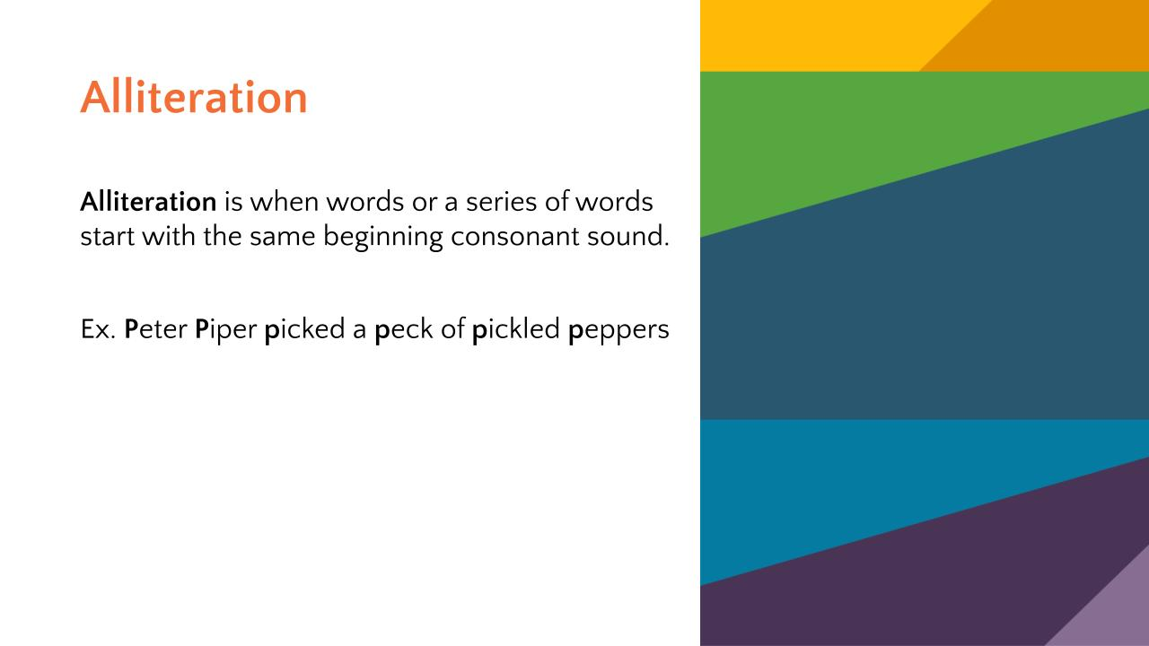

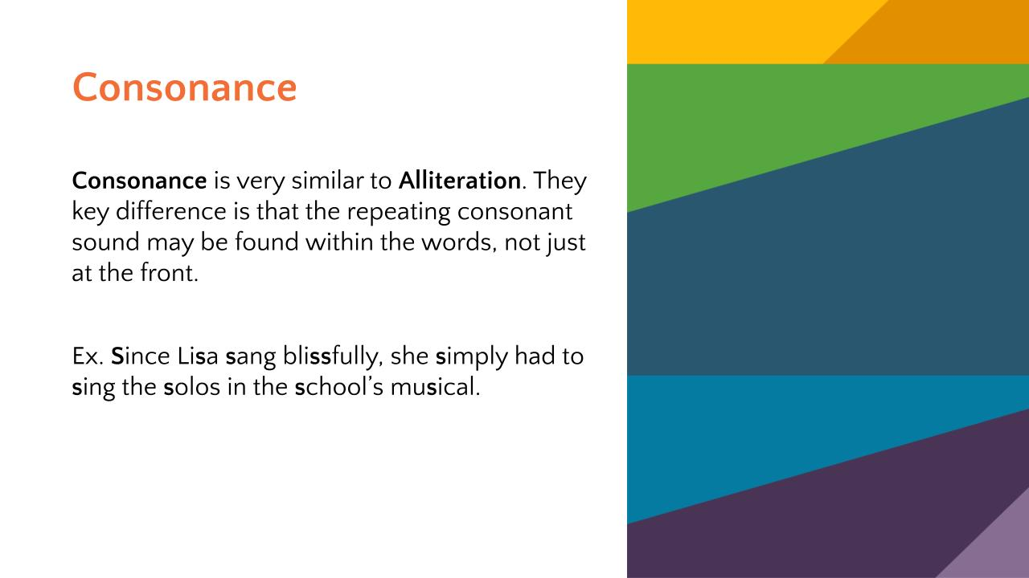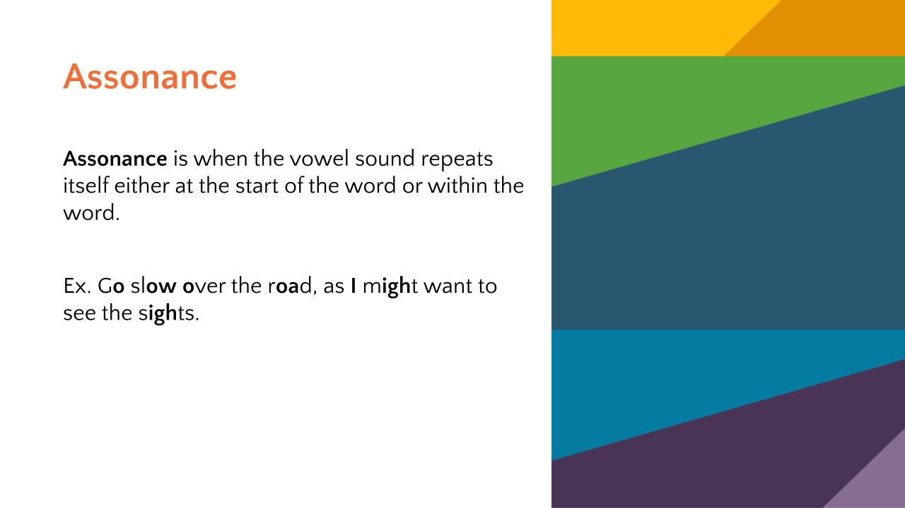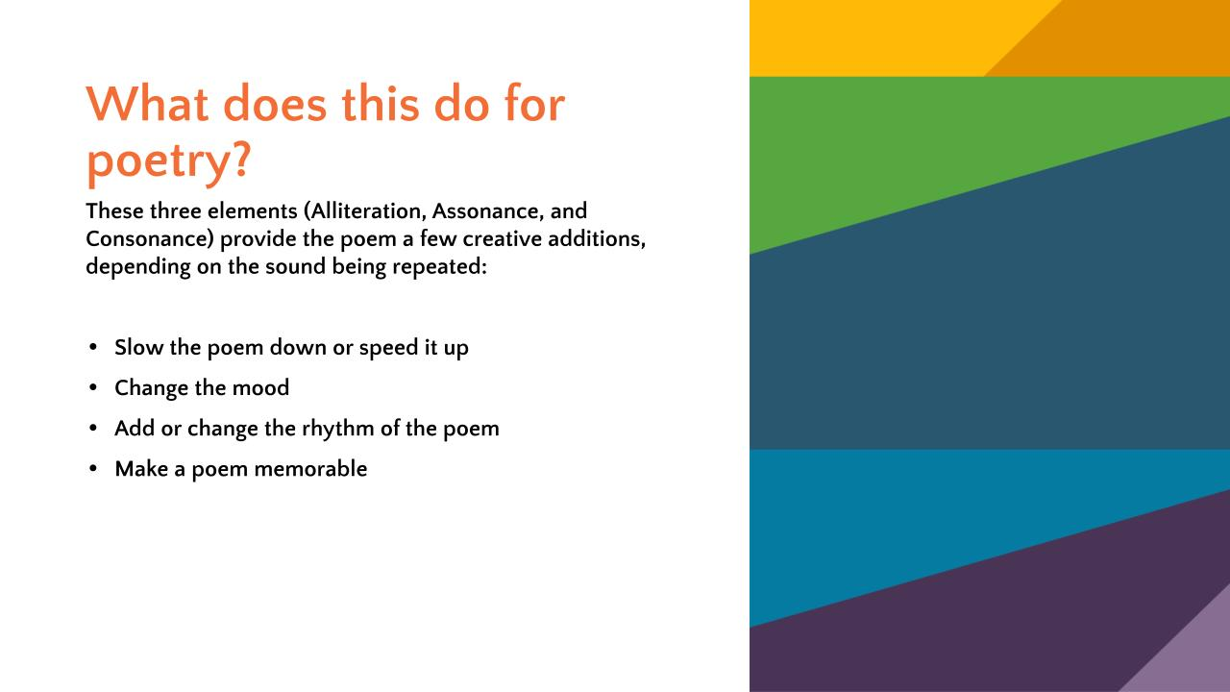

Supplemental Sensory Language Words

Smell Taste Touch Sound Sight

|  |  |  |  |  |
| --- | --- | --- | --- | --- |
| Salty | Spicy | Smooth | Racket | Bright |
| Greasy | Sour | Cold | Clang | Dull |
| Buttery | Raw | Cool | Loud | Dim |
| Sour | Bitter | Rough | Buzz | **Colors** |
| Strong | Delicious | Slimy | Croak | Blurry |
| Rich | Crispy | Hot | Whisper | Towering |
| Sweet | Strong | Furry | Ruckus | Sparkling |
| Burning | Hot | Clammy | Bang | Shiny |
| Bitter | Cold | Moist | Buzz | Reflecting |
| Fishy | Overwhelming | Steamy | Soft | Shimmering |
| Chocolatey | Rich | Soft | Booming | Dark |
| Cologne | Smooth | Shallow | Laughing | Surrounding |
| Perfume | Creamy | Gooey | Giggling | Glittery |
| Rainy | Crunchy | Bumpy | Gentle | Shady |
| Old | Moldy | Vibration | Swift |  |
| New | Rubbery | Hard | Scraping |  |
| Spicy | Sharp | Silky | Sizzle |  |
| Oniony | Gooey | Scaley | Hiss |  |
| Stinky | Grainy | Grainy | Howl |  |
| Pungent |  | Solid | **Animal sounds** |  |
| Clean |  | Wet |  |  |
| Fresh |  | Spiky |  |  |
| Lemony |  | Fluffy |  |  |
| Stale |  | Slippery |  |  |
|  |  | Warm |  |  |
|  |  |  |  |  |
|  |  |  |  |  |
|  |  |  |  |  |
|  |  |  |  |  |
|  |  |  |  |  |
|  |  |  |  |  |
|  |  |  |  |  |
|  |  |  |  |  |
|  |  |  |  |  |
|  |  |  |  |  |
|  |  |  |  |  |
|  |  |  |  |  |
|  |  |  |  |  |

Sensory Language

Using sensory language is a writing style. Writers use words to evoke sensations and to create images in readers’ minds. Writers present their emotions, thoughts, and ideas in an inviting way that involves their readers. Readers feel like they are in the story experiencing events alongside the characters. Sensory words are strong nouns, verbs, and adjectives. They enable readers to smell, taste, touch, hear, and see things in the text they are reading. Using sensory language brings writing to life.

In the chart below, record sensory words that relate to the corresponding sense.

Smell Taste Touch Sound Sight

|  |  |  |  |  |
| --- | --- | --- | --- | --- |
|  |  |  |  |  |
|  |  |  |  |  |
|  |  |  |  |  |
|  |  |  |  |  |
|  |  |  |  |  |
|  |  |  |  |  |
|  |  |  |  |  |
|  |  |  |  |  |
|  |  |  |  |  |
|  |  |  |  |  |
|  |  |  |  |  |
|  |  |  |  |  |
|  |  |  |  |  |
|  |  |  |  |  |
|  |  |  |  |  |
|  |  |  |  |  |
|  |  |  |  |  |
|  |  |  |  |  |
|  |  |  |  |  |
|  |  |  |  |  |
|  |  |  |  |  |
|  |  |  |  |  |
|  |  |  |  |  |
|  |  |  |  |  |
|  |  |  |  |  |
|  |  |  |  |  |
|  |  |  |  |  |
|  |  |  |  |  |
|  |  |  |  |  |
|  |  |  |  |  |
|  |  |  |  |  |
|  |  |  |  |  |

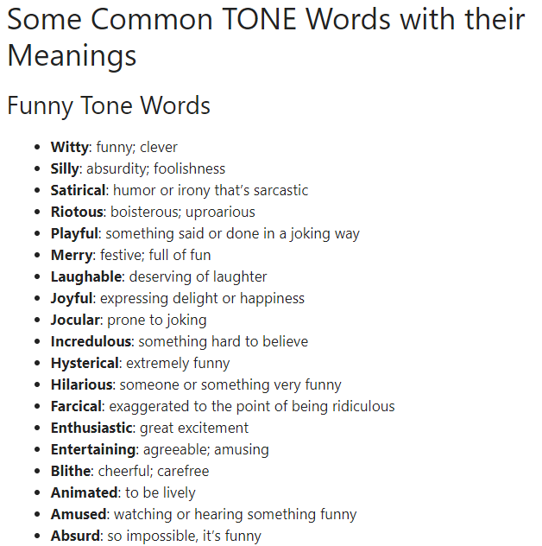

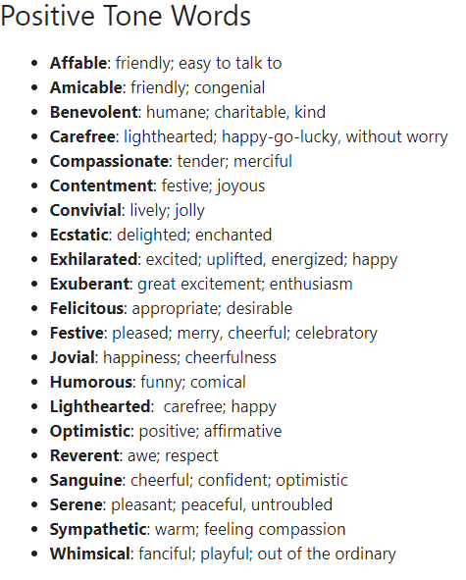

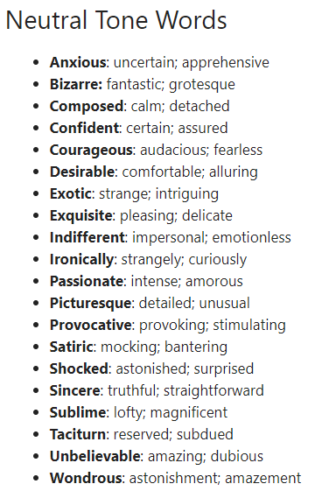

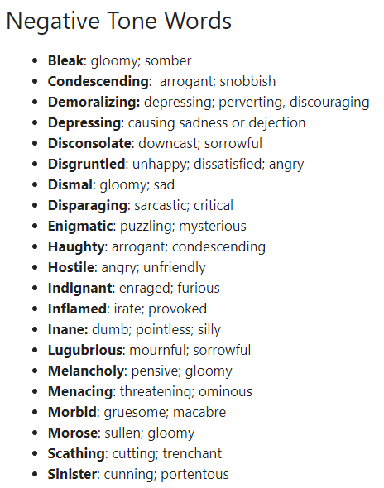

“TONE Words: List of 300+ Useful Words to Describe TONE of the Authors.” *ESL Forums*, uploaded by The English Teacher, 9 Mar. 2019, [TONE Words: List of 300+ Useful Words to Describe TONE of the Authors - ESL Forums](https://eslforums.com/tone-words/#Some_Common_TONE_Words_with_their_Meanings)

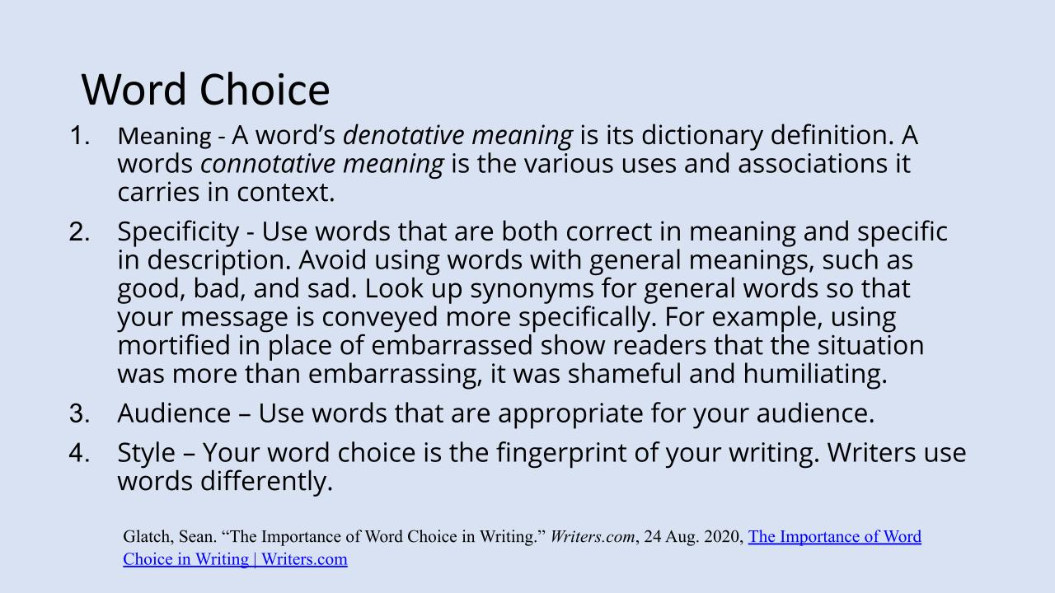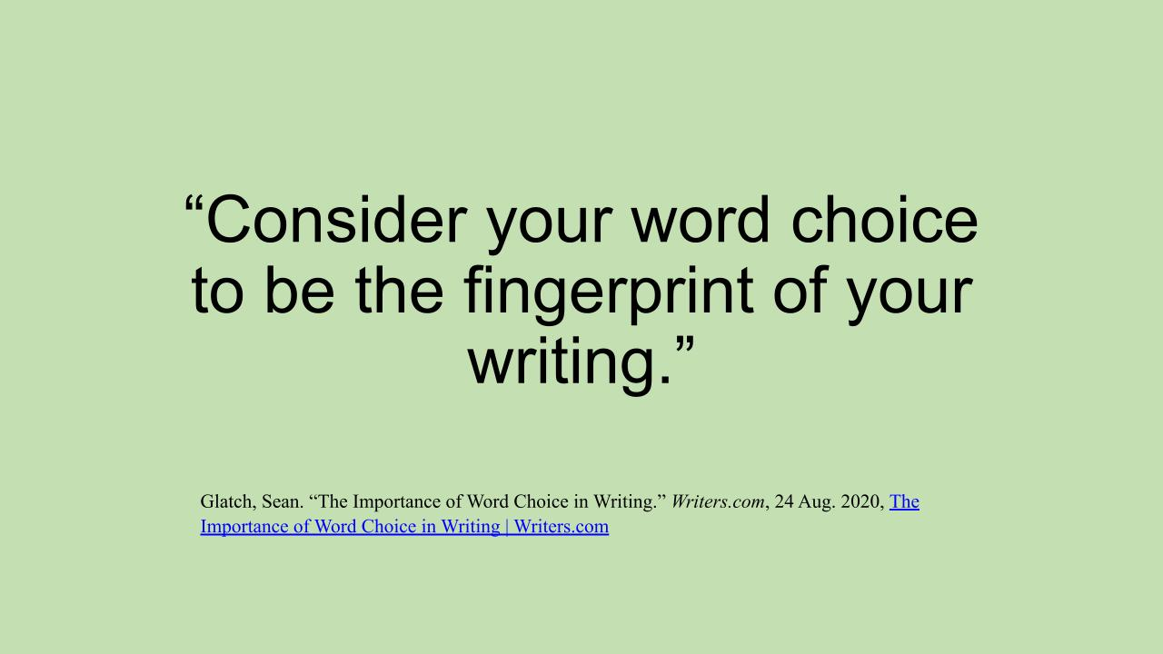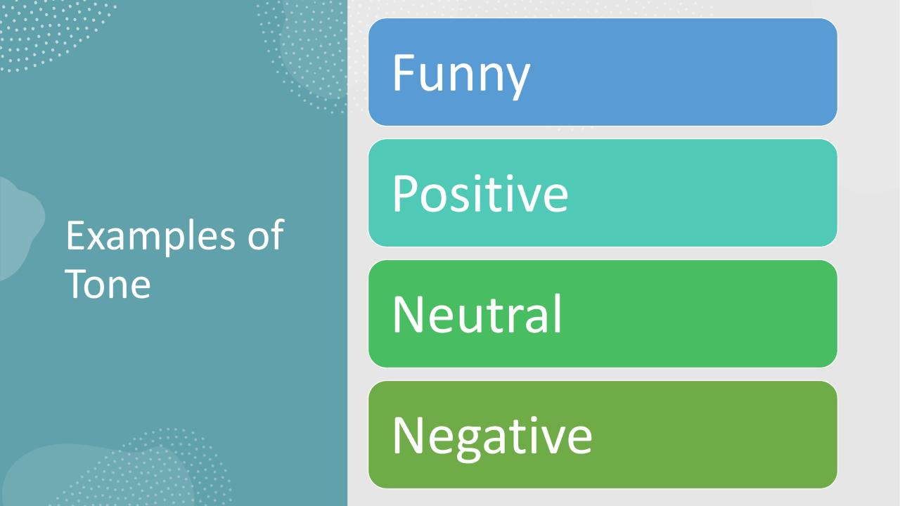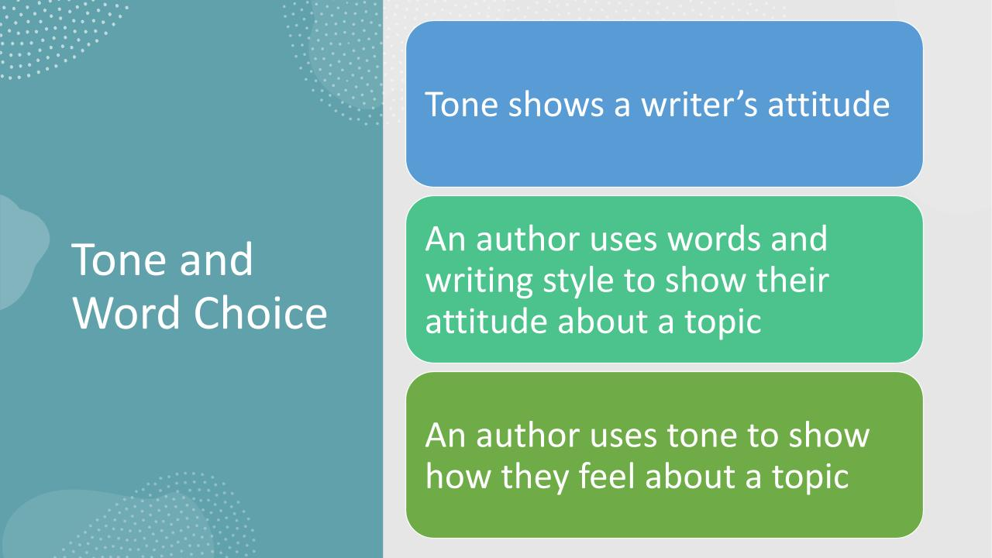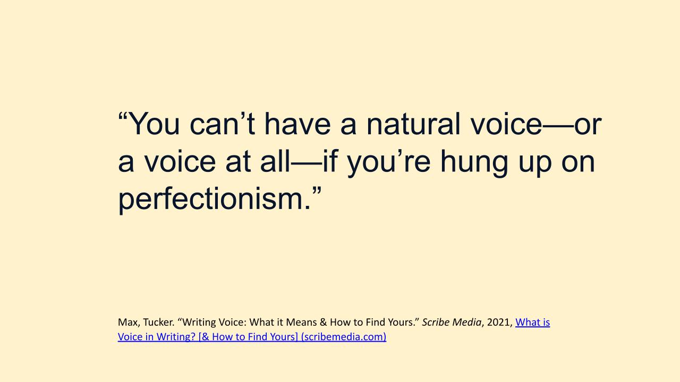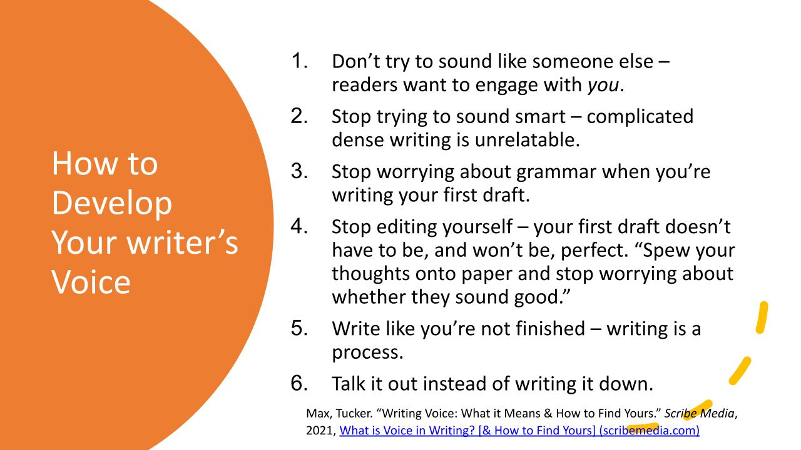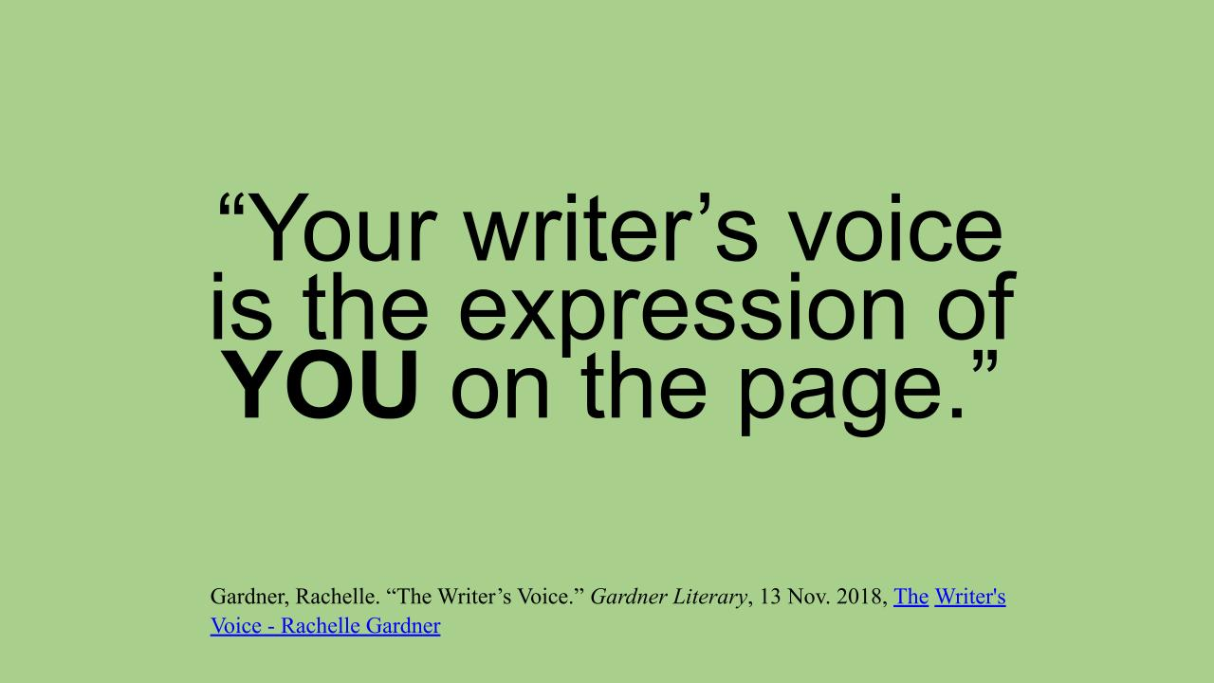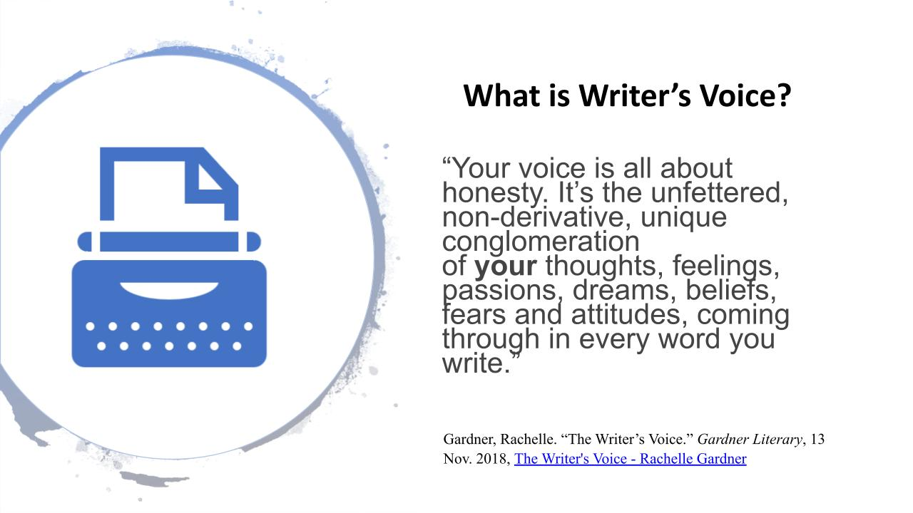

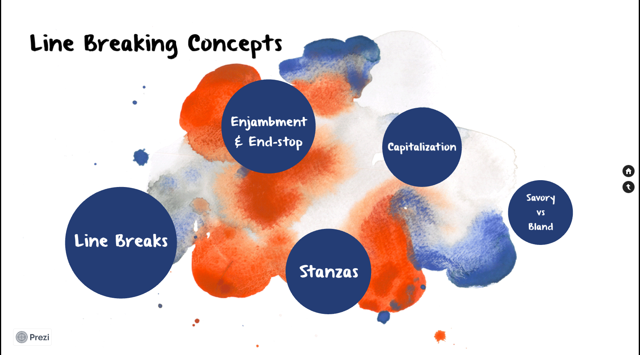

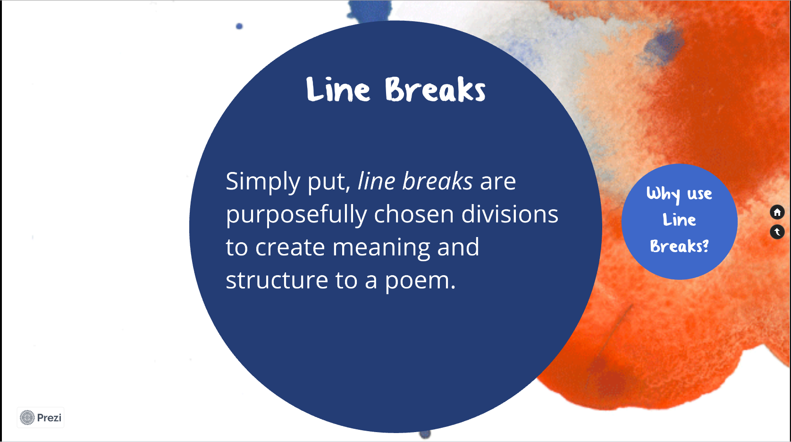

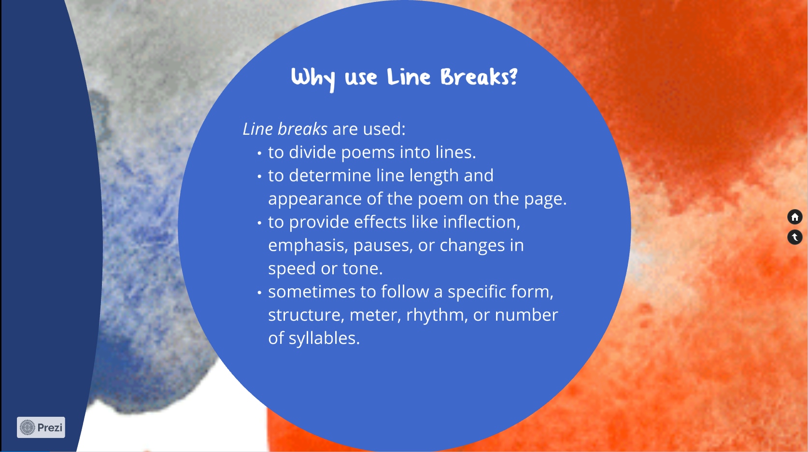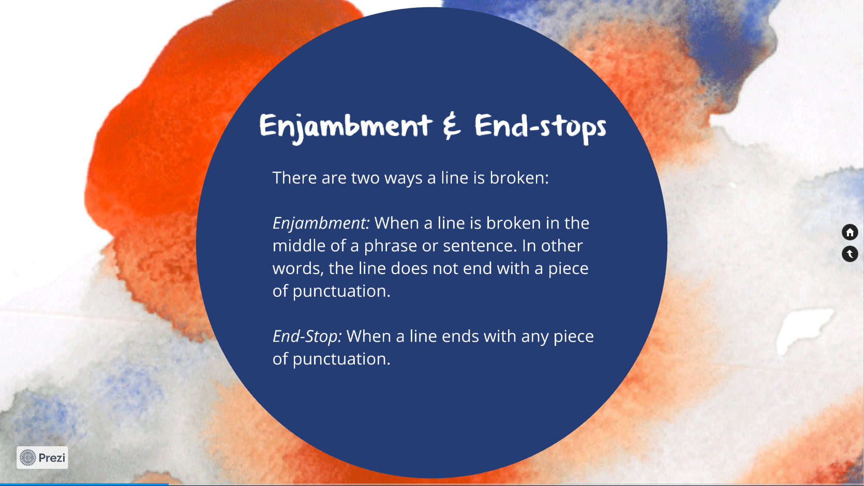

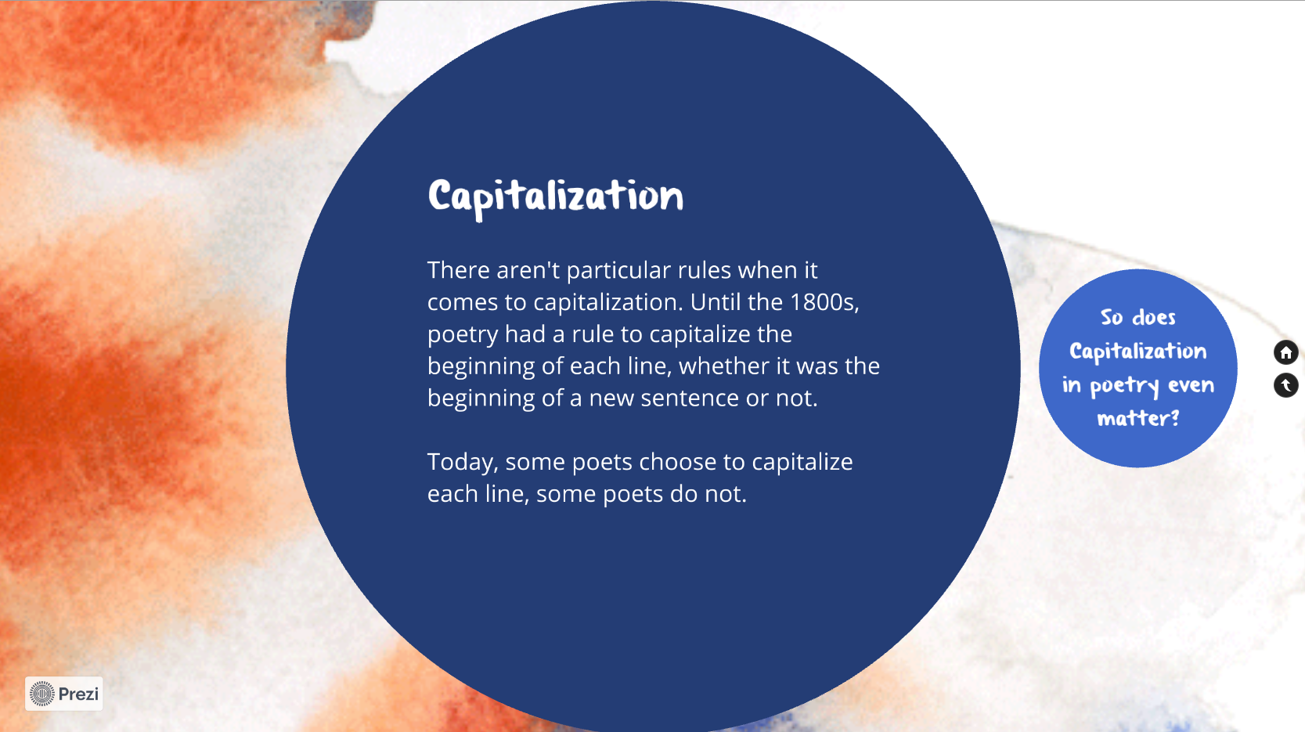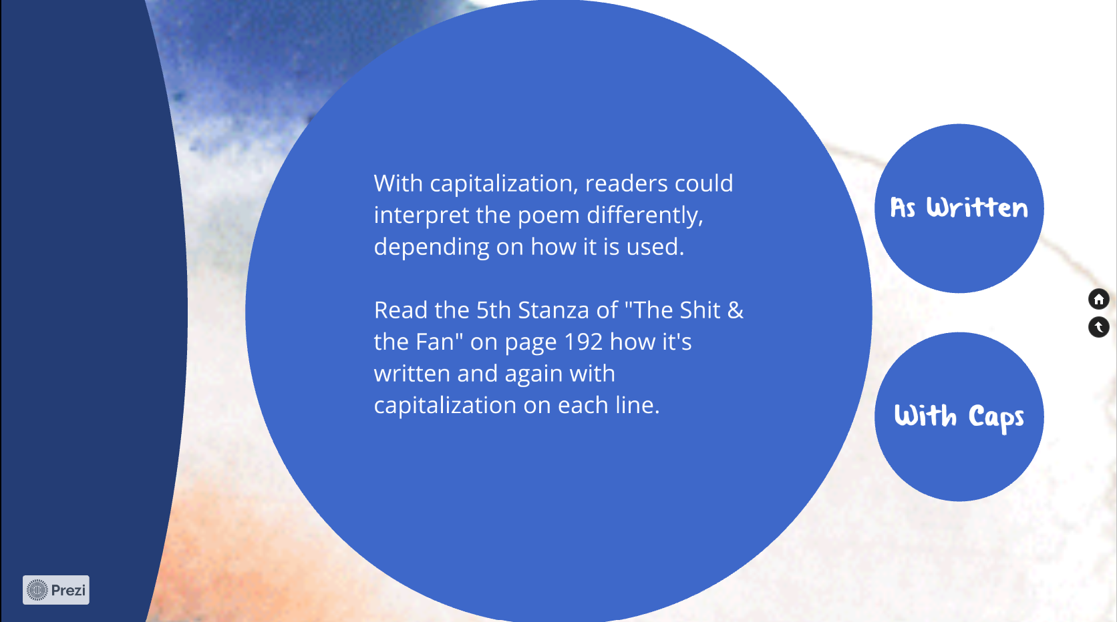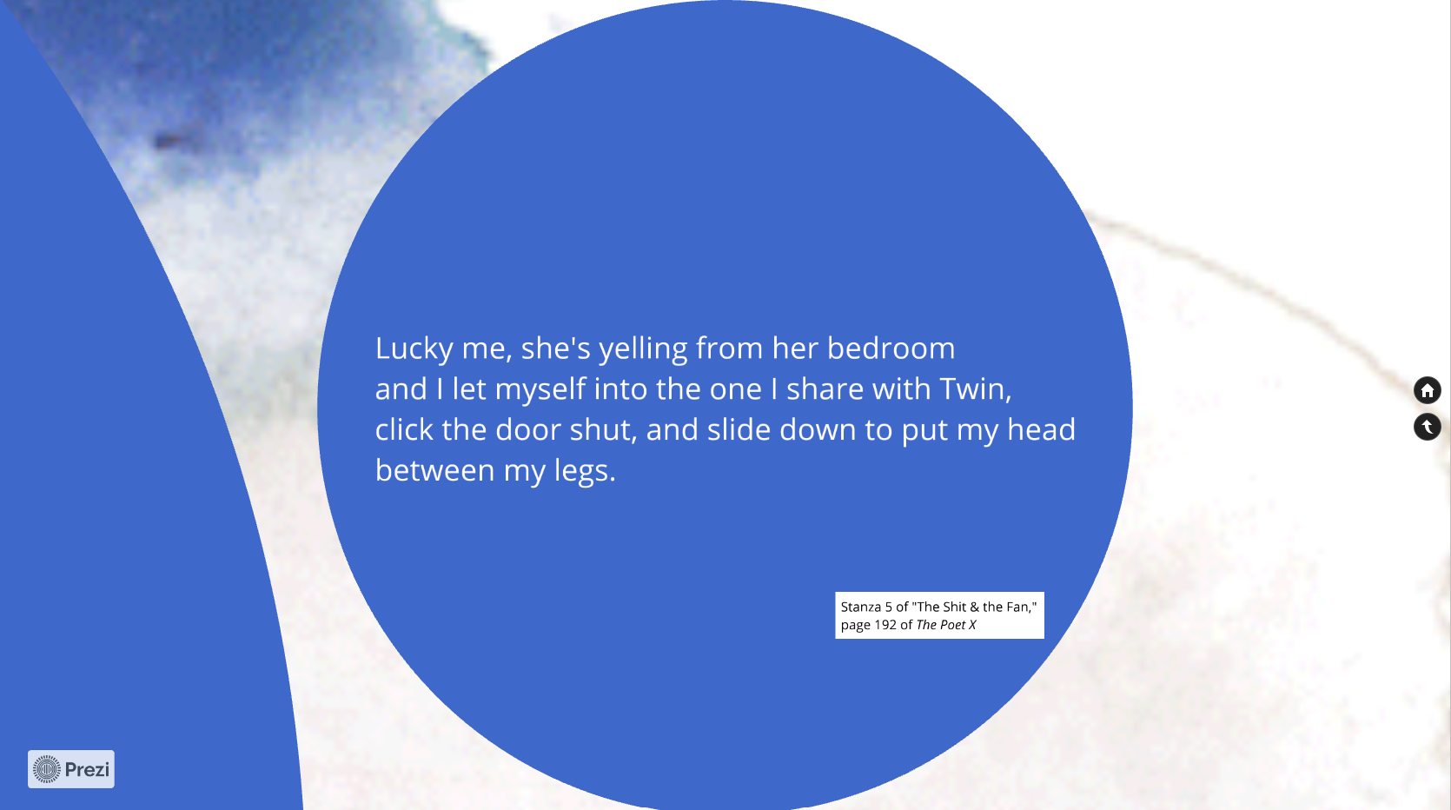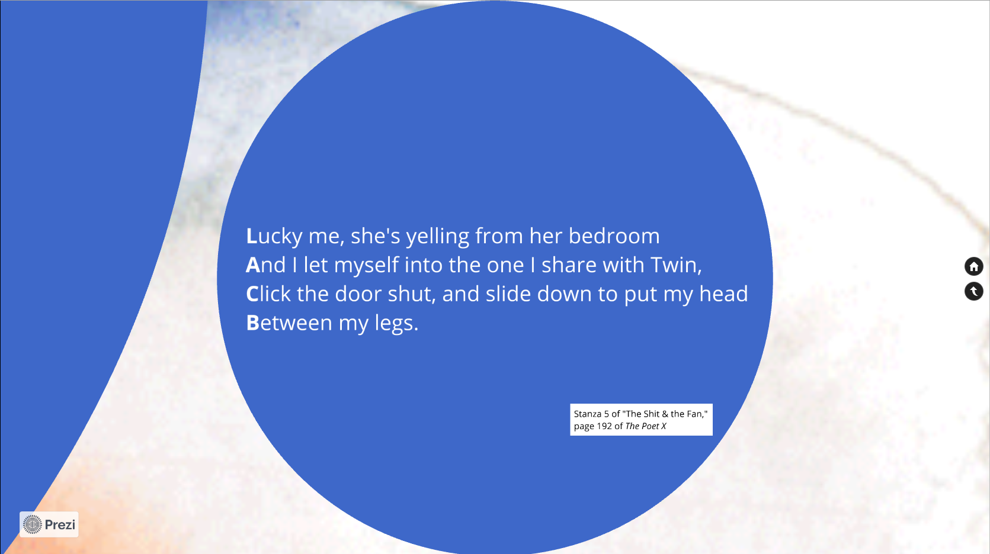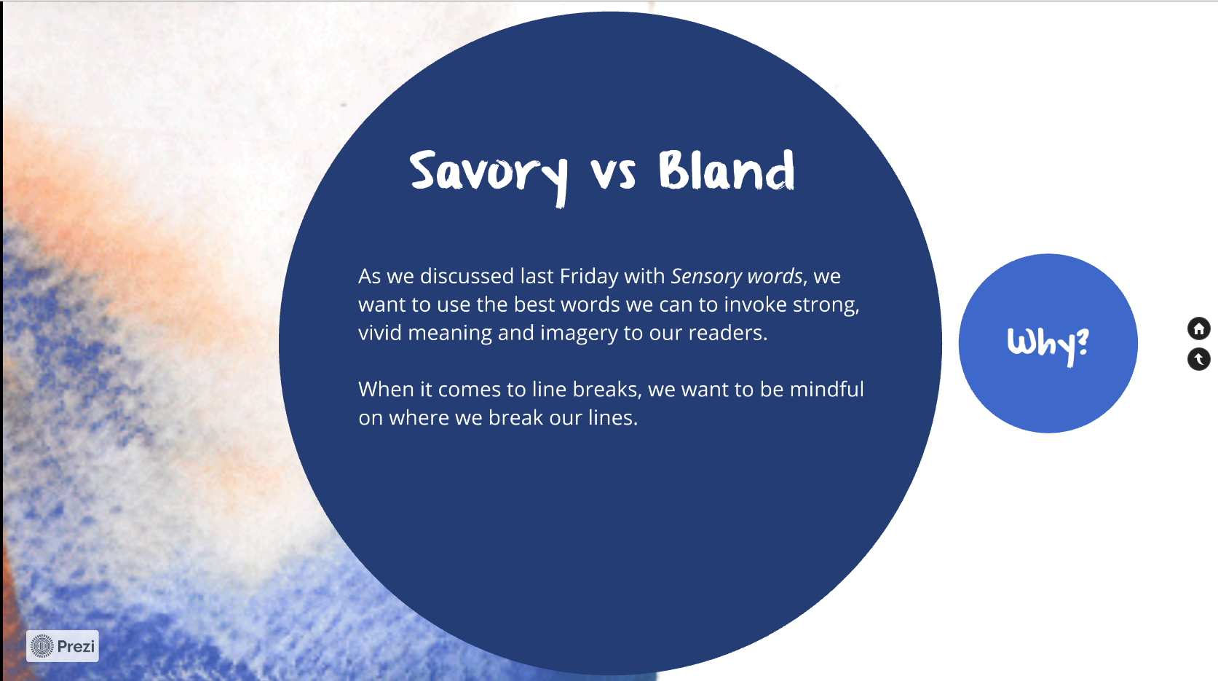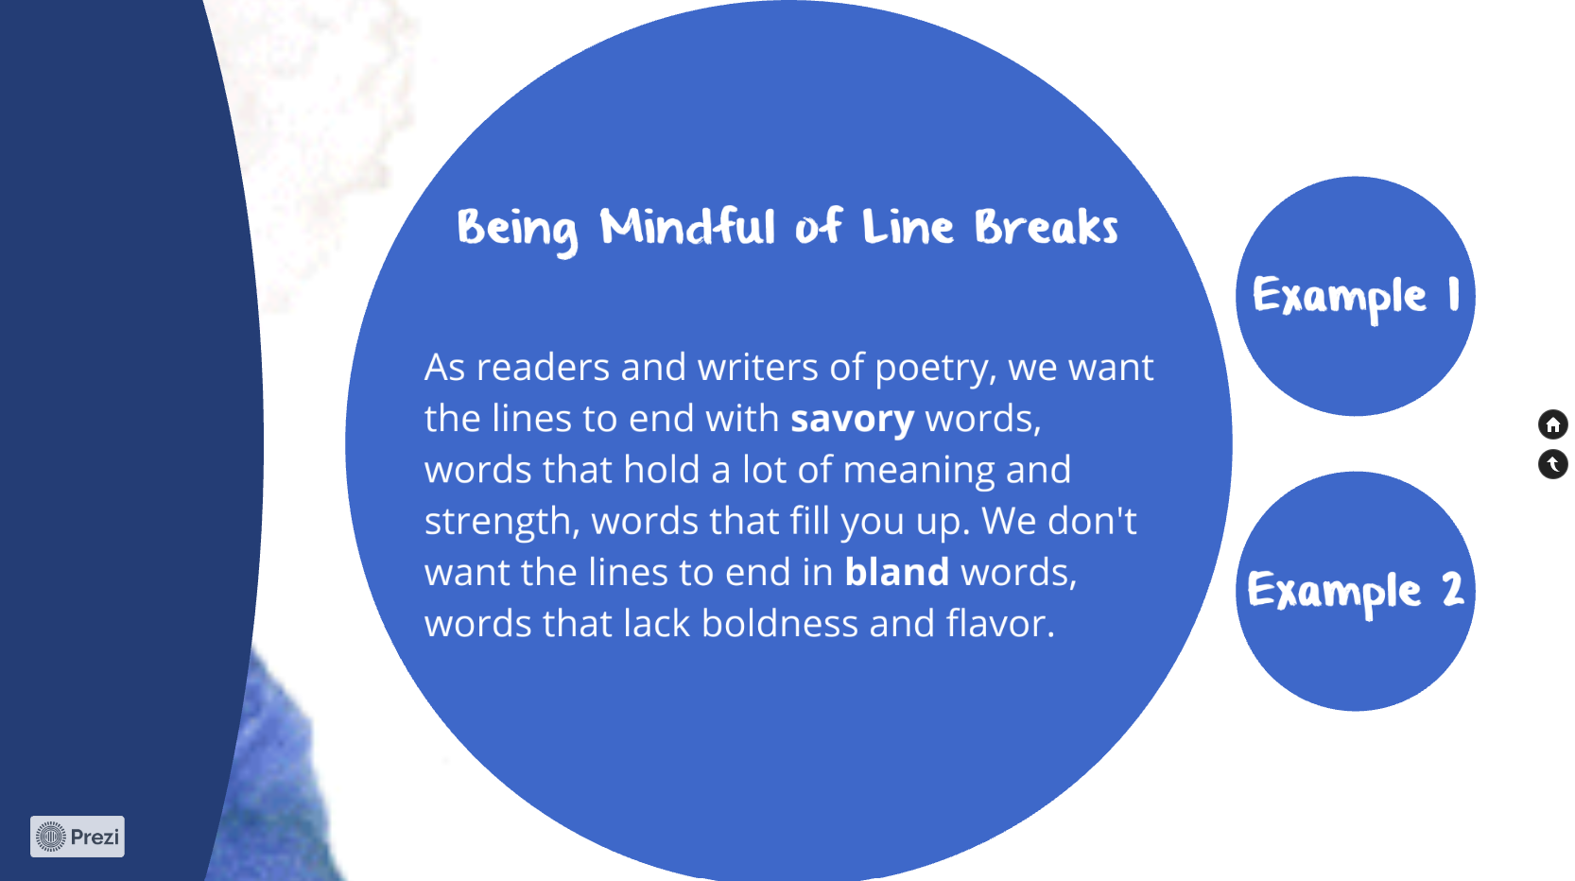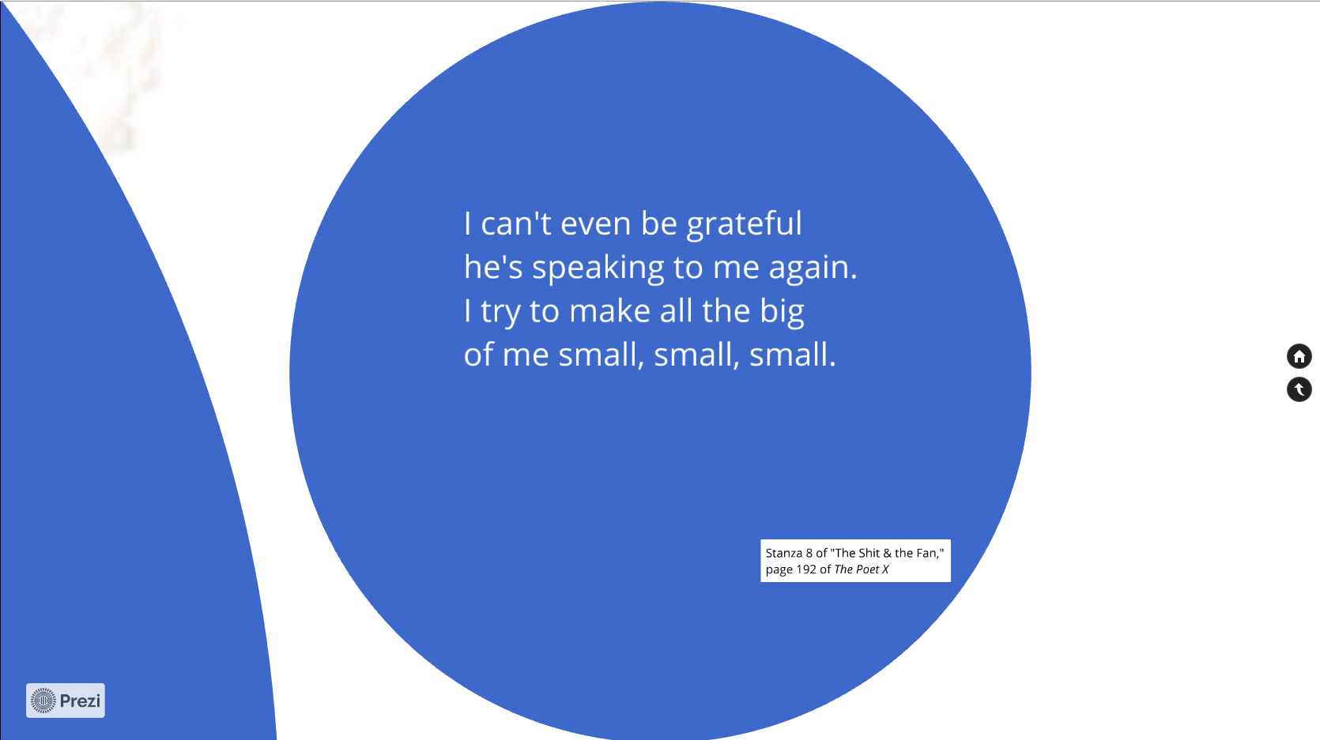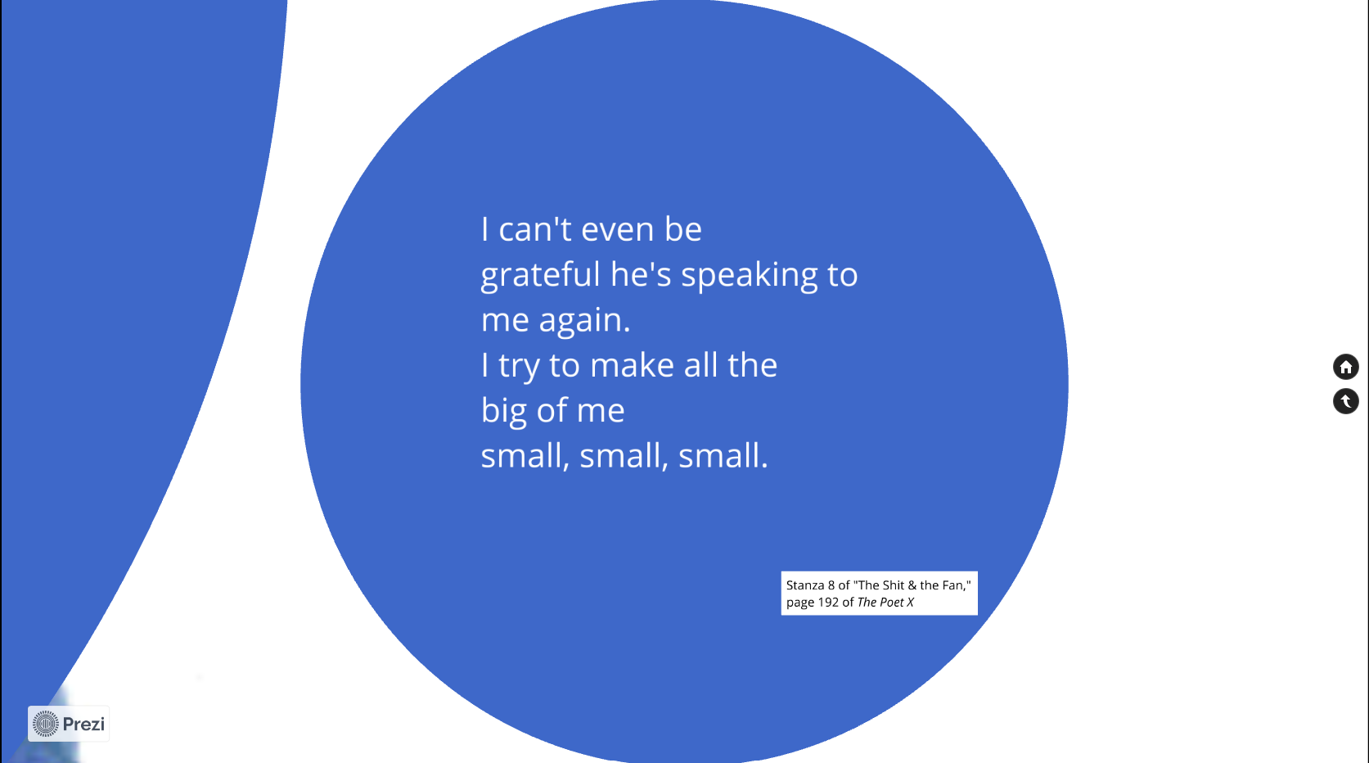

Line Breaking ConceptsPrezi Link: <https://prezi.com/view/Mdn1fVvP2SVUXAfKtk9j/>

*Line Breaking Analysis*

Today, we discussed a variety of concepts relating to line breaks. Your assignment is to choose *one* poem from Part II of *The Poet X* and analyze the poem for the concepts from today’s lesson. (Total of 20 points)

**Part I:** In your own words, define each of the terms and give a strong example of the concept from the poem you chose from Part II of *The Poet X*. (12 points = 2 points per term/concept = 1 point for the definition and 1 points for the example from the book)

*Line Breaks:*

*Stanza:*

*Enjambment:*

*End-stop:*

*Capitalization:*

*Savory vs Bland Line Endings:*

**Part II:** Now that you’ve defined and provided examples for each of the terms related to line breaking, you will analyze the poem you’ve chosen. In a short paragraph of at least six to eight sentences, explain how Acevedo’s use of one of the concepts mentioned in Part I creates structure and/or meaning to the poem. In other words, how does the concept you’re discussing affect the poem?

I have added some questions to get your mind thinking about the analysis. Please don’t answer each question individually—they are there to help you think about how to write your analysis paragraph and what to include if you’re not sure what to write. Make sure you write in paragraph form and not just listing or answering the following questions.

(8 points = 2 points for choosing a line breaking concept, 2 points for referencing the text, and 4 points for the analysis of how the line breaking concept adds to the poem)

*Questions to think about*: How did Acevedo’s use of [***x***] add to the poem? How would the poem have sounded/felt had she not added [***x***] to the poem or done it differently? Why is adding [***x***] to the poem a good decision as a writer? What does the use of [***x***] do for the reader’s experience?

**Questions for Memoirists**

• What are my earliest memories? How far back can I remember?

• What are the most important things that have happened to me in my life so far?

• What have I seen that I can’t forget?

• What’s an incident that shows what my friends and I are like?

• What’s an incident that shows what my pet(s) and I are like?

• What’s something that happened to me at school that I’ll always remember?

• What’s a time when I had a feeling that surprised me?

• What’s an incident that changed how I think or feel about something?

• What’s an incident that changed my life?

• What’s a time or place that I was perfectly happy?

• What’s a time or place that I laughed a lot?

• What’s a time or place when it felt as if my heart were breaking?

• What’s a time with a parent that I’ll never forget?

• What’s a time with a grandparent that I’ll never forget?

• What’s a time with a brother or sister that I’ll never forget?

• Can I remember a time I learned to do something, or did something for the first time?

• What memories emerge when I make a timeline of my life so far and note the most important things that happened to me each year?

© 2002 by Nancie Atwell *Lessons That Change Writers*

The Perfect Cake

The craving, So we tried again, over and

the craving, over,

for a cake with delicious obsessing to reach our goal.

frosting The Second Cake

smeared like snow on a gave us hope.

mountain summit. Its batter of luscious

The First Cake ingredients

was nothing like our vision. cast a sugary scent around

It was square, flat, and the kitchen.

tasteless, Unlike the first

and we had no frosting to this cake rose to the brim of

cover it. the pan.

We sat there We opened the oven door

and stared blankly at our with hopeful expressions,

creation. but with the first bite

“It could be chocolate,” I we knew we had failed.

said hopefully. Again.

But it wasn’t.

Our dream of the perfect

cake

became the perfect

nightmare.

The Third Cake? We began to feel defeated. Then I moved, knife in

Not quite sure what to call We dreamed of grand cakes hand.

it-- we now suspected would The sliver I shaved was

not vanilla, never exist. small,

definitely not chocolate. The Fourth Cake but it was all I needed to

I looked at it baking in the we approached with mixed tell me

oven: emotions. if this cake was worth our

our third, we stirred vanilla, effort.

possibly the third horrible flour,

failure. eggs, It was.

It emerged poured the batter I smiled.

with a brown layer encasing slow as molasses into the We had succeeded

the hoped-for soft insides. pan, After many tries,

We each took a sliver from and smoothed the surface. Colleen and I reached our

the edges. But our thoughts of the goal:

I prayed perfect cake The Perfect Cake.

for the right taste to explode seemed now like impossible --Audrey Stoltz

in my mouth dreams.

as I uneasily took a bite-- At last it was ready.

a bite of too much flour. We moved slowly,

With expressions of disgust frightened of what might lie

we threw away the third waiting in the oven.

attempt, We placed the cake

the third disappointment. on the table in front of us.

List of Poetry Forms

Haiku

Sonnet (Shakespearean)

Couplet

Quatrain

Anaphora

Limerick

Concrete

Ballad

Acrostic

Prose poetry

Blackout Poems

Tanka

*Impromptu Speech Scoring Sheet*

Name(s): ______________________________________________________________________

Name of poetry form (1 pts): ______________________________________________________

Definition given (2 pts): __________________________________________________________ _____________________________________________________________________________

Traits/Rules (3 pts): _____________________________________________________________ __________________________________________________________________________________________________________________________________________________________

Examples (2 pts): _______________________________________________________________ _____________________________________________________________________________Delivery (4 pts): ________________________________________________________________

_____________________________________________________________________________

_____________________________________________________________________________

Comments:

Score: _____ / 12

Name_____________

Date______________

Period_____________

Poem #1 page number and title: __________________________________________________________

What is the “So What?” of this poem?

____________________________________________________________________________________________________________________________________________________________________________________________________________________________________________________________________________________________________________________________________________________

Poem #2 page number and title: __________________________________________________________

What is the “So What?” of this poem?

____________________________________________________________________________________________________________________________________________________________________________________________________________________________________________________________________________________________________________________________________________________

Poem #3 page number and title: __________________________________________________________

What is the “So What?” of this poem?

_________________________________________________________________________________________________________________________________________________________________________________________________________________________________________________________________________________________________________________________________________________

**Poetry Group Assignments**

Group 1:

* “Spoken Word” (76-77)
* “Invitation” (281-82)
* “Poetic Justice” (349-50)

Group 2:

* “Holding a Poem in the Body” (79-80)
* “Longest Week” (293)
* “At the New York Citywide Slam” (353)

Group 3:

* “First Poetry Club Meeting” (256-57)
* “If Your Hand Causes You to Sin” (304-305)
* the last stanza of “Stronger” (343)

Group 4:

* “Nerves” (258)
* “If Your Hand Causes You to Sin” (304-305)
* “Poetic Justice” (349-50)

Group 5:

* “When I’m Done” (259)
* “Longest Week” (293)
* “Burn” (308)

Group 6:

* “Compliments” (260)
* “Slam Prep” (344-45)
* “At the New York Citywide Slam” (353)

Group 7:

* “Here” (264)
* “Signed Up” (277-78)
* “Ms. Galiano Explains the Five Rules of Slam:” (346)

Group 8:

* “Signed Up” (277-78)
* “Xiomara’s Secret Rules of Slam:” (347)
* “Poetic Justice” (349-50)

Group 9:

* “The Mic is Open” (279-80)
* “The Poetry Club’s Real Rules of Slam:” (348)
* the last stanza of “Stronger” (343)

**Peer Review Workshop Checklist:**

Your response to your peers should be thoughtful and help them better their work with positive critique. Carefully read your peers' poems then work through the checklist below, discussing the work and offering suggestions.

1. *Start With What’s Good*

Give some positives about your peers' poems: What did you like? What is working well in the poem? What struck you the most while reading it?

1. *Literary and Poetic Elements*

Look at the technical aspects of the poem: Is the form consistent? Is there rhythm and/or a rhyme scheme? Stanza breaks? How does it flow? What is the word play like? Does the poem use poetic elements like figure of speech, metaphor or simile, symbolism, allegory, imagery, repetition, or personification? Are there any other elements you can point out? Make some suggestions for bettering these elements.

1. *Poetry Lesson Points*

Look for incorporation of the poetry lessons from the unit: How does it use the five senses/sensory language? Does it effectively employ tone and diction use? Does it incorporate alliteration, assonance, consonance? Do you understand the poem's general message? What is the “so what”? Does the ending leave the reader satisfied?

1. *Spoken Word*

After reading the poem, discuss: Will this poem translate well into spoken word? What stanzas/lines/words have the potential to be most impactful when performed? Where could the voice be articulated for emphasis? Where could hand gestures or changes in body language be applicable?

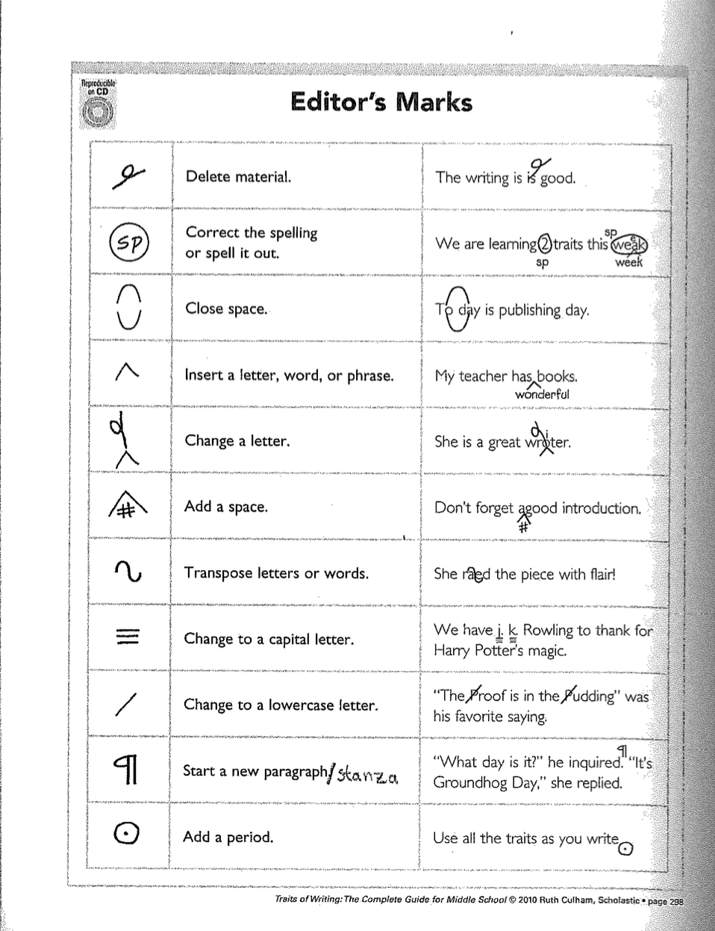

Works Cited

Acevedo, Elizabeth. *The Poet X*. Harper Teen, 2018.

“Ariana Brown - ‘Ode to Thrift Stores.’” *YouTube,* uploaded by Button Poetry, 7 Dec. 2017. [youtu.be/PFZJoU44uOo](https://youtu.be/PFZJoU44uOo).

Atwell, Nancie. *In the Middle: A Lifetime of Learning About Writing, Reading, and Adolescents*. Heinemann, 2015.

Atwell, Nancie. *Lessons That Change Writers*. Heinemann, 2002.

Beers, Kylene. “Tomorrow is Not Simply Another Day at School.” *Kylene Beers*, WordPress, 6 Jan. 2021, kylenebeers.com/blog/2021/01/06/tomorrow-is-not-simply-another-day-at-school/.

Bergman, Bennet. “Line Break.” *LitCharts*, LitCharts LLC, 5 May 2017, [www.litcharts.com/literary-devices-and-terms/line-break](http://www.litcharts.com/literary-devices-and-terms/line-break). Web. 17 Apr 2021.

Brits, Leona. “Writer’s Voice: What Is It and How to Find Yours.” *The Writing Cooperative*, 2 Jul. 2018, [writingcooperative.com/the-writers-voice-what-is-and-how-to-find-yours-ed82f1884984](https://writingcooperative.com/the-writers-voice-what-is-and-how-to-find-yours-ed82f1884984).

“Chibbi - Lost and Found: An Oral History.” *YouTube*, uploaded by Button Poetry, 12 Mar. 2021, [youtu.be/b6L3y7Ari0Q](http://youtu.be/b6L3y7Ari0Q).

Culham, Ruth. *Traits of Writing: The Complete Guide for Middle School*. Scholastic, 2010.

Dobson, Andrew. “Who am I? Self Identity – How to Build Personal Character.” *Mindfit Hypnosis,* 4 Mar. 2020, [mindfithypnosis.com/who-am-i-self-identity/](https://mindfithypnosis.com/who-am-i-self-identity/).

Gardner, Rachelle. “The Writer’s Voice.” *Gardner Literary*, 13 Nov. 2018, [rachellegardner.com/the-writers-voice/](https://rachellegardner.com/the-writers-voice/).

Glatch, Sean. “The Importance of Word Choice in Writing.” *Writers.com*, 24 Aug. 2020, [writers.com/word-choice-in-writing](https://writers.com/word-choice-in-writing).

“How to Write a ‘Where I’m From ‘ Poem.” *Pen & the Pad*, 12 Jul. 2018, [penandthepad.com/write-where-im-from-poem-4615832.html](https://penandthepad.com/write-where-im-from-poem-4615832.html).

“I Am From Poem.” *Freeology*, [freeology.com/worksheet-creator/poetry/i-am-from-poem/](https://freeology.com/worksheet-creator/poetry/i-am-from-poem/).

Kemp, A. C. “6 Tips for Teaching Impromptu Speaking.” TESOL Blog, TESOL International Association, 25 Feb. 2021, blog.tesol.org/6-tips-for-teaching-impromptu-speaking/.

“Marvin Hodges - ‘Blue Genes.’” *YouTube*, uploaded by Button Poetry, 4 Apr. 2015, youtu.be/C5HRBib3hNs.

Max, Tucker. “Writing Voice: What it Means & How to Find Yours.” *Scribe Media*, 2021, [scribemedia.com/voice-in-writing/](https://scribemedia.com/voice-in-writing/).

Milner, Joseph O., et al. *Bridging English*. 5th ed., Pearson, 2012.

Oliver, Mary. *A Poetry Handbook*. Mariner, 1994.

Padgett, Ron. *The Teachers and Writers Handbook of Poetic Forms*. Teachers & Writers Collaborative, Ed. 2, 2007.

“Sabrina Benaim - Explaining my Depression to my Mother.” *YouTube,* uploaded by Button Poetry, 20 Nov. 2014, [www.youtube.com/watch?v=aqu4ezLQEUA&list=PLC5PJtWBigV2f4TM4Gx7IlPe1ummqg5jt&index=5](https://www.youtube.com/watch?v=aqu4ezLQEUA&list=PLC5PJtWBigV2f4TM4Gx7IlPe1ummqg5jt&index=5).

“Students Reading ‘I Am From’ Poems.” *YouTube*, uploaded by Aukram Burton, 3 Nov. 2012, [www.youtube.com/watch?v=tmrAa2neiKU](https://www.youtube.com/watch?v=tmrAa2neiKU).

“Tanesha Nicole and Jose Soto - For The Loud Families.” *YouTube*, uploaded by Button Poetry, 25 Apr. 2021, [youtu.be/KKxxl6upMfo](https://youtu.be/KKxxl6upMfo).

“The Poet X// Book Review.” *YouTube*, uploaded by Mrs. Dunn Reads, 21 May 2018, [youtu.be/rt0OMkKCpiQ](https://youtu.be/rt0OMkKCpiQ).

“TONE Words: List of 300+ Useful Words to Describe TONE of the Authors.” *ESL Forums*, uploaded by The English Teacher, 9 Mar. 2019, [eslforums.com/tone-words/#Some_Common_TONE_Words_with_their_Meanings](https://eslforums.com/tone-words/#Some_Common_TONE_Words_with_their_Meanings).

“What is Sensory Language.” *YouTube*, uploaded by Mometrix Academy, 9 Jan. 2018, [www.youtube.com/watch?v=T08PmnRiGCo](https://www.youtube.com/watch?v=T08PmnRiGCo).

“Where I’m From / a Poem,” *YouTube*, uploaded by Ollie, 22 Sep. 2018, [www.youtube.com/watch?v=3ilgDe5Hbus](https://www.youtube.com/watch?v=3ilgDe5Hbus).